8.04 Find a short side
Year 8 Maths · A5 question sheet · Level 3 · Challenge
This worksheet challenges you to find shorter sides in harder problems: exact values, triangles inside other shapes and problems with more than one step. Tip: label the hypotenuse first. Then $a^{2}=c^{2}−b^{2}$. Keep the full calculator value until the end, and round only your final answer.

 Fluency
- Find the length of the unknown side in each triangle. Each answer is exact.
- 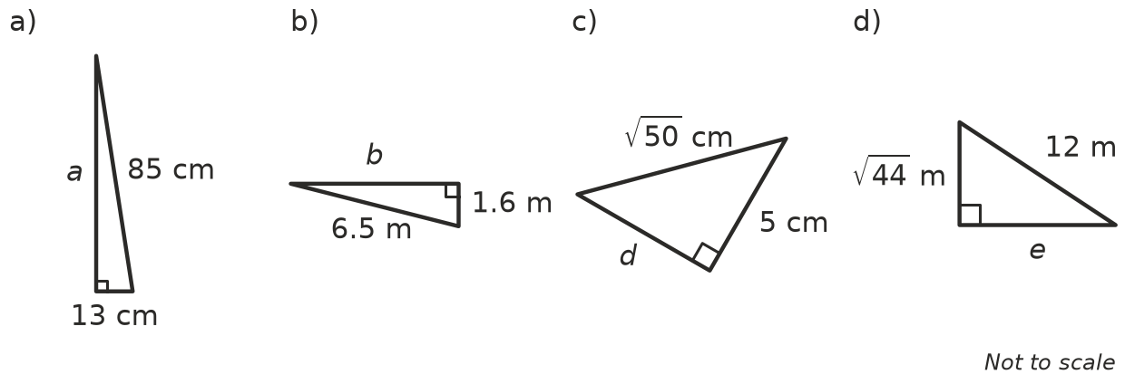
  - a =
  - b =
  - d =
  - e =
- In triangle ABC, AD is at right angles to BC.
- 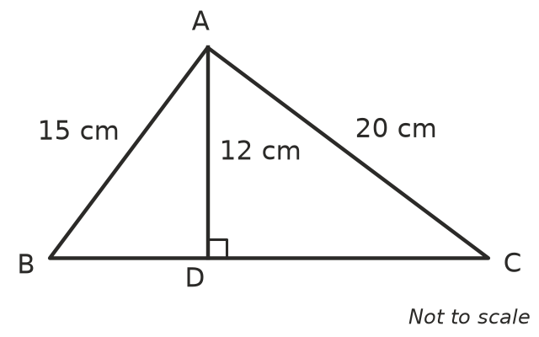
  - Find BD.
  - Find DC.
  - Find BC.
  - Show that triangle ABC has a right angle at A.
- An equilateral triangle has sides of 8 cm. Its height cuts the base in half.
  - Find the height of the triangle, correct to 2 decimal places.
  - Find the area of the triangle, correct to 2 decimal places.

 Reasoning
- Zara is asked to find a shorter side of a right-angled triangle with a hypotenuse of 7 cm and another side of 9 cm. Explain why this triangle cannot exist.
- A right-angled triangle has two sides of 9 cm and 15 cm. The third side could be a shorter side or the hypotenuse. Find both possible lengths of the third side, correct to 2 decimal places where needed.
- A right-angled triangle has a hypotenuse of 7.4 cm and a shorter side of 3.6 cm. Lucas rounds 7.4² to 55 and 3.6² to 13 before he subtracts, and gets 6.48 cm for the other shorter side.
  - Find the correct length, to 2 decimal places.
  - Explain why Lucas got a different answer.

 Problem solving
- A 6.5 m ladder leans against a wall with its foot 2.5 m from the wall.
  - How far up the wall does the ladder reach?
  - The foot of the ladder slides 1.4 m further away from the wall. How far does the top of the ladder slide down the wall?
- The front of an A-frame tent is an isosceles triangle. The two sloping sides are 2.6 m long and the base is 2 m wide. How tall is the tent in the middle?
- 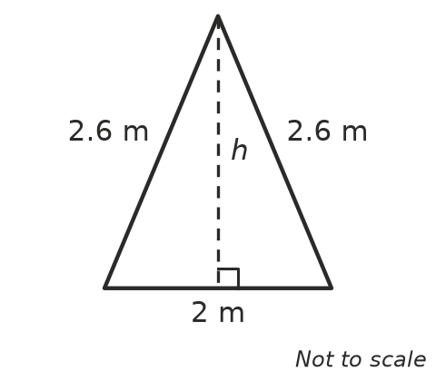
- A rectangle has a diagonal of 15 cm. Its sides are in the ratio 3 : 4. Find the length, the width and the area of the rectangle.
- A circle has a radius of 25 cm. A chord AB is 48 cm long. The line from the centre O to the middle M of the chord is at right angles to the chord. How far is the chord from the centre?
- 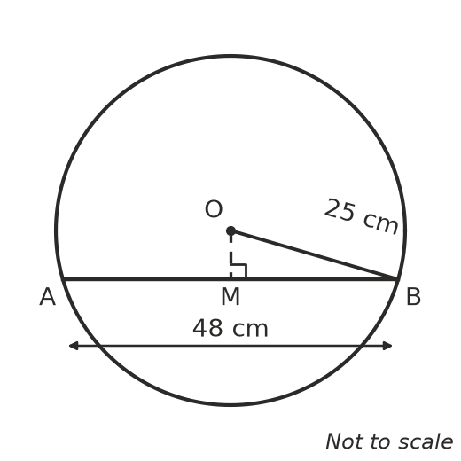
- A rope hangs from the top of a flagpole. When it hangs straight down, 1 m of rope lies on the ground. When the rope is pulled tight, its end touches the ground 5 m from the base of the pole. Try different heights (for example 10 m, 11 m, 12 m) to find the height of the flagpole.

