8.03 Find the hypotenuse
Year 8 Maths · Worksheet · Level 3 · Challenge
Name: ____________________ Date: ______________
This worksheet challenges you to find hypotenuses in harder situations: mixed units, exact square roots, triangles joined together and lengths inside 3D boxes. Tip: draw a right-angled triangle for every step, and keep exact values (or the full calculator value) until the final answer.

 Fluency
- Find the length of the hypotenuse in each triangle. Give an exact answer if it is a whole number or a decimal that stops; otherwise round to 2 decimal places.
- 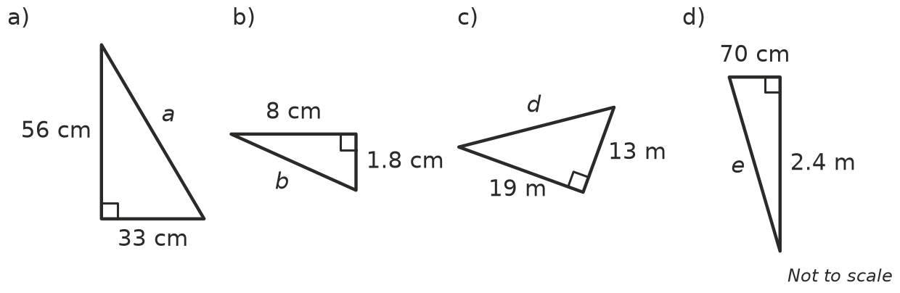
  - a = ______________
  - b = ______________
  - d = ______________
  - e = ______________
- Each right-angled triangle has the two shorter sides given. Find the hypotenuse. Each answer is a whole number.
  - $\sqrt{3}$ cm and $\sqrt{6}$ cm ______________
  - 2 cm and $\sqrt{5}$ cm ______________
  - $\sqrt{10}$ m and $\sqrt{15}$ m ______________
  - 3 m and $\sqrt{7}$ m ______________

 Reasoning
- Two right-angled triangles are joined along the side x.
- 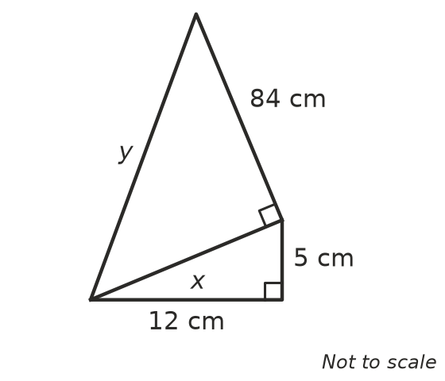
  - Find x. ______________
  - Use your answer to find y. ______________
- Without finding any square roots, decide which is longer: the hypotenuse of a right-angled triangle with shorter sides 7 cm and 8 cm, or one with shorter sides 4 cm and 10 cm. Explain.

- Without a calculator, explain why the hypotenuse of a right-angled triangle with shorter sides of 10 cm and 1 cm is only a little more than 10 cm.

 Problem solving
- The diagonals of a rhombus cut each other in half at right angles. Rhombus ABCD has diagonals of 24 cm and 10 cm. Find its perimeter.
- 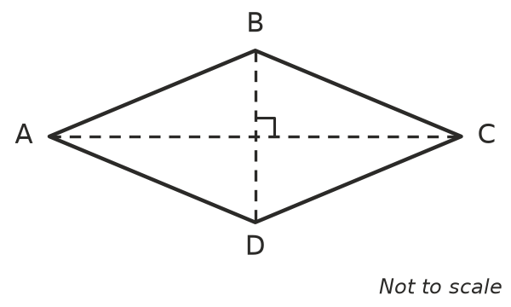

- Find the distance between the points P(−3, 2) and Q(5, −4).
- 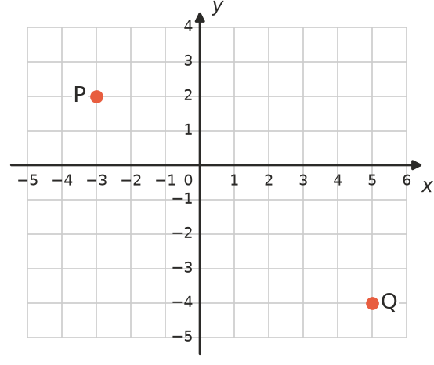

- A box is 40 cm long, 30 cm wide and 120 cm tall.
- 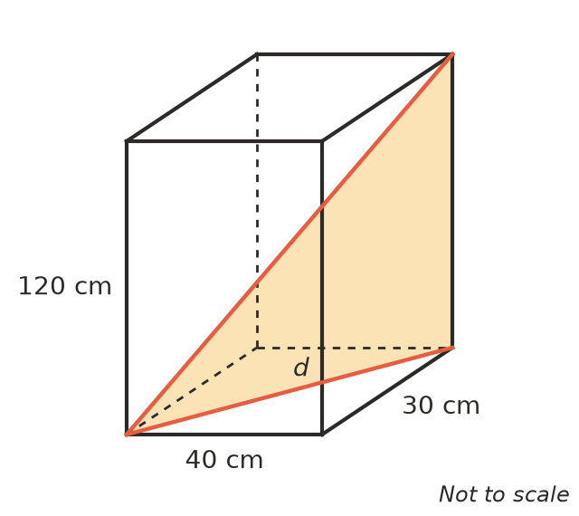
  - Find the length of the diagonal across the base, d. ______________
  - Use the right-angled triangle shaded in the picture to find the length of the longest straight rod that fits inside the box, from a bottom corner to the opposite top corner. ______________
  - Will a 1.25 m umbrella fit in the box with the lid closed? Explain. ______________
- Two planes leave an airport at the same time. One flies north at 600 km/h and the other flies east at 800 km/h. How far apart are they after 1.5 hours?

- A cyclist rides 3 km east, then 2 km north, then 5 km east, then 4 km north. How far is she from her starting point in a straight line?

- A TV screen is 96 cm wide and 54 cm tall.
  - Find the length of the diagonal, to the nearest centimetre. ______________
  - TV sizes are given in inches, where 1 inch = 2.54 cm. What size TV is this, to the nearest inch? ______________
- The triangle with sides 3, 4, 5 has shorter sides that are whole numbers next to each other.
  - Find the hypotenuse of a right-angled triangle with shorter sides 20 and 21. ______________
  - Find the hypotenuse of a right-angled triangle with shorter sides 119 and 120. ______________

