8.03 Find the hypotenuse
Year 8 Maths · A5 question sheet · Level 2 · Core
This worksheet practises finding the hypotenuse of a right-angled triangle with $c^{2}=a^{2}+b^{2}$. Tip: write the equation, square and add, then take the square root. Make sure both sides are in the same unit before you start, and round only at the very end.

 Understanding
- For each triangle, write an equation using Pythagoras’ theorem, then solve it.
- 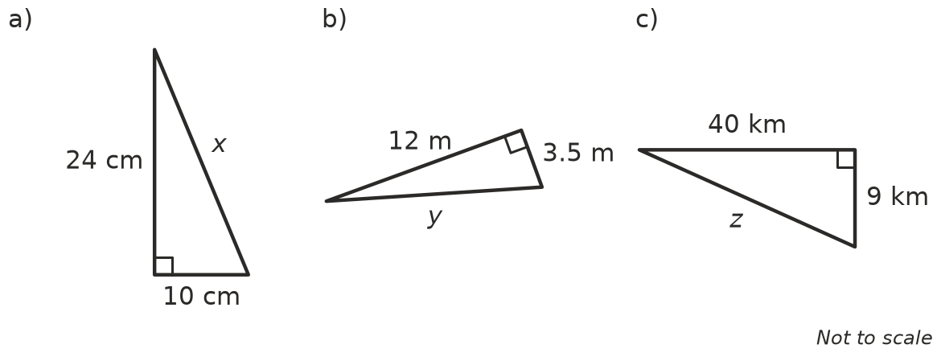
  - Equation: ______________ x =
  - Equation: ______________ y =
  - Equation: ______________ z =

 Fluency
- Find the length of the hypotenuse in each triangle. Each answer is exact.
- 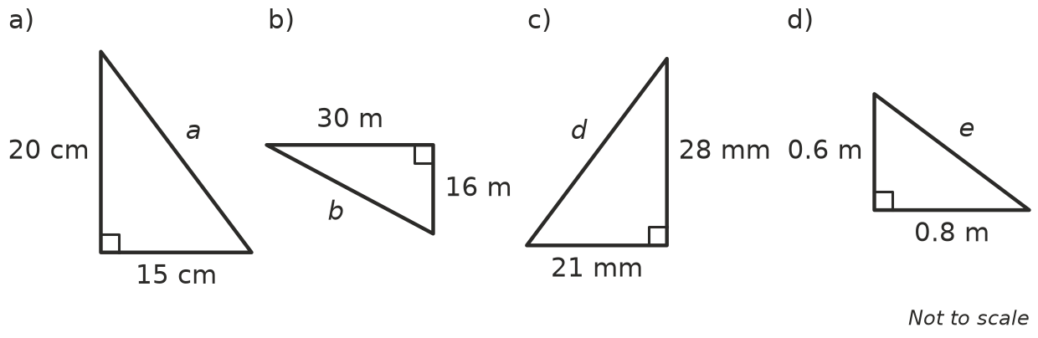
  - a =
  - b =
  - d =
  - e =
- Find the length of the hypotenuse in each triangle. Round your answers to 1 decimal place.
- 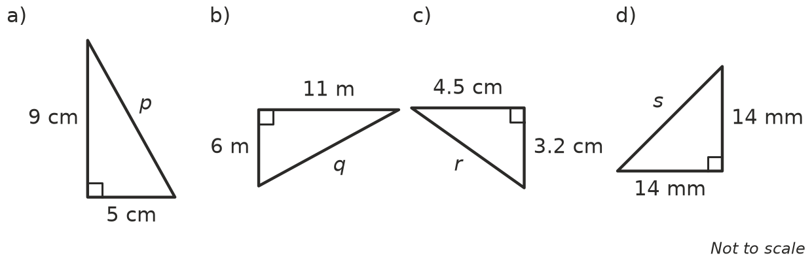
  - p =
  - q =
  - r =
  - s =
- A right-angled triangle has the two shorter sides given. Write the exact length of the hypotenuse using a square root.
  - 2 cm and 5 cm
  - 3 cm and 3 cm
  - 1 m and 7 m
- A right-angled triangle has shorter sides of 90 cm and 1.2 m. Find the length of the hypotenuse in metres.

 Reasoning
- Josh is finding the hypotenuse of a triangle with shorter sides 7 cm and 9 cm. His working is: c² = 7² + 9² = 49 + 81 = 130, so c = 130 ÷ 2 = 65 cm.
  - Explain Josh’s mistake.
  - Find the correct answer, to 1 decimal place.
- A right-angled triangle has shorter sides of 9 cm and 13 cm. Which of these could be the hypotenuse: 12 cm, 15.8 cm or 22 cm? Explain without using Pythagoras’ theorem for the two wrong answers.
- Explain why the hypotenuse is always shorter than the two shorter sides added together. Hint: think about walking along the sides of the triangle.

 Problem solving
- A fishing boat sails 24 km south and then 7 km west. How far is it from where it started?
- A phone screen is 7 cm wide and 15 cm tall. Find the length of its diagonal, correct to the nearest millimetre.
- A farm gate is 2.4 m wide and 1.5 m high. A timber brace runs diagonally from one corner to the opposite corner.
  - Find the length of the brace, to 2 decimal places.
  - Timber costs $9 per metre. Find the cost of the brace, using your rounded length.
- Points A and B are plotted on a grid where each square is 1 unit.
- 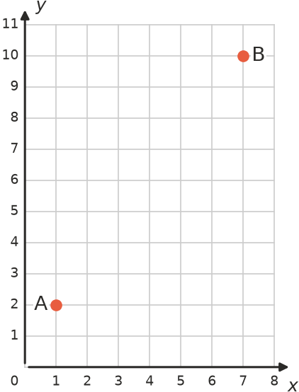
  - How far across and how far up is it from A to B? across ______________, up
  - Find the straight-line distance from A to B.
- A right-angled triangle has two shorter sides that are both 5 cm. Find the length of the hypotenuse, as an exact value and correct to 2 decimal places.

