8.03 Find the hypotenuse
Year 8 Maths · A5 question sheet · Level 1 · Warm-up
This worksheet practises using Pythagoras’ theorem to find the hypotenuse of a right-angled triangle. Tip: square the two shorter sides, add them, then take the square root. Check that your answer is longer than both shorter sides.

 Understanding
- Copy and fill in the gaps to find the hypotenuse c.
- 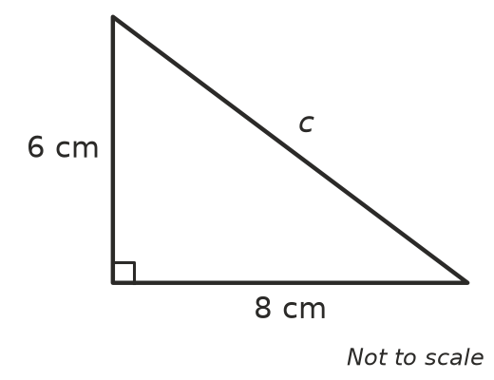
- c² = 6² + 8²
- c² =
- c = ______________ = ______________ cm
- Copy and fill in the gaps to find the hypotenuse c.
- 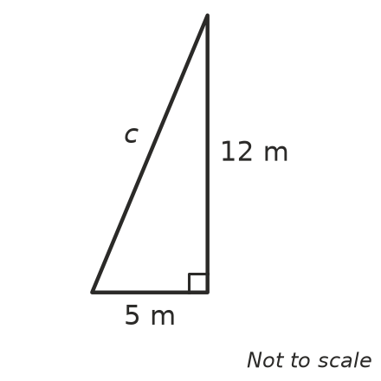
- c² =
- c = ______________ m

 Fluency
- Find the length of the hypotenuse in each triangle. Each answer is a whole number.
- 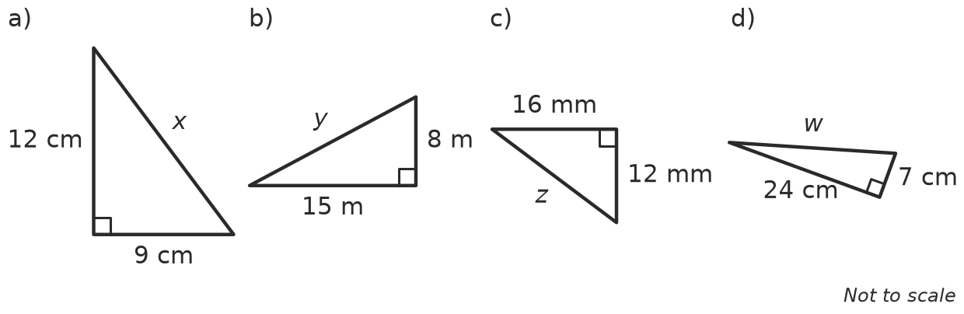
  - x =
  - y =
  - z =
  - w =
- Use a calculator to find the hypotenuse in each triangle. Round your answers to 1 decimal place.
- 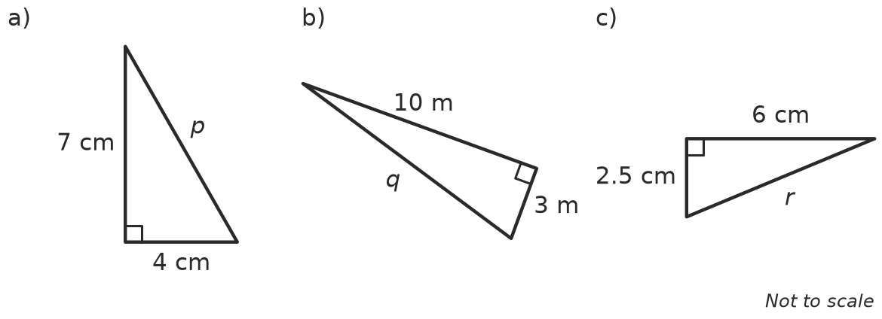
  - p =
  - q =
  - r =

 Reasoning
- Lily is finding the hypotenuse of a right-angled triangle with shorter sides 5 cm and 7 cm. Her working is: c² = 5² + 7² = 10 + 14 = 24.
  - What did Lily do wrong?
  - Find the correct length of the hypotenuse, to 1 decimal place.
- A right-angled triangle has shorter sides of 6 cm and 8 cm. Without working it out, explain why the hypotenuse must be longer than 8 cm but shorter than 14 cm.

 Problem solving
- A wooden gate is 1.2 m wide and 0.9 m tall. A diagonal brace runs from one corner to the opposite corner. How long is the brace?
- Ana walks 300 m east and then 400 m north. How far is she from where she started, in a straight line?
- A TV screen is 80 cm wide and 45 cm tall. The size of a TV is the length of the diagonal of its screen. Find the size of this TV, to the nearest centimetre.
- A rectangular park is 60 m long and 80 m wide. Tom walks along the diagonal instead of along two edges.
  - How long is the diagonal?
  - How much shorter is Tom’s walk than walking along the two edges?
- A ramp rises 1 m over a horizontal distance of 5 m. How long is the ramp? Round to 2 decimal places.

