8.02 Pythagoras' theorem
Year 8 Maths · Worksheet · Level 3 · Challenge
Name: ____________________ Date: ______________
This worksheet takes Pythagoras’ theorem further: naming sides with letters, testing triangles, making Pythagorean triads and working with exact lengths. Tip: if the two shorter sides squared add up to more than the longest side squared, the largest angle is acute; if they add up to less, it is obtuse.

 Understanding
- Write Pythagoras’ theorem for each right-angled triangle, using the vertex letters. For c), write it for both triangle PQS and triangle PRS.
- 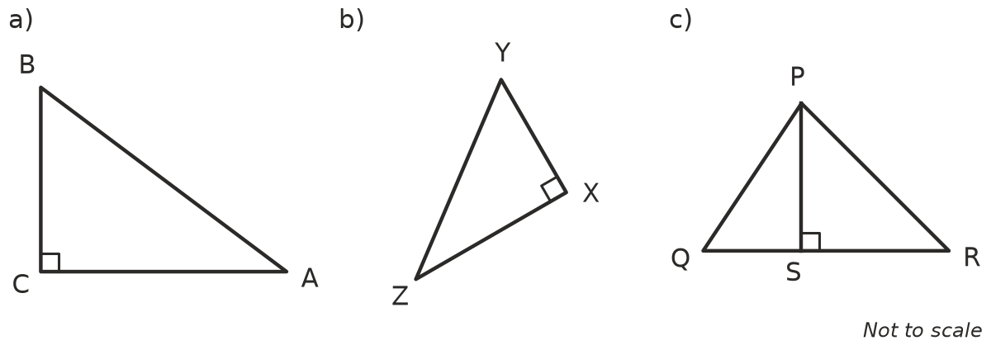
  - ______________
  - ______________
  - Triangle PQS: ______________ Triangle PRS: ______________

 Fluency
- Test whether each set of side lengths makes a right-angled triangle. Show your working.
  - 20, 21, 29 ______________
  - 11, 60, 61 ______________
  - 14, 48, 51 ______________
  - 0.9, 1.2, 1.5 ______________
  - $\sqrt{7}$, 3, 4 ______________
  - $\frac{3}{4}$, 1, $\frac{5}{4}$ ______________
- Each right-angled triangle has the two shorter sides given. Find the exact length of the hypotenuse. Then write whether it is rational or irrational.
  - 3 cm and 5 cm ______________
  - 2 cm and $\sqrt{5}$ cm ______________
  - $\sqrt{2}$ m and $\sqrt{7}$ m ______________
  - 6 mm and 6 mm ______________
- You can make Pythagorean triads from any two whole numbers m and n, with m bigger than n. The three sides are m² − n², 2mn and m² + n². Complete the table.
m | n | m² − n² | 2mn | m² + n²
2 | 1
3 | 2
4 | 1
4 | 3

Check that your last row really is a Pythagorean triad.

 Reasoning
- Kai says, “If you double every side of a right-angled triangle, the new triangle is still right-angled.”
  - Show that Kai is right for the triangle with sides 8, 15 and 17.

  - Explain why doubling always works. Hint: what happens to each square when a side is doubled?

- Use the tip at the top of the page to decide whether each triangle is acute-angled, right-angled or obtuse-angled.
  - 5, 6, 7 ______________
  - 5, 6, 9 ______________
  - 9, 40, 41 ______________
- Explain why a right-angled triangle can never have three sides that are all odd whole numbers. Hint: is an odd number squared odd or even?

 Problem solving
- A right-angled triangle has two sides of 12 cm and 16 cm. Find the two possible lengths of the third side. Give an exact answer for each.

- Squares are drawn on the sides of right-angled triangles.
  - The squares on the two shorter sides have areas of 45 cm² and 36 cm². How long is the hypotenuse? ______________
  - The square on the hypotenuse has an area of 100 cm² and the square on one shorter side has an area of 64 cm². How long is the other shorter side? ______________
- Builders in ancient Egypt are said to have made right angles with a loop of rope tied into 12 equal sections.
  - Which three whole-number side lengths, adding to 12 sections, make a right angle? ______________
  - Which Pythagorean triad could be made with a rope of 30 equal sections? ______________
- A right-angled triangle has sides x, x + 7 and x + 8, where x is a whole number. Try x = 1, 2, 3, … to find x. Write the three side lengths.

- The spiral is made of right-angled triangles. Each triangle has a side of length 1, and the hypotenuse of each triangle becomes a side of the next one.
- 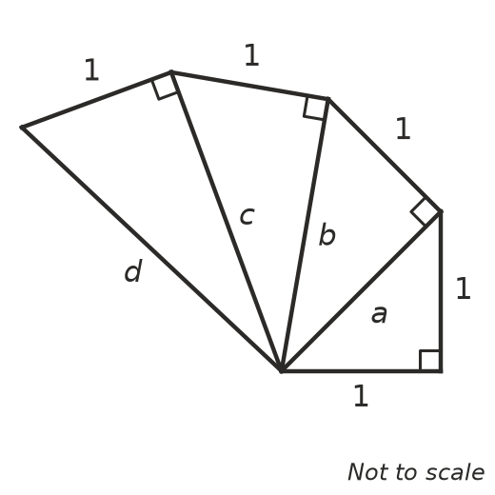
  - Find the exact lengths a, b, c and d. ______________, ______________, ______________, ______________
  - Which of these lengths are rational? ______________

