8.02 Pythagoras' theorem
Year 8 Maths · A5 question sheet · Level 2 · Core
This worksheet practises Pythagoras’ theorem: in a right-angled triangle, $c^{2}=a^{2}+b^{2}$, where c is the hypotenuse (the longest side, opposite the right angle). You will also use it backwards to test whether a triangle is right-angled. Tip: when you test a triangle, always square the longest side on its own.

 Understanding
- Name the hypotenuse of each triangle using two letters.
  - 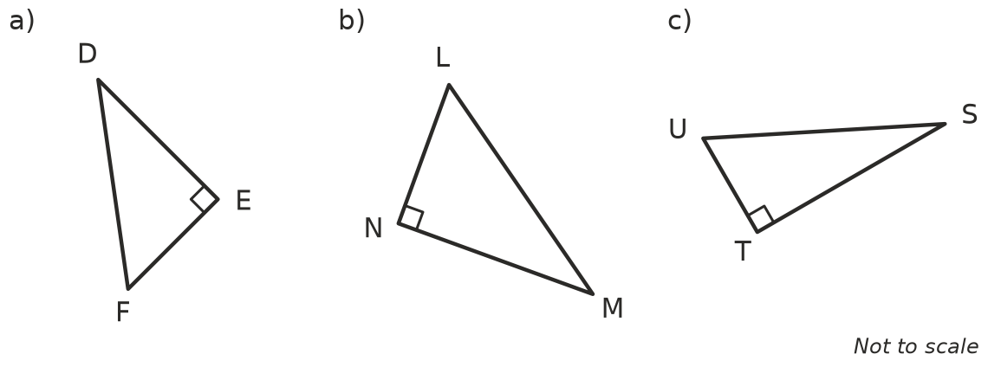

- Write Pythagoras’ theorem for each triangle.
  - 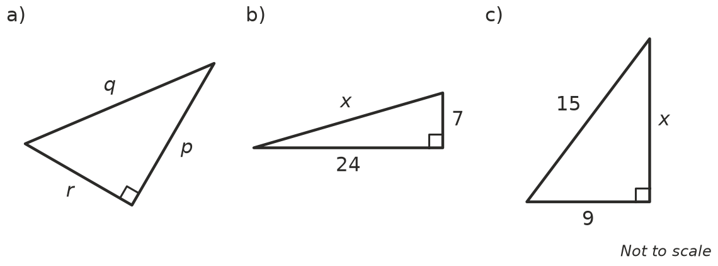

 Fluency
- Test whether each set of side lengths makes a right-angled triangle. Show your working and write yes or no.
  - 9, 12, 15
  - 7, 24, 25
  - 6, 9, 11
  - 10, 24, 26
  - 12, 16, 21
  - 1.5, 2, 2.5
- The numbers 5, 12, 13 are a Pythagorean triad.
  - Multiply each number by 3. ______________, ______________,
  - Show that the new numbers are also a Pythagorean triad.
- Each right-angled triangle has the two shorter sides given. Find c² and then write the exact length of the hypotenuse c. Use a square root sign where needed.
  - 2 cm and 3 cm c² = ______________ c =
  - 1 m and 4 m c² = ______________ c =
  - 4 mm and 4 mm c² = ______________ c =
  - 5 cm and 12 cm c² = ______________ c =
  - Which of your answers in a) to d) are irrational numbers?

 Reasoning
- Ella works out the hypotenuse of a right-angled triangle with shorter sides 5 cm and 12 cm. Her working is: c² = 5 + 12 = 17, so c = $\sqrt{17}$ cm. Explain her mistake and find the correct answer.
- Jack tests whether a triangle with sides 5, 13 and 12 is right-angled. He works out 5² + 13² = 194 and 12² = 144. Because they are not equal, he says it is not right-angled. Explain his mistake and give the correct conclusion.
- Use $c^{2}=a^{2}+b^{2}$ to explain why the hypotenuse must be longer than each of the other two sides.

 Problem solving
- Ayesha is marking out a garden bed with string. She measures 60 cm along one side and 80 cm along the other. The diagonal between the two marks is 1 m. Is the corner a right angle? Show your working.
- A picture frame is meant to be a rectangle. It measures 48 cm by 64 cm, and one diagonal measures 82 cm. Are the corners right angles? Explain.
- Each set of numbers is a Pythagorean triad with one number missing. Find the missing whole number.
  - 8, 15, ______________ (the missing number is the longest)
  - ______________, 40, 41
- A triangle has sides of $\sqrt{5}$ cm, $\sqrt{11}$ cm and 4 cm. Is it right-angled? Show your working.

