8.02 Pythagoras' theorem
Year 8 Maths · A5 question sheet · Level 1 · Warm-up
This worksheet introduces Pythagoras’ theorem. In a right-angled triangle, the longest side is called the hypotenuse. It is always opposite the right angle. If the hypotenuse is c and the two shorter sides are a and b, then $c^{2}=a^{2}+b^{2}$. Tip: find the right angle first, then look straight across from it to find the hypotenuse.

 Understanding
- Copy and fill in the gaps.
- In a right-angled triangle, the longest side is called the ______________, and it is opposite the ______________ angle.
- Name the hypotenuse of each triangle using two letters.
  - 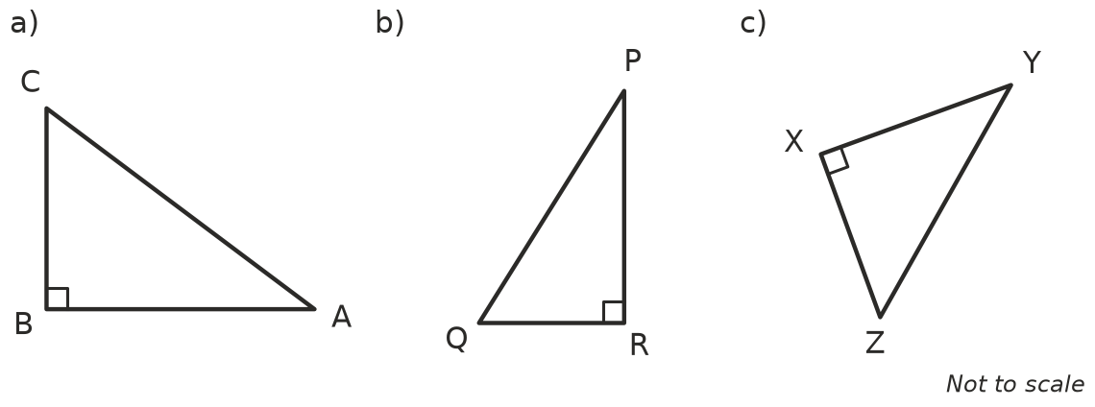

- Write Pythagoras’ theorem for each triangle. Part a) is started for you.
- 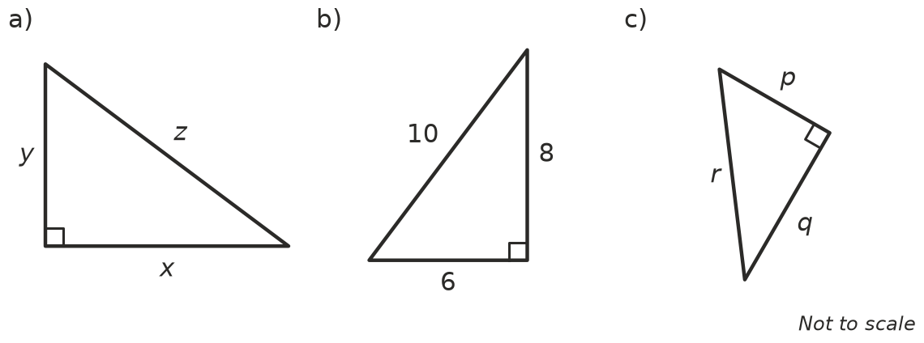
  - z² = ______________ +
  - ______________ = ______________ +
  - ______________ = ______________ +

 Fluency
- Copy and complete the table to test whether each triangle is right-angled. A triangle is right-angled when the two shorter sides squared add up to the longest side squared.
Sides | Shorter sides squared and added | Longest side squared | Right-angled?
3, 4, 5 | 3² + 4² = 9 + 16 = 25 | 5² = 25 | Yes
6, 8, 10
5, 12, 13
4, 5, 6
2, 3, 4

- A right-angled triangle has shorter sides a = 9 cm and b = 12 cm. Copy and fill in the gaps to find the hypotenuse c.
- $c^{2}=a^{2}+b^{2}$
- c² = 9² + 12² = ______________ + ______________ =
- c = ______________ = ______________ cm

 Reasoning
- Ben says, “The hypotenuse is always the side along the bottom of the triangle.” Explain why Ben is wrong.
- A triangle has sides of 7 cm, 8 cm and 10 cm. Is it right-angled? Show your working.

 Problem solving
- A builder checks that the corner of a concrete slab is square. She measures 3 m along one edge and 4 m along the other edge. The distance between the two marks is 5 m. Show that the corner is a right angle.
- A triangle has sides of 8 cm, 15 cm and 17 cm.
  - Show that it is a right-angled triangle.
  - Which side is the hypotenuse?
- Whole numbers like 3, 4, 5 that fit Pythagoras’ theorem are called a Pythagorean triad.
  - Double each number in 3, 4, 5. ______________, ______________,
  - Show that your new numbers are also a Pythagorean triad.
- A right-angled triangle has two shorter sides that are both 1 cm long.
  - Find c², the hypotenuse squared.
  - Write the exact length of the hypotenuse using a square root.
  - Is this length a rational or an irrational number?

