8.01 Squares and square roots
Year 8 Maths · Worksheet · Level 3 · Challenge
Name: ____________________ Date: ______________
This worksheet stretches your skills with squares and square roots, including decimals, fractions and estimating. Tip: squaring and square rooting undo each other, so ${\left(\sqrt{13}\right)}^{2}$ = 13. A square root of a whole number that is not a perfect square is irrational.

 Understanding
- Work these out without a calculator.
  - 1.2² + 0.5² = ______________
  - $\sqrt{1.69}$ = ______________
  - ${\left(\frac{3}{5}\right)}^{2}+{\left(\frac{4}{5}\right)}^{2}$ = ______________
  - $\sqrt{0.0049}$ = ______________
  - $\sqrt{\frac{49}{144}}$ = ______________
  - ${\left(\sqrt{13}\right)}^{2}$ = ______________

 Fluency
- Find the exact value of each. Each answer is a whole number or a decimal that stops.
  - $\sqrt{{20}^{2}+{21}^{2}}$ = ______________
  - $\sqrt{{41}^{2}−9^{2}}$ = ______________
  - $\sqrt{{2.4}^{2}+{0.7}^{2}}$ = ______________
  - $\sqrt{{65}^{2}−{33}^{2}}$ = ______________
- Without a calculator, use squares of decimals to find each square root correct to 1 decimal place. Show your squares. Then check with a calculator, correct to 3 decimal places.
  - $\sqrt{55}$ ≈ ______________ Calculator: ______________

  - $\sqrt{110}$ ≈ ______________ Calculator: ______________

- Find the positive value of x in each equation.
  - x² + 36 = 100 x = ______________
  - x² = 12² + 35² x = ______________
  - 2x² = 98 x = ______________
  - x² − 7² = 24² x = ______________
  - x² + x² = 50 x = ______________

 Reasoning
- Write true or false. For a false statement, give an example that shows it is false. For a true statement, give an example that fits.
  - $\sqrt{a+b}$ = $\sqrt{a}$ + $\sqrt{b}$ for all positive numbers a and b. ______________
  - $\sqrt{a×b}$ = $\sqrt{a}$ × $\sqrt{b}$ for all positive numbers a and b. ______________
  - The square of an odd number is always odd. ______________
  - The square root of a number is always smaller than the number. ______________
- Without a calculator, explain which two whole numbers next to each other $\sqrt{300}$ lies between.

- Explain why a perfect square can never end in the digit 7.

 Problem solving
- A square courtyard has the same area as a rectangle 12 m long and 3 m wide. How long is each side of the courtyard?

- A square photo is enlarged so that its area is 4 times as big.
  - The original photo had sides of 15 cm. How long are the sides of the enlarged photo? ______________
  - What happens to the side length of any square when its area is multiplied by 4? Explain.

- A square paddock has an area of 12 000 m². Fencing costs $18 per metre. Find the cost of fencing all the way around the paddock, to the nearest dollar.

- Find the smallest perfect square that is greater than 200 and ends in the digit 6.

- Three squares are placed edge to edge so that they surround a triangle. Their areas are 9 cm², 16 cm² and 25 cm².
- 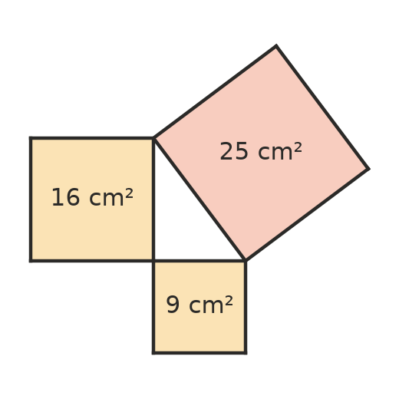
  - Find the side length of each square. ______________, ______________, ______________
  - What do you notice about the three areas?

  - What kind of angle does the triangle seem to have where the two smaller squares meet? ______________

