8.01 Squares and square roots
Year 8 Maths · Worksheet · Level 1 · Warm-up
Name: ____________________ Date: ______________
This worksheet revises squares and square roots, which you will need for Pythagoras’ theorem. Tip: squaring and taking the square root undo each other. 6² = 36, so $\sqrt{36}$ = 6.

 Understanding
- Find the area of each square.
- 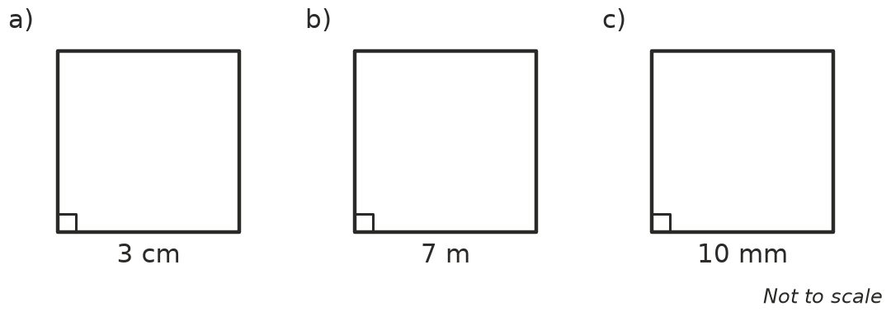
  - Area = 3² = ______________ cm²
  - Area = 7² = ______________ m²
  - Area = 10² = ______________ mm²
- Complete the table of square numbers.
Number | Square | Number | Square
1 |  | 7
2 |  | 8
3 |  | 9
4 |  | 10
5 |  | 11
6 |  | 12

- Use your table to find each square root.
  - $\sqrt{16}$ = ______________
  - $\sqrt{49}$ = ______________
  - $\sqrt{81}$ = ______________
  - $\sqrt{100}$ = ______________
  - $\sqrt{1}$ = ______________
  - $\sqrt{144}$ = ______________

 Fluency
- Work these out. Do the squares first, then add or subtract.
  - 3² + 4² = ______________
  - 6² + 8² = ______________
  - 10² − 6² = ______________
  - 13² − 5² = ______________
  - 5² + 12² = ______________
- Use a calculator to square each decimal.
  - 2.5² = ______________
  - 1.2² = ______________
  - 0.3² = ______________
  - 4.1² = ______________
- Each square root lies between two whole numbers that are next to each other. Fill in the gaps.
  - $\sqrt{20}$ is between ______________ and ______________
  - $\sqrt{50}$ is between ______________ and ______________
  - $\sqrt{90}$ is between ______________ and ______________
  - $\sqrt{3}$ is between ______________ and ______________
- Now use a calculator to find each square root from Question 6. Round to 1 decimal place.
  - $\sqrt{20}$ ≈ ______________
  - $\sqrt{50}$ ≈ ______________
  - $\sqrt{90}$ ≈ ______________
  - $\sqrt{3}$ ≈ ______________

 Reasoning
- Write down the numbers in this list that are perfect squares: 25, 30, 36, 48, 64, 80, 100, 120

- Sam says $\sqrt{9+16}$ = $\sqrt{9}$ + $\sqrt{16}$ = 3 + 4 = 7.
  - Work out $\sqrt{9+16}$ by adding first. ______________
  - Is Sam right? Explain.

 Problem solving
- A square tile has an area of 64 cm².
  - How long is each side of the tile? ______________
  - What is the perimeter of the tile? ______________
- A square paddock has an area of 2500 m².
  - How long is each side of the paddock? ______________
  - How much fencing is needed to go all the way around it? ______________
- Find two square numbers (bigger than 0) that add up to 100.
- ______________ + ______________ = 100

