Probability: Practice test 3
Year 8 Maths · Test · Test 3
Name: ____________________ Date: ______________
Time: 45 minutes
Total: 40 marks
Show your working in the boxes. Then write each final answer on the answer sheet on the last page. Write probabilities as fractions in simplest form unless the question asks for something else.

 Section A: No calculator
- A bag holds 5 red, 3 yellow and 4 green counters. One counter is taken out at random. Find the probability that the counter is:
  - yellow (1 mark)

  - red or green (1 mark)

  - blue. (1 mark)

- Answer each part.
  - The probability that a mango taken at random from a box is ripe is $\frac{7}{12}$. What is the probability that it is not ripe? (1 mark)

  - The weather forecast gives a 35% chance of rain tomorrow. What is the chance that it will not rain? (1 mark)

- The universal set is ξ = {1, 2, 3, …, 16}. A is the set of multiples of 4 in ξ. B is the set of numbers in ξ that are greater than 10.
  - List the elements of A ∩ B. (1 mark)

  - List the elements of A ∪ B. (1 mark)

  - How many elements are in (A ∪ B)′? (1 mark)

  - A number is chosen at random from ξ. Find P(A ∩ B′). (1 mark)

- The 36 students in a Year 8 group were asked whether they have a sister (S) and whether they have a brother (B). The Venn diagram shows the results.
- 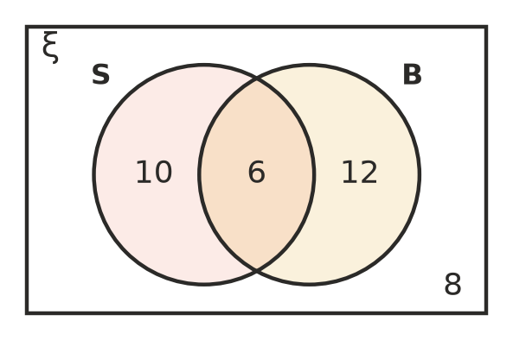
  - How many students have a brother? (1 mark)

  - A student is chosen at random. Find the probability that the student has a sister but no brother. (1 mark)

  - A student is chosen at random. Find P(S ∪ B). (1 mark)

  - A student is chosen at random. Find P(B′). (1 mark)

- At the beach, 80 people were counted. The two-way table shows whether they were swimming and whether they were wearing a hat. The letters p, q, r, s and t stand for missing numbers.
 | Hat | No hat | Total
Swimming | 12 | p | 30
Not swimming | q | 14 | r
Total | s | t | 80

  - Find the values of p, q, r, s and t. (2 marks)

  - One person is chosen at random. Find the probability that the person is wearing a hat. (1 mark)

  - One person is chosen at random. Find the probability that the person is swimming without a hat. (1 mark)

  - One person is chosen at random. Find the probability that the person is not swimming or has no hat (or both). (1 mark)

- For lunch, Jess chooses a sandwich (ham, chicken or salad) and a drink (water or juice) at random.
- 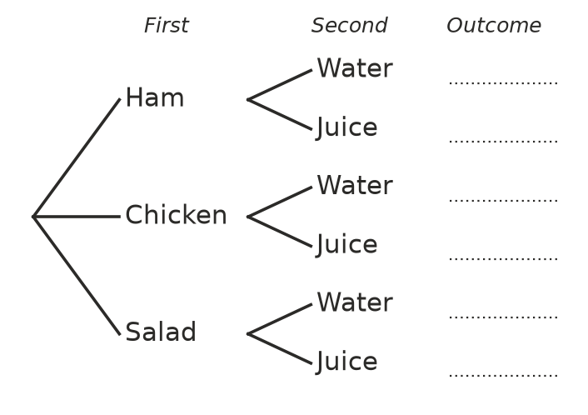
  - Complete the tree diagram by writing every outcome. Use letters, for example HW for ham and water. (1 mark)

  - Find the probability that Jess chooses chicken and juice. (1 mark)

  - Find the probability that Jess does not choose ham. (1 mark)

- A number is chosen at random from 1 to 20. Look at these four pairs of events.
- Pair 1: the number is even; the number is a multiple of 5
- Pair 2: the number is prime; the number is a multiple of 6
- Pair 3: the number is less than 10; the number is odd
- Pair 4: the number is a factor of 12; the number is greater than 8
  - Which pair of events is mutually exclusive? (1 mark)

  - Find the probability that the number is prime or a multiple of 6. (1 mark)

- Priya says that for an event A, P(A) = 0.7 and P(A′) = 0.4.
- Explain why this cannot be right, and find the correct value of P(A′). (2 marks)

- In a class of 50 students, 22 are girls and 30 catch the bus to school. The probability that a student chosen at random is a boy who does not catch the bus is $\frac{3}{25}$. Find the probability that a student chosen at random is a girl who catches the bus. (3 marks)

 Section B: Calculator allowed
- At a country show, 450 people were asked whether they live locally or are visitors, and whether they came by car.
 | Local | Visitor | Total
Car | 168 | 141 | 309
No car | 97 | 44 | 141
Total | 265 | 185 | 450

  - One person is chosen at random. Find the probability that the person is a visitor. Write your answer as a decimal rounded to 2 decimal places. (1 mark)

  - Find the probability that a person chosen at random is local and did not come by car. Write your answer as a percentage, rounded to 1 decimal place. (1 mark)

  - Find the probability that a person chosen at random came by car or is a visitor (or both). Write your answer as a decimal rounded to 2 decimal places. (1 mark)

- A family has two children. Each child is equally likely to be a boy or a girl. Liam uses a digital tool to simulate 250 families with two children.
Number of girls | 0 | 1 | 2
Frequency | 58 | 129 | 63

  - Find the experimental probability that a family has at least one girl. Write your answer as a decimal. (1 mark)

  - List the outcomes for two children (for example BG means first a boy, then a girl), and find the theoretical probability of at least one girl. (1 mark)

  - Liam simulates 1000 families. About how many would you expect to have two girls? (1 mark)

- Every Year 8 student chooses exactly one elective: Art, Music, Woodwork or Drama. For a student chosen at random, P(Art) = 0.32, P(Music) = 0.21 and P(Woodwork) = 0.29.
  - Find P(Drama). (1 mark)

  - Find the probability that a student does not choose Woodwork. (1 mark)

  - There are 200 Year 8 students. How many would you expect to choose Art or Music? (1 mark)

- On a farm, 55% of the sheep are older than 2 years (A), 40% were shorn this month (B), and 15% are older than 2 years and were shorn this month. A sheep is chosen at random.
- 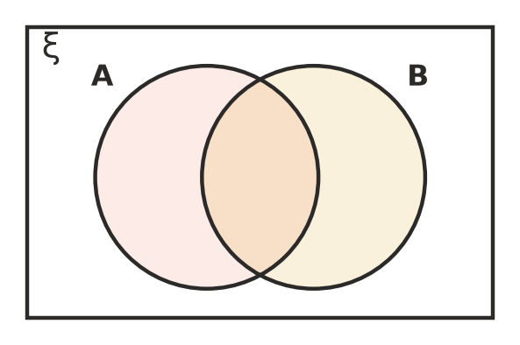
  - Complete the Venn diagram with probabilities, and find P(A ∪ B). (1 mark)

  - Find the probability that the sheep is in neither A nor B. (1 mark)

  - Find the probability that the sheep is in exactly one of A and B. (1 mark)

 Answer sheet
Name: ____________________
Write your final answer for each question in the table.
Question | Answer | Marks | Question | Answer | Marks
1a |  | /1 | 6b |  | /1
1b |  | /1 | 6c |  | /1
1c |  | /1 | 7a |  | /1
2a |  | /1 | 7b |  | /1
2b |  | /1 | 8 |  | /2
3a |  | /1 | 9 |  | /3
3b |  | /1 | 10a |  | /1
3c |  | /1 | 10b |  | /1
3d |  | /1 | 10c |  | /1
4a |  | /1 | 11a |  | /1
4b |  | /1 | 11b |  | /1
4c |  | /1 | 11c |  | /1
4d |  | /1 | 12a |  | /1
5a |  | /2 | 12b |  | /1
5b |  | /1 | 12c |  | /1
5c |  | /1 | 13a |  | /1
5d |  | /1 | 13b |  | /1
6a | (on the tree diagram) | /1 | 13c |  | /1
 |  |  |  | Total | /40

