Probability: Practice test 2
Year 8 Maths · Test · Test 2
Name: ____________________ Date: ______________
Time: 45 minutes
Total: 40 marks
Show your working in the boxes. Then write each final answer on the answer sheet on the last page. Write probabilities as fractions in simplest form unless the question asks for something else.

 Section A: No calculator
- Each letter of the word KANGAROO is written on its own tile. The tiles are put in a bag and one tile is taken out at random. Find the probability that the tile shows:
  - the letter A (1 mark)

  - a vowel (1 mark)

  - a letter that is not O. (1 mark)

- Answer each part.
  - The probability that a seed will sprout is 0.82. What is the probability that the seed will not sprout? (1 mark)

  - For an event A, P(A′) = $\frac{3}{10}$. Find P(A). (1 mark)

- The universal set is ξ = {1, 2, 3, …, 20}. F is the set of factors of 18, so F = {1, 2, 3, 6, 9, 18}. O is the set of odd numbers less than 12, so O = {1, 3, 5, 7, 9, 11}.
  - List the elements of F ∩ O. (1 mark)

  - List the elements of F ∪ O. (1 mark)

  - How many elements are in F′? (1 mark)

  - A number is chosen at random from ξ. Find the probability that it is in F but not in O. (1 mark)

- At a school fundraiser, 40 families were asked whether they bought a sausage (S) and whether they bought a cake (C). The Venn diagram shows the results.
- 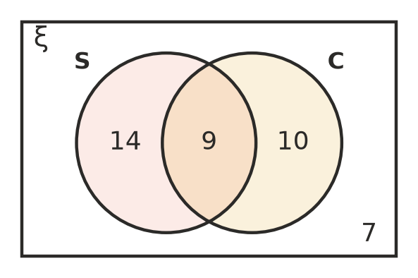
  - How many families bought a cake? (1 mark)

  - A family is chosen at random. Find P(S ∩ C). (1 mark)

  - A family is chosen at random. Find P(S ∪ C). (1 mark)

  - A family is chosen at random. Find the probability that the family bought a cake but not a sausage. (1 mark)

- Sixty students were asked whether they ate breakfast this morning. The two-way table shows some of the results. The letters p, q, r, s and t stand for missing numbers.
 | Breakfast | No breakfast | Total
Boys | p | 7 | 28
Girls | q | r | s
Total | 45 | t | 60

  - Find the values of p, q, r, s and t. (2 marks)

  - One student is chosen at random. Find the probability that the student did not eat breakfast. (1 mark)

  - One student is chosen at random. Find the probability that the student is a girl who ate breakfast. (1 mark)

  - One student is chosen at random. Find the probability that the student is a boy. (1 mark)

- Spinner A has two equal sections numbered 1 and 2. Spinner B has three equal sections numbered 1, 2 and 3. Both spinners are spun and the two numbers are added.
+ | 1 | 2 | 3
1
2

  - Complete the table to show every possible total. (1 mark)

  - Find the probability that the total is 4. (1 mark)

  - Find the probability that the total is an odd number. (1 mark)

- A number is chosen at random from 1 to 10. Consider these events.
- A: the number is greater than 7 B: the number is less than 4 C: the number is even
  - Are events A and B mutually exclusive? Give a reason. (1 mark)

  - Are events A and C mutually exclusive? Give a reason. (1 mark)

- A fair six-sided die is rolled. Tom says, “Rolling an even number and rolling a number greater than 3 are mutually exclusive, because they are two different events.”
- Explain why Tom is wrong. (2 marks)

- In a class of 30 students, 4 play neither soccer nor cricket and 18 play soccer. The number of students who play only soccer is twice the number who play both sports. One student is chosen at random. Find the probability that the student plays cricket. (3 marks)

 Section B: Calculator allowed
- A bakery recorded the drink ordered by 320 customers and whether they ate in or took their order away.
 | Coffee | Tea | Total
Eat in | 85 | 47 | 132
Takeaway | 151 | 37 | 188
Total | 236 | 84 | 320

  - One customer is chosen at random. Find the probability that the customer took their order away. Write your answer as a decimal. (1 mark)

  - Find the probability that a customer chosen at random ordered tea and ate in. Write your answer as a percentage, rounded to 1 decimal place. (1 mark)

  - Find the probability that a customer chosen at random ordered coffee or took their order away (or both). Write your answer as a decimal rounded to 2 decimal places. (1 mark)

- Zara uses a digital tool to simulate rolling two fair six-sided dice 600 times. A total of 7 comes up 93 times.
  - Find the experimental probability of a total of 7. Write your answer as a decimal. (1 mark)

  - There are 36 equally likely outcomes when two dice are rolled, and 6 of them give a total of 7. Find the theoretical probability of a total of 7, as a decimal rounded to 3 decimal places. (1 mark)

  - How many 7s would you expect in 600 rolls? (1 mark)

- Every student at a school is in exactly one sports house: Red, Blue, Gold or Green. For a student chosen at random, P(Red) = 0.27, P(Blue) = 0.24 and P(Gold) = 0.3.
  - Find P(Green). (1 mark)

  - Find P(Red or Gold). (1 mark)

  - There are 700 students at the school. How many are in Blue or Green? (1 mark)

- Fifty people were asked whether they watch the TV news (N) and whether they read a newspaper (R). The Venn diagram shows the results.
- 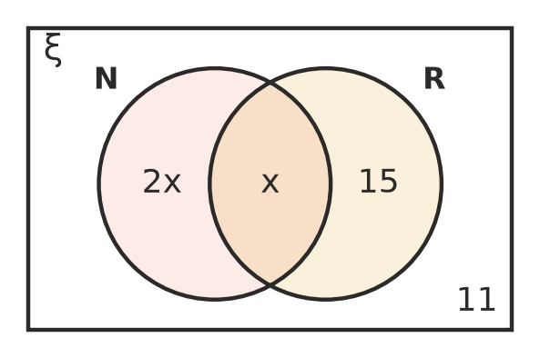
  - Find the value of x. (1 mark)

  - One person is chosen at random. Find the probability that the person watches the TV news. Write your answer as a decimal. (1 mark)

  - One person is chosen at random. Find the probability that the person does exactly one of these two things. Write your answer as a decimal. (1 mark)

 Answer sheet
Name: ____________________
Write your final answer for each question in the table.
Question | Answer | Marks | Question | Answer | Marks
1a |  | /1 | 6b |  | /1
1b |  | /1 | 6c |  | /1
1c |  | /1 | 7a |  | /1
2a |  | /1 | 7b |  | /1
2b |  | /1 | 8 |  | /2
3a |  | /1 | 9 |  | /3
3b |  | /1 | 10a |  | /1
3c |  | /1 | 10b |  | /1
3d |  | /1 | 10c |  | /1
4a |  | /1 | 11a |  | /1
4b |  | /1 | 11b |  | /1
4c |  | /1 | 11c |  | /1
4d |  | /1 | 12a |  | /1
5a |  | /2 | 12b |  | /1
5b |  | /1 | 12c |  | /1
5c |  | /1 | 13a |  | /1
5d |  | /1 | 13b |  | /1
6a | (in the table) | /1 | 13c |  | /1
 |  |  |  | Total | /40

