Probability: Practice test 1
Year 8 Maths · Test · Test 1
Name: ____________________ Date: ______________
Time: 45 minutes
Total: 40 marks
Show your working in the boxes. Then write each final answer on the answer sheet on the last page. Write probabilities as fractions in simplest form unless the question asks for something else.

 Section A: No calculator
- Twelve cards are numbered 1 to 12. One card is chosen at random.
  - List the sample space. (1 mark)

  - Find the probability that the number is a multiple of 3. (1 mark)

  - Find the probability that the number is a factor of 12. (1 mark)

- Answer each part.
  - The probability that the school bus is late on any day is 0.15. What is the probability that the bus is not late? (1 mark)

  - The probability that a spinner lands on red is $\frac{2}{7}$. What is the probability that it does not land on red? (1 mark)

- The universal set is ξ = {1, 2, 3, …, 15}. Two sets are A = {2, 4, 6, 8, 10, 12, 14} and B = {3, 6, 9, 12, 15}.
  - List the elements of A ∩ B. (1 mark)

  - List the elements of A ∪ B. (1 mark)

  - List the elements of B′. (1 mark)

  - A number is chosen at random from ξ. Find P(A ∪ B). (1 mark)

- The Venn diagram shows the 30 students in a Year 8 class. F is the set of students who play footy and B is the set of students who play in the school band.
- 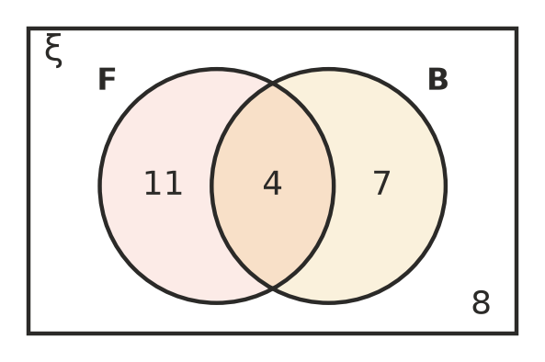
  - How many students play footy? (1 mark)

  - How many students do only one of these two activities? (1 mark)

  - A student is chosen at random. Find the probability that the student plays footy and plays in the band. (1 mark)

  - A student is chosen at random. Find the probability that the student does not play in the band. (1 mark)

- At a church camp, 40 people each chose one activity: canoeing or hiking. The two-way table shows some of the results. The letters p, q, r, s and t stand for missing numbers.
 | Canoeing | Hiking | Total
Adults | 6 | p | 15
Children | q | 9 | r
Total | s | t | 40

  - Find the values of p, q, r, s and t. (2 marks)

  - One person is chosen at random. Find the probability that the person is a child. (1 mark)

  - One person is chosen at random. Find the probability that the person is an adult who chose hiking. (1 mark)

  - One person is chosen at random. Find the probability that the person chose canoeing. (1 mark)

- A coin is tossed and then a spinner with three equal sections numbered 1, 2 and 3 is spun.
- 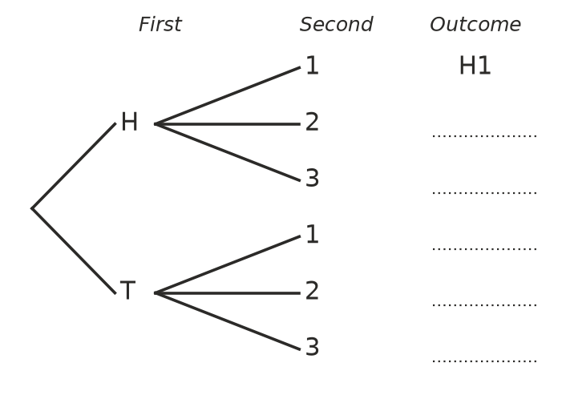
  - Complete the tree diagram by writing every outcome. The first one (H1) has been done for you. (1 mark)

  - Find the probability of getting a head and a 2. (1 mark)

  - Find the probability of getting a tail or a 3 (or both). (1 mark)

- A fair six-sided die is rolled once. Consider these events.
- A: rolling an even number B: rolling a 5 C: rolling a number less than 3
  - Are events A and B mutually exclusive? Give a reason. (1 mark)

  - Are events A and C mutually exclusive? Give a reason. (1 mark)

- The probability that tomorrow will be sunny is 0.6. The probability that tomorrow will be windy is 0.5. Mia says, “The probability that tomorrow will be sunny or windy is 0.6 + 0.5 = 1.1.”
- Explain why Mia must be wrong. (2 marks)

- A bag holds only red, green and blue marbles. A marble is taken at random. The probability that it is red is $\frac{1}{4}$ and the probability that it is green is $\frac{1}{3}$. There are 10 blue marbles in the bag. How many marbles are in the bag altogether? (3 marks)

 Section B: Calculator allowed
- A survey asked 250 Year 8 students whether they live in town or on a farm, and whether they own a pet.
 | Pet | No pet | Total
Town | 96 | 64 | 160
Farm | 78 | 12 | 90
Total | 174 | 76 | 250

  - One student is chosen at random. Find the probability that the student owns a pet. Write your answer as a decimal. (1 mark)

  - One student is chosen at random. Find the probability that the student lives on a farm and has no pet. Write your answer as a percentage. (1 mark)

  - What percentage of the farm students own a pet? Round your answer to 1 decimal place. (1 mark)

- Ben uses a digital tool to simulate tossing two coins at the same time. He runs the simulation 400 times.
Number of heads | 0 | 1 | 2
Frequency | 95 | 211 | 94

  - Find the experimental probability of getting exactly one head. Write your answer as a decimal rounded to 2 decimal places. (1 mark)

  - List the outcomes for tossing two coins, and use them to find the theoretical probability of getting exactly one head. (1 mark)

  - Ben runs the simulation 10 000 more times. What would you expect to happen to the experimental probability of exactly one head? (1 mark)

- At the school canteen, each student buys exactly one drink. The probability that a student buys water is 0.35, juice is 0.28 and milk is 0.17. Every other student buys a smoothie.
  - Find the probability that a student buys water or juice. (1 mark)

  - Find the probability that a student does not buy milk. (1 mark)

  - On one day 300 students buy a drink. How many would you expect to buy a smoothie? (1 mark)

- In a group of 60 people, 38 like tennis (T), 29 like cricket (C) and 7 like neither sport.
- 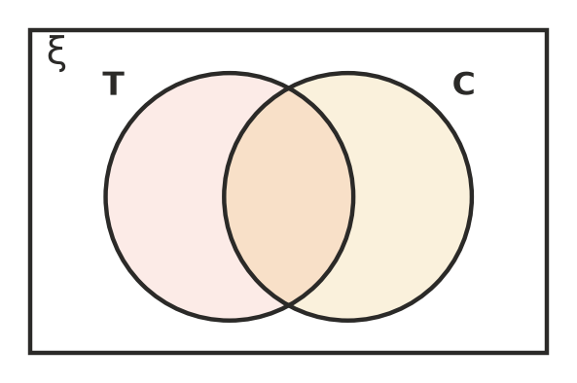
  - Complete the Venn diagram. How many people like both sports? (1 mark)

  - One person is chosen at random. Find the probability that the person likes exactly one of the two sports. Write your answer as a decimal. (1 mark)

  - One person is chosen at random. Find the probability that the person likes cricket but not tennis. Write your answer as a decimal. (1 mark)

 Answer sheet
Name: ____________________
Write your final answer for each question in the table.
Question | Answer | Marks | Question | Answer | Marks
1a |  | /1 | 6b |  | /1
1b |  | /1 | 6c |  | /1
1c |  | /1 | 7a |  | /1
2a |  | /1 | 7b |  | /1
2b |  | /1 | 8 |  | /2
3a |  | /1 | 9 |  | /3
3b |  | /1 | 10a |  | /1
3c |  | /1 | 10b |  | /1
3d |  | /1 | 10c |  | /1
4a |  | /1 | 11a |  | /1
4b |  | /1 | 11b |  | /1
4c |  | /1 | 11c |  | /1
4d |  | /1 | 12a |  | /1
5a |  | /2 | 12b |  | /1
5b |  | /1 | 12c |  | /1
5c |  | /1 | 13a |  | /1
5d |  | /1 | 13b |  | /1
6a | (on the tree diagram) | /1 | 13c |  | /1
 |  |  |  | Total | /40

