10.05 Mutually exclusive events
Year 8 Maths · Worksheet · Level 2 · Core
Name: ____________________ Date: ______________
This worksheet practises identifying mutually exclusive events and using the addition rule. Tip: if A and B are mutually exclusive, P(A ∩ B) = 0 and P(A ∪ B) = P(A) + P(B). If they are not mutually exclusive, the overlap gets counted twice, so subtract it once: P(A ∪ B) = P(A) + P(B) − P(A ∩ B).

 Understanding
- Two normal dice are rolled. Are the events mutually exclusive? Write yes or no. If no, give an outcome in both.
  - a total of 7 and a double ______________
  - a total of 8 and a double ______________
  - a total less than 4 and a total greater than 10 ______________
  - at least one 6 and a total of 4 ______________
- Complete each sentence about mutually exclusive events A and B.
  - P(A ∩ B) = ______________
  - In a Venn diagram, the circles for A and B ______________
  - P(A ∪ B) = ______________

 Fluency
- A and B are mutually exclusive, P(A) = 0.35 and P(B) = 0.4.
  - P(A ∪ B) ______________
  - P(neither A nor B) ______________
  - P(A ∩ B) ______________
- A whole number from 1 to 30 is chosen at random. A is “a multiple of 4” and B is “a multiple of 6”.
  - Are A and B mutually exclusive? Explain. ______________
  - Find P(A ∪ B). ______________

- Find P(A ∪ B) for each pair of events.
 | P(A) | P(B) | P(A ∩ B) | P(A ∪ B)
a) | 0.5 | 0.3 | 0.1
b) | $\frac{1}{3}$ | $\frac{1}{4}$ | 0
c) | 0.62 | 0.25 | 0.17
d) | $\frac{2}{5}$ | $\frac{3}{10}$ | $\frac{1}{10}$

  - Which pair of events is mutually exclusive? ______________
- The Venn diagram shows the probabilities of two mutually exclusive events.
- 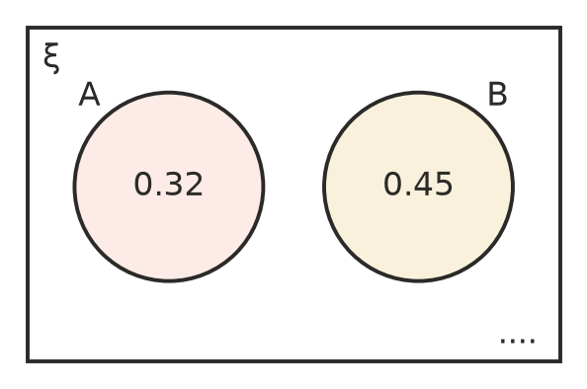
  - Find the missing probability outside the circles. ______________
  - Find P(A ∪ B). ______________
  - Find P(A′). ______________

 Reasoning
- Explain why two events with P(A) = 0.6 and P(B) = 0.5 cannot be mutually exclusive. ______________

  - Are complementary events always mutually exclusive? Explain. ______________

  - Are mutually exclusive events always complementary? Explain with an example. ______________

 Problem solving
- Every student at a school is in exactly one sports house. For a student chosen at random, P(Red) = 0.28, P(Blue) = 0.3 and P(Gold) = 0.24. The rest are in Green.
  - Find P(Red or Gold). ______________
  - Find P(not Blue). ______________
  - The school has 650 students. How many are in Green? ______________
- Two normal dice are rolled. A is “a total of 7”, B is “a total of 11” and C is “at least one 5”.
  - Find P(A or B). ______________
  - Are A and C mutually exclusive? Explain. ______________
  - Find P(A or C). ______________

- In a group of 80 students, 35 chose cricket, 28 chose tennis and 10 chose both.
  - Are “chose cricket” and “chose tennis” mutually exclusive? ______________
  - One student is chosen at random. Find P(cricket or tennis). ______________
- A spinner can only land on A, B or C. P(A) = $2x$, P(B) = $3x$ and P(C) = $x$ + 0.1.
  - Find $x$. ______________

  - Find P(A or C). ______________

