10.05 Mutually exclusive events
Year 8 Maths · Worksheet · Level 1 · Warm-up
Name: ____________________ Date: ______________
This worksheet practises deciding whether two events are mutually exclusive and adding their probabilities. Tip: two events are mutually exclusive if they cannot happen at the same time. In a Venn diagram their circles do not overlap. For mutually exclusive events, P(A or B) = P(A) + P(B).

 Understanding
- A normal die is rolled. Are the two events mutually exclusive? Write yes or no. If no, give an outcome that is in both.
  - rolling a 2 and rolling a 5 ______________
  - rolling an even number and rolling a number greater than 4 ______________
  - rolling an odd number and rolling an even number ______________
  - rolling a prime number and rolling an even number ______________
- Which Venn diagram shows two mutually exclusive events? Answer: ______________
- 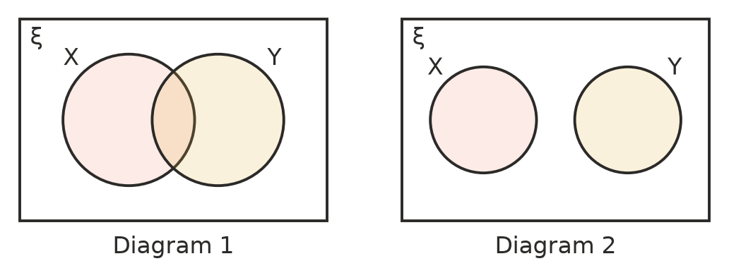

 Fluency
- A bag holds 4 red, 3 blue and 5 yellow marbles. One marble is taken at random.
  - P(red or blue) ______________
  - P(blue or yellow) ______________
  - P(red or yellow) ______________
- A spinner lands on red, blue or green. P(red) = 0.2, P(blue) = 0.35 and P(green) = 0.45.
  - P(red or blue) ______________
  - P(not green) ______________
  - P(red or green) ______________
- Are these events mutually exclusive? Write yes or no.
  - Today is Monday. Today is a weekend day. ______________
  - A student is in Year 8. The student plays footy. ______________
  - A traffic light is showing red. The same light is showing green. ______________
  - Sam is wearing a hat. Sam is wearing sunglasses. ______________

 Reasoning
- A die is rolled. Explain why “rolling an even number” and “rolling a 4” are not mutually exclusive. ______________

- A die is rolled. Max says, “P(even) = $\frac{1}{2}$ and P(greater than 3) = $\frac{1}{2}$, so P(even or greater than 3) = $\frac{1}{2}$ + $\frac{1}{2}$ = 1.”
  - Explain Max’s mistake. ______________

  - Find the correct probability. ______________

 Problem solving
- Every student orders exactly one lunch from the canteen. P(pie) = 0.3, P(sushi) = 0.25, P(wrap) = 0.15, and the rest order something else.
  - Find P(pie or sushi). ______________
  - Find P(something else). ______________
  - Find P(not a wrap). ______________
- A whole number from 1 to 20 is chosen at random. A is “a multiple of 5”, B is “a multiple of 6” and C is “an even number”.
  - Are A and B mutually exclusive? Explain. ______________
  - Find P(A or B). ______________
  - Are A and C mutually exclusive? Explain. ______________
- In a class of 30 students, 8 are in the choir and 11 are in the band. Nobody is in both, because the rehearsals are at the same time.
- 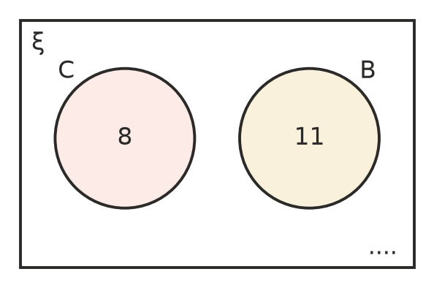
  - How many students are in neither? Write it in the Venn diagram. ______________
  - One student is chosen at random. Find P(choir or band). ______________
  - Find P(neither). ______________

