10.04 Two-way tables
Year 8 Maths · Worksheet · Level 2 · Core
Name: ____________________ Date: ______________
This worksheet practises completing two-way tables, swapping between tables and Venn diagrams, and finding “and”, “or” and “not” probabilities. Tip: read the question carefully to see who is being chosen from. If the person is chosen from everyone in the table, divide by the grand total.

 Understanding
- The table shows 120 Year 8 students, whether they have a part-time job and whether they play weekend sport.
 | Sport | No sport | Total
Job | 18 | 22 | 40
No job | 50 | 30 | 80
Total | 68 | 52 | 120

- One student is chosen at random. Find:
  - P(job and sport) ______________
  - P(no sport) ______________
  - P(job or sport) ______________
  - P(neither a job nor sport) ______________
- In the table in question 1, which number shows the students who play sport but have no job? Answer: ______________
  - 18
  - 22
  - 50
  - 68

 Fluency
- The table shows how Year 7 and Year 8 students get to school.
 | Bus | Not bus | Total
Year 7 | 34 |  | 90
Year 8 |  | 41
Total | 75 |  | 172

  - Complete the table.
  - One student is chosen at random. Find P(Year 8 and catches the bus). ______________
  - Find P(does not catch the bus). ______________
- The Venn diagram shows 50 households with a dog (D) and a cat (C).
- 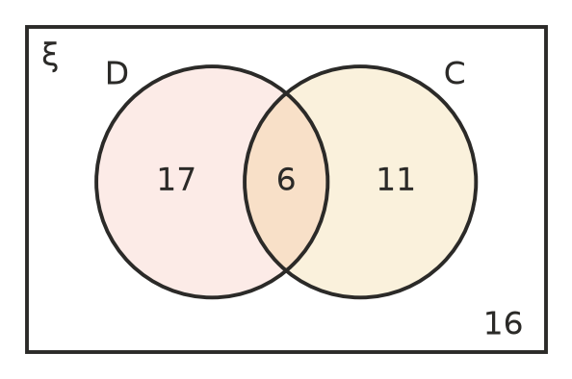
  - Complete the two-way table.
 | Cat | No cat | Total
Dog
No dog
Total

  - Find P(cat but no dog). ______________
  - Find P(dog or cat). ______________
- The table shows 60 students who sing in the choir and who play piano.
 | Piano | No piano | Total
Choir | 7 | 13 | 20
No choir | 9 | 31 | 40
Total | 16 | 44 | 60

  - Show the same information in the Venn diagram (C = choir, P = piano).
- 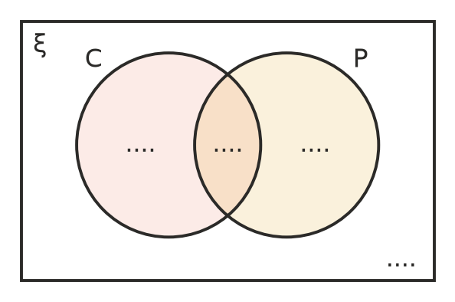
  - Find P(choir or piano). ______________
- Spinner X has 3 equal sections numbered 1 to 3. Spinner Y has 4 equal sections numbered 1 to 4. Both are spun and the numbers are multiplied.
× | 1 | 2 | 3 | 4
1
2
3

  - Complete the table.
  - P(product is even) ______________
  - P(product greater than 6) ______________

 Reasoning
- Use the table in question 1. Ali says the answer to “What fraction of students with a job play sport?” is $\frac{18}{40}$. Bea says it is $\frac{18}{120}$. Who is right? Explain what each fraction means. ______________

- Explain why the four numbers inside a 2 × 2 two-way table (not the totals) always add up to the grand total. ______________

 Problem solving
- At a footy match, 150 fans were surveyed. 90 support the home team and the rest support the away team. 70 fans are wearing a scarf, and 25 of these are away supporters.
 | Scarf | No scarf | Total
Home
Away
Total

  - Complete the table.
  - One fan is chosen at random. Find P(away supporter without a scarf). ______________
  - Find P(home supporter or wearing a scarf). ______________
- Kim gets to school by bus or by train. The table shows probabilities for a school day chosen at random.
 | Late | On time | Total
Bus | 0.12 |  | 0.4
Train
Total | 0.2 |  | 1

  - Complete the table.
  - Find P(train and on time). ______________
  - Find P(late or catches the bus). ______________
- A survey asked 64 students whether they learn a musical instrument. 40 of the students are in Year 8 and the rest are in Year 7. $\frac{3}{8}$ of all the students learn an instrument, including 9 of the Year 7 students.
  - Draw and complete a two-way table.

  - One student is chosen at random. Find P(Year 8 and does not learn an instrument). ______________
- Two dice are rolled. Each cell of the table shows the larger of the two numbers (or the number itself if they are the same).
Larger | 1 | 2 | 3 | 4 | 5 | 6
1
2
3
4
5
6

  - Complete the table.
  - P(the larger number is 6) ______________
  - P(the larger number is 3 or less) ______________

