10.04 Two-way tables
Year 8 Maths · Worksheet · Level 1 · Warm-up
Name: ____________________ Date: ______________
This worksheet practises reading and completing two-way tables and using them to find probabilities. Tip: each row adds across to its total and each column adds down to its total. The number in the bottom-right corner is the grand total: everyone in the table.

 Understanding
- The table shows how 50 students get their lunch.
 | Brings lunch | Buys lunch | Total
Year 7 | 18 | 7 | 25
Year 8 | 15 | 10 | 25
Total | 33 | 17 | 50

  - How many Year 8 students buy lunch? ______________
  - How many students buy lunch altogether? ______________
  - How many students are in the table? ______________
  - One student is chosen at random. Find P(Year 7 and brings lunch). ______________
  - Find P(buys lunch). ______________
- Complete the two-way table for two Year 8 classes.
 | Has a pet | No pet | Total
8A | 16 |  | 26
8B |  | 9
Total | 30

 Fluency
- Use your table from question 2. One student is chosen at random. Find each probability.
  - P(in 8B) ______________
  - P(has a pet) ______________
  - P(in 8A and has no pet) ______________
- The Venn diagram shows the students in a class who play footy (F) and cricket (C).
- 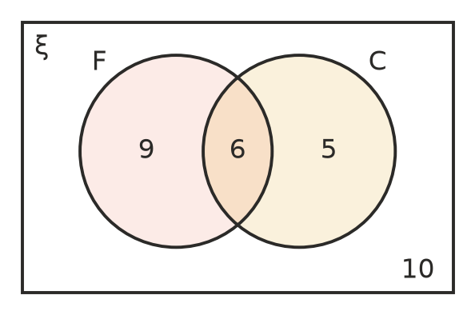
- Use it to complete the two-way table.
 | Cricket | Not cricket | Total
Footy
Not footy
Total

- A farmer has 60 sheep.
 | Male | Female | Total
Merino | 12 |  | 40
Dorper |  | 15 | 20
Total |  |  | 60

  - Complete the table.
  - One sheep is chosen at random. Find P(female Merino). ______________
  - Find P(Dorper). ______________
  - Find P(male). ______________

 Reasoning
- Explain how you can check that a completed two-way table is correct. ______________

- Use the table in question 1. Lily is asked for the probability that a student chosen at random from all 50 students is in Year 8 and buys lunch. She writes $\frac{10}{25}$. Explain her mistake and give the correct answer. ______________

 Problem solving
- There are 30 students on a camp. 16 are in Year 7 and the rest are in Year 8. 20 students chose kayaking and the rest chose bushwalking. 12 of the Year 7 students chose kayaking.
 | Kayaking | Bushwalking | Total
Year 7
Year 8
Total

  - Complete the table.
  - One student is chosen at random. Find P(Year 8 and bushwalking). ______________
  - Find P(kayaking). ______________
- A coin is tossed and a die is rolled. This two-way table shows the outcomes.
 | 1 | 2 | 3 | 4 | 5 | 6
H | H1
T

  - Complete the table. How many outcomes are there? ______________
  - P(heads and an even number) ______________
  - P(tails and a number greater than 4) ______________
- At a fundraiser barbecue, 80 people bought either a sausage sizzle or a veggie burger. Some also bought a drink.
 | Drink | No drink | Total
Sausage sizzle |  | 22 | 50
Veggie burger | 18
Total |  |  | 80

  - Complete the table.
  - One person is chosen at random. Find P(veggie burger and no drink). ______________
  - Find P(bought a drink). ______________

