10.03 Venn diagrams
Year 8 Maths · Worksheet · Level 3 · Challenge
Name: ____________________ Date: ______________
This worksheet practises two- and three-set Venn diagrams, including regions described with symbols, missing values, algebra and probabilities. Tip: with three sets, fill the centre (all three) first, then the regions where exactly two sets overlap, then the “only” regions, and finally the region outside all the circles.

 Understanding
- The regions of this Venn diagram are labelled W, X, Y and Z. Write the letters of all the regions that make up each set.
- 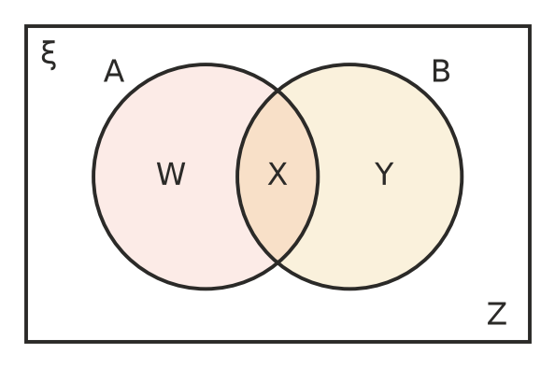
  - (A ∩ B)′ ______________
  - A′ ______________
  - A ∪ B′ ______________
  - (A ∩ B′) ∪ (A′ ∩ B) ______________
- The Venn diagram shows the electives chosen by 100 students: drama (D), music (M) and art (A). One student is chosen at random.
- 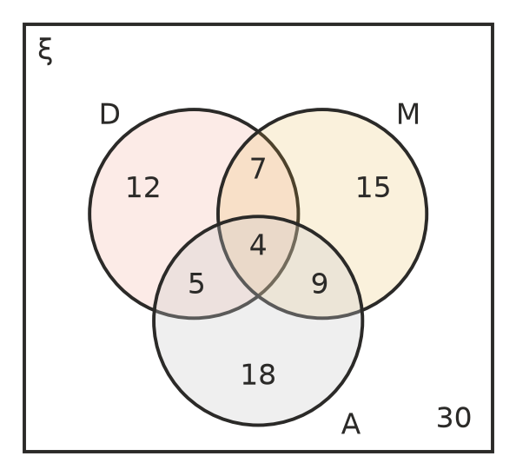
  - P(D) ______________
  - P(exactly two electives) ______________
  - P(at least two electives) ______________
  - P(music and art, but not drama) ______________
  - P(none of these) ______________

 Fluency
- Fifty people at the beach were asked what they did that day: swim (S), surf (F) or fish (H). 3 did all three, 8 swam and surfed, 6 swam and fished, 5 surfed and fished, 25 swam, 18 surfed and 14 fished.
- 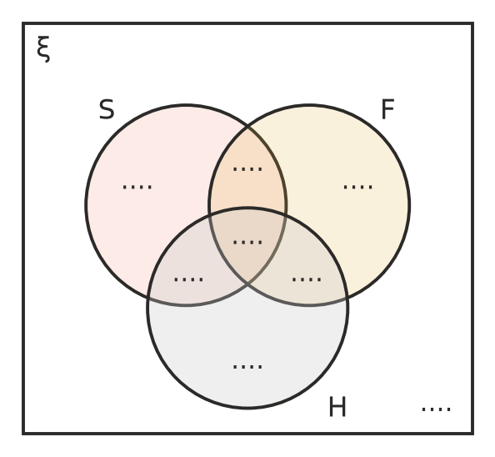
  - Complete the Venn diagram. (The numbers 8, 6 and 5 include the 3 people who did all three.)
  - How many people did none of the three? ______________
  - Find P(did exactly one activity). ______________
  - Find P(swam or surfed). ______________
- For two events, P(A) = 0.45, P(B) = 0.35 and P(A ∪ B) = 0.6.
- 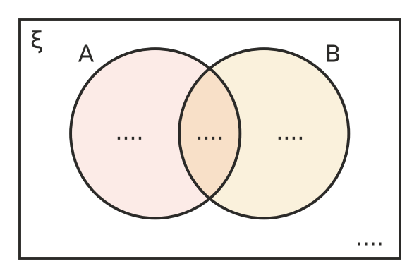
  - Write the probability in each region of the Venn diagram.
  - Find P(A ∩ B′). ______________
  - Find P(A′ ∩ B′). ______________
- The Venn diagram shows 40 students.
- 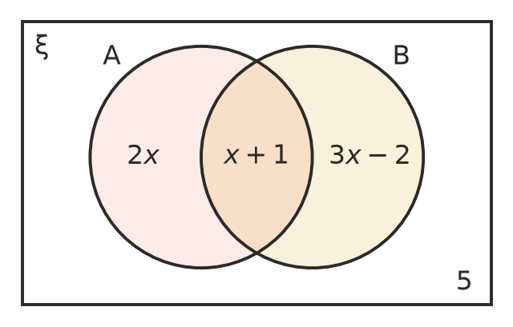
  - Find the value of $x$. ______________

  - One student is chosen at random. Find P(A). ______________
  - Find P(B only). ______________

 Reasoning
- For two events, P(A) = 0.7 and P(B) = 0.6.
  - Explain why A and B must overlap. ______________

  - What is the smallest possible value of P(A ∩ B)? ______________
  - What is the largest possible value of P(A ∩ B)? ______________
- Use a Venn diagram to explain why n(A ∪ B) = n(A) + n(B) − n(A ∩ B). ______________

 Problem solving
- ξ = {1, 2, 3, …, 30}. A is the set of multiples of 2, B is the set of multiples of 3 and C is the set of multiples of 5.
  - Draw a three-set Venn diagram and write how many numbers are in each region.

  - A number is chosen at random. Find P(in exactly one of the sets). ______________
  - Find P(in none of the sets). ______________
- Two normal dice are rolled. A is the event “at least one 6” and B is the event “a total of 10 or more”.
  - Draw a Venn diagram showing the number of outcomes (out of 36) in each region.

  - Find P(A ∪ B). ______________
  - Find P(A ∩ B′). ______________
- In a group of 200 students, 120 have a phone and 90 have a laptop. The probability that a student chosen at random has neither is 0.1.
  - Find P(has a phone and a laptop). ______________

  - Find P(has exactly one of the two). ______________
- In a class of 28 students, 17 play a sport and 15 play an instrument.
  - What is the smallest possible number of students who do both? ______________
  - What is the largest possible number who do both? ______________
  - If 6 students do neither, how many do both? ______________
- The Venn diagram shows 54 people. Find:
- 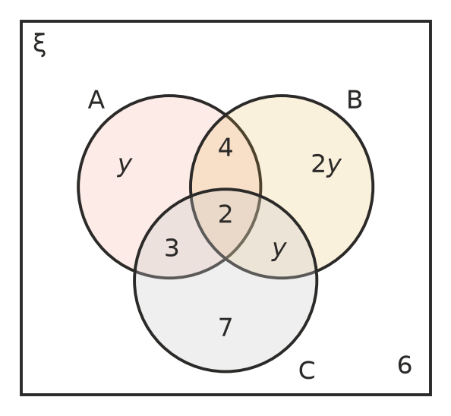
  - the value of $y$ ______________

  - P(B) ______________
  - P(in exactly two of the sets) ______________

