10.03 Venn diagrams
Year 8 Maths · Worksheet · Level 2 · Core
Name: ____________________ Date: ______________
This worksheet practises reading, completing and drawing Venn diagrams with two and three sets, and using them to find probabilities. Tip: fill a Venn diagram from the inside out. Start with the overlap, then the “only” regions, then the region outside the circles. All the regions together must add up to the total.

 Understanding
- The Venn diagram shows the 60 Year 8 students who play an instrument (I) and play in a sports team (S). One student is chosen at random.
- 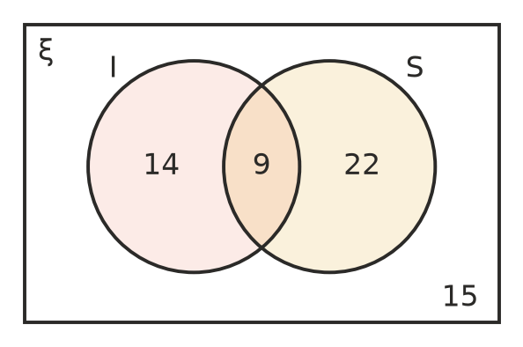
  - P(I) ______________
  - P(I ∩ S) ______________
  - P(I ∪ S) ______________
  - P(neither) ______________
  - P(S only) ______________
- The regions of this Venn diagram are labelled W, X, Y and Z.
- 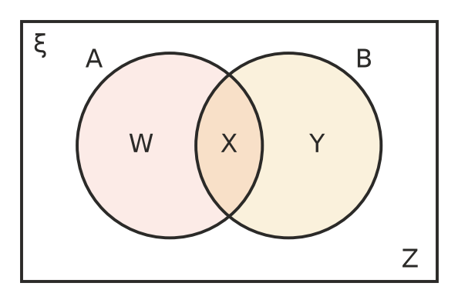
- Write the letter of the region that matches each set.
  - A ∩ B ______________
  - A ∩ B′ ______________
  - A′ ∩ B ______________
  - (A ∪ B)′ ______________
  - Which regions make up A ∪ B? ______________

 Fluency
- ξ = {1, 2, 3, …, 20}. P is the set of prime numbers and O is the set of odd numbers.
- 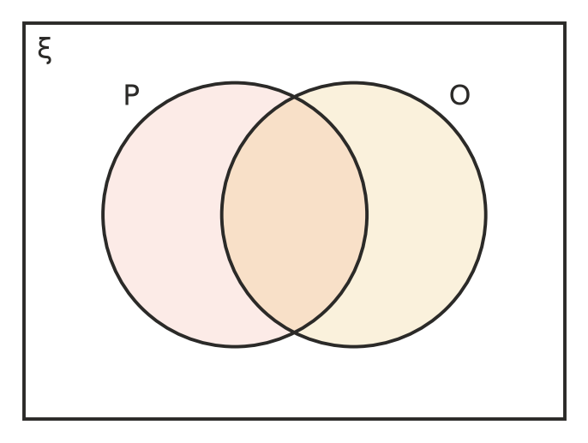
  - Write each number from 1 to 20 in the correct region.
  - A number is chosen at random. Find P(P ∩ O). ______________
  - Find P(O′). ______________
  - Find P(P ∪ O). ______________
- Thirty-two students were asked about breakfast. 20 had cereal (C), 14 had toast (T) and 6 had both.
- 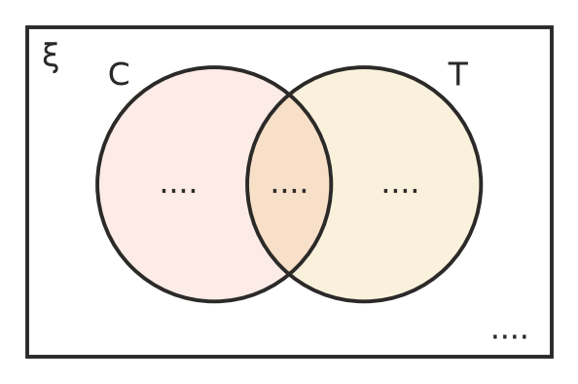
  - Complete the Venn diagram.
  - P(toast only) ______________
  - P(neither) ______________
  - P(cereal or toast) ______________
- Fifty people are shown in this Venn diagram.
- 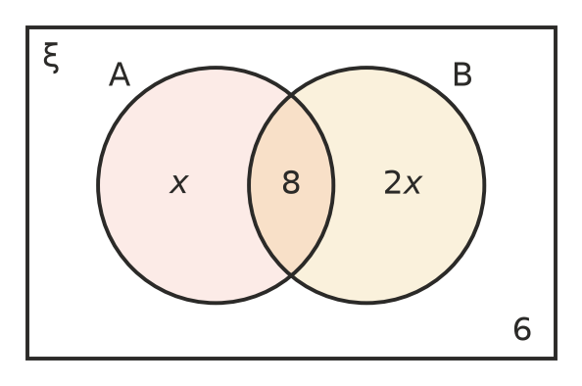
  - Find the value of $x$. ______________

  - One person is chosen at random. Find P(B). ______________

 Reasoning
- In a group of 45 students, everyone plays footy or swims (or both). 23 play footy and 31 swim.
  - Explain why 23 + 31 is more than 45. ______________

  - How many students do both? ______________
- Explain why the probabilities in all four regions of a two-set Venn diagram must add up to 1. ______________

 Problem solving
- For two events, P(A) = 0.6, P(B) = 0.5 and P(A ∩ B) = 0.3.
- 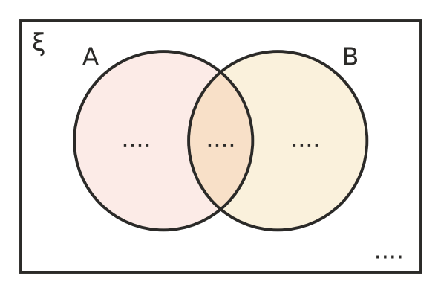
  - Write the probability in each region of the Venn diagram.
  - Find P(A ∪ B). ______________
  - Find P(exactly one of A and B). ______________
- On a camp of 80 students, 45 went canoeing (C), 38 did archery (A) and 12 did neither.
  - How many students did both? ______________
  - Draw a Venn diagram to show this information.

  - Find P(canoeing only). ______________
  - Find P(exactly one activity). ______________
- The Venn diagram shows the 30 members of a youth band who play guitar (G), drums (D) and piano (P).
- 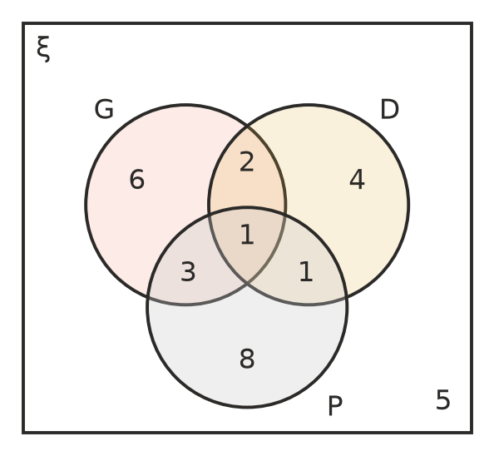
  - How many members play piano? ______________
  - Find P(plays all three). ______________
  - Find P(plays exactly one instrument). ______________
  - Find P(plays guitar and piano). ______________
  - Find P(plays none of these). ______________
- Two normal dice are rolled. D is the event “a double” and E is the event “a total of 8”.
- 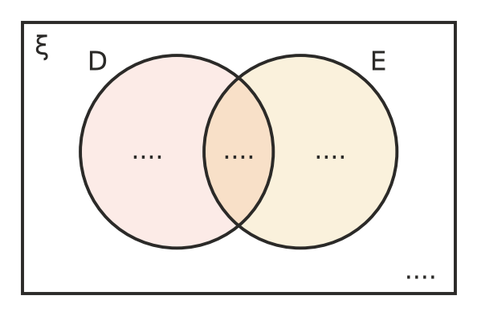
  - Write the number of outcomes (out of 36) in each region.
  - Find P(D ∪ E). ______________
- At a fundraiser barbecue, 120 people were served. 70 bought a sausage sizzle, 45 bought a drink, and the probability that a person chosen at random bought neither is $\frac{1}{6}$.
  - How many people bought neither? ______________
  - How many people bought both? ______________
  - Find P(bought a drink only). ______________

