10.03 Venn diagrams
Year 8 Maths · Worksheet · Level 1 · Warm-up
Name: ____________________ Date: ______________
This worksheet practises reading and drawing Venn diagrams and using them to find probabilities. Tip: the overlap of the circles is “both”, the part of a circle outside the overlap is “only”, and the space outside both circles is “neither”. To find a total for one circle, add its “only” part and the overlap.

 Understanding
- The Venn diagram shows how many students in a Year 8 class do music (M) and art (A).
- 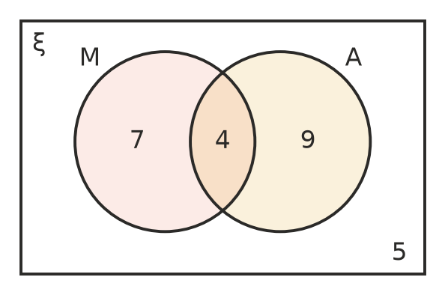
  - How many students do music? ______________
  - How many do both music and art? ______________
  - How many do art only? ______________
  - How many do neither? ______________
  - How many students are in the class? ______________
- The four regions of this Venn diagram are labelled P, Q, R and S.
- 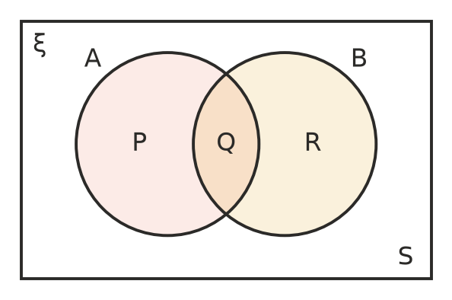
  - Which region is “in A and in B”? ______________
  - Which region is “in B only”? ______________
  - Which region is “in neither A nor B”? ______________
  - Which two regions together make up A? ______________

 Fluency
- Use the Venn diagram in question 1. One student is chosen at random. Find each probability in simplest form.
  - P(music) ______________
  - P(music and art) ______________
  - P(neither) ______________
  - P(art only) ______________
  - P(music or art) ______________
- ξ = {1, 2, 3, 4, 5, 6, 7, 8, 9, 10}. A is the set of even numbers and B is the set of multiples of 3. Write each number in the correct region.
- 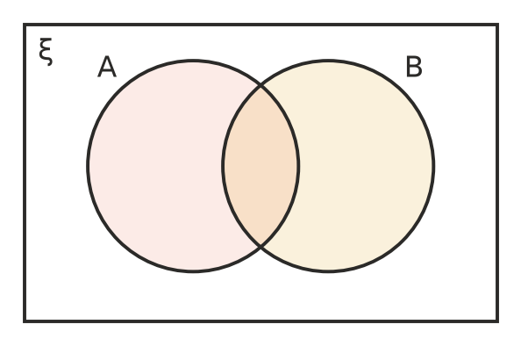
- In a class of 30 students, 12 like pies (P), 15 like sausage rolls (S) and 5 like both.
- 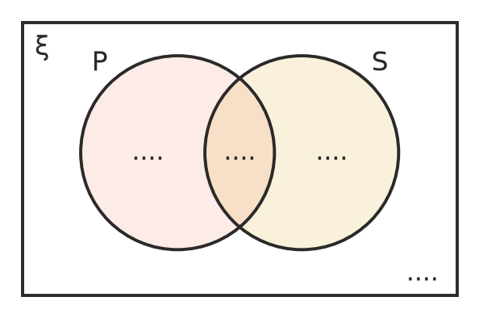
  - Complete the Venn diagram. (Start with the overlap.)
  - How many students like neither? ______________
  - Find P(likes neither). ______________
- ξ = {1, 2, 3, …, 12}. F is the set of factors of 12 and O is the set of odd numbers.
- 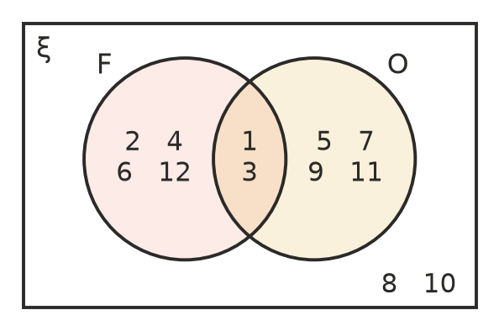
  - List F ∩ O. ______________
  - A number is chosen at random. Find P(F ∪ O). ______________
  - Find P(odd but not a factor of 12). ______________

 Reasoning
- This Venn diagram shows the students in a class who play netball (N) and basketball (B).
- 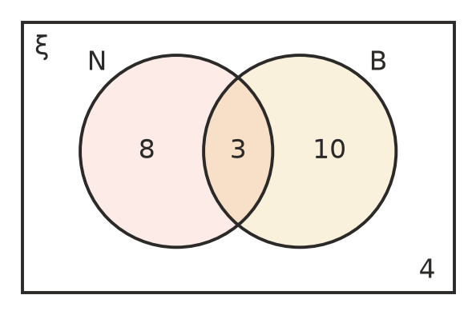
- Jo says, “11 play netball and 13 play basketball, so 11 + 13 = 24 students play netball or basketball.” Explain Jo’s mistake and give the correct number. ______________

- Kai uses the Venn diagram in question 1 and says P(music) = $\frac{7}{25}$. Explain his mistake. ______________

 Problem solving
- At a church camp there are 40 campers. 24 went kayaking (K), 18 did the high ropes (H) and 6 did neither.
- 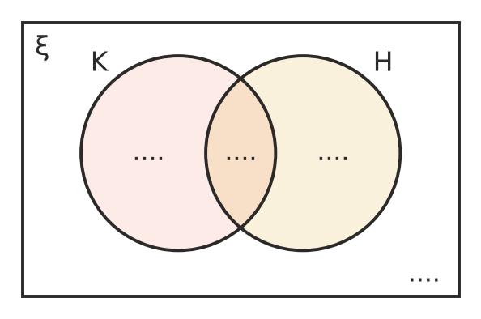
  - How many campers did at least one activity? ______________
  - How many did both? ______________
  - Complete the Venn diagram.
  - Find P(kayaking only). ______________
- A normal die is rolled. A is the event “an even number” and B is the event “a number greater than 2”.
  - Write the numbers 1 to 6 in the Venn diagram.
  - P(A and B) ______________
  - P(neither A nor B) ______________
- The Venn diagram shows the 50 students in Year 8 who play footy (F) and cricket (C).
- 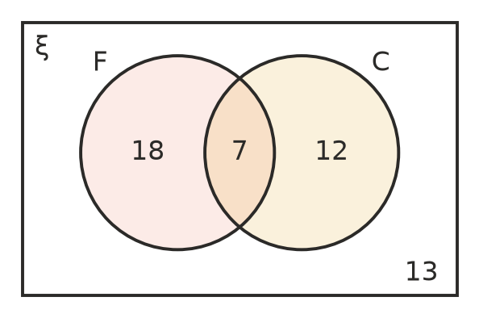
- One student is chosen at random. Find:
  - P(plays both) ______________
  - P(plays exactly one of the two sports) ______________
  - P(does not play cricket) ______________

