10.01 Calculate probability
Year 8 Maths · A5 question sheet · Level 3 · Challenge
This worksheet practises finding probabilities for experiments with two, three or four steps, including taking objects with and without putting them back. Tip: count outcomes carefully with a table or a tree diagram, and check that every outcome you count is equally likely.

 Understanding
- A whole number from 1 to 50 is chosen at random. Find each probability in simplest form.
  - P(multiple of 7)
  - P(the number contains the digit 3)
  - P(square number)
  - P(not a multiple of 5)
- Two normal dice are rolled and the numbers are added. Which statement is true?
  - A total of 6 and a total of 8 are equally likely.
  - A total of 2 is as likely as a total of 7.
  - A total of 12 is more likely than a total of 11.
  - There are 11 possible totals, so each has a probability of $\frac{1}{11}$.

 Fluency
- Two normal dice are rolled. The difference is the larger number minus the smaller number (0 if they are the same).
Difference | 1 | 2 | 3 | 4 | 5 | 6
1
2
3
4
5
6

  - Copy and complete the table.
  - P(difference of 0)
  - P(difference of 1)
  - P(difference of at least 3)
  - Which difference is the most likely?
- A quiz has three true-or-false questions. Hamish has no idea of the answers, so he guesses each one. Each guess is either correct (C) or wrong (W).
- 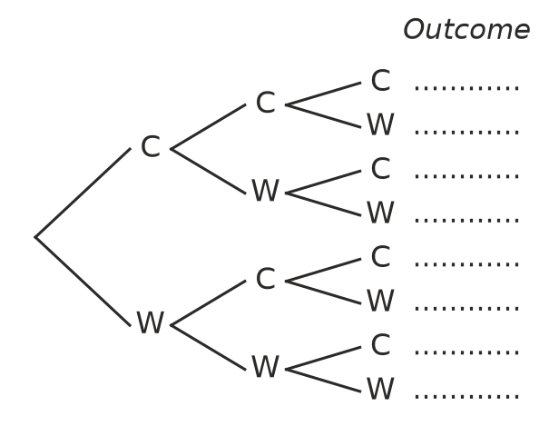
  - Write all the outcomes at the ends of the branches.
  - P(all three correct)
  - P(exactly two correct)
  - P(at least one correct)
- A bag holds 3 red and 2 blue marbles. A marble is taken, its colour is written down, and it is put back. Then a second marble is taken.
  - How many equally likely outcomes are there? (Hint: name the marbles R1, R2, R3, B1, B2.)
  - P(two red)
  - P(both the same colour)
  - P(at least one blue)
- A bag holds 2 red marbles (R1, R2) and 2 blue marbles (B1, B2). Two marbles are taken one after the other, without putting the first one back.
  - List all the outcomes.
  - P(two red)
  - P(one of each colour)
  - Explain why there are fewer outcomes than if the first marble was put back.

 Reasoning
- Two dice are rolled and the numbers are multiplied. Sam says, “The product is either even or odd, so they are equally likely.” Show that Sam is wrong by finding P(product is even).
- This spinner is spun twice.
- 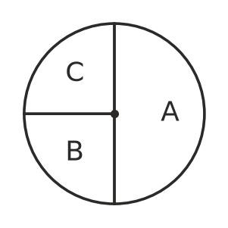
- Lily lists the outcomes AA, AB, AC, BA, BB, BC, CA, CB, CC and says P(AA) = $\frac{1}{9}$.
  - Explain Lily’s mistake.
  - Find the correct P(AA).

 Problem solving
- A bag holds red and white counters. The probability of taking a red counter is $\frac{3}{8}$. When 4 more red counters are added, the probability of taking a red counter becomes $\frac{1}{2}$. How many counters were in the bag at the start, and how many were red?
- Spinner X has 3 equal sections numbered 1, 2, 3. Spinner Y has 4 equal sections numbered 1, 2, 3, 4. Both are spun and the numbers are added.
  - Show all the outcomes in a table.
  - P(total of 5)
  - P(odd total)
  - Which totals are the most likely?
- Design a bag of 12 marbles using only red, blue and green, so that P(red) = $\frac{1}{2}$ and P(blue) is twice P(green). How many of each colour?
- A coin is tossed four times.
  - How many outcomes are there?
  - P(exactly two heads)
  - P(more heads than tails)
- A bike lock has three dials. Each dial shows a digit from 0 to 9.
  - How many different codes are possible?
  - Ruby remembers the first two digits but not the last. What is the probability she gets it right on her first guess?
  - Ben remembers only the first digit. What is the probability he gets it right on his first guess?
  - A code is set at random. Find the probability that all three digits are different.

