10.01 Calculate probability
Year 8 Maths · A5 question sheet · Level 2 · Core
This worksheet practises finding probabilities for one event and for two or three events in a row, using lists, tables and tree diagrams. Tip: when all outcomes are equally likely, P(event) = number of favourable outcomes ÷ total number of outcomes. For two steps, multiply: 2 outcomes then 3 outcomes gives 2 × 3 = 6 outcomes.

 Understanding
- One letter is chosen at random from the word KANGAROO.
  - How many letters are there?
  - P(A)
  - P(O)
  - P(vowel)
  - P(not K)
- A normal die is rolled. Which event has a probability of $\frac{1}{3}$?
  - rolling a 3
  - rolling a number less than 3
  - rolling an odd number
  - rolling a number greater than 3

 Fluency
- A spinner has 10 equal sections numbered 1 to 10. It is spun once. Find each probability in simplest form.
  - P(even number)
  - P(multiple of 3)
  - P(prime number)
  - P(factor of 12)
  - P(not a multiple of 4)
  - P(square number)
- Two normal dice are rolled and the numbers are added.
+ | 1 | 2 | 3 | 4 | 5 | 6
1
2
3
4
5
6

  - Copy and complete the table.
  - P(total of 8)
  - P(a double, the same number on both dice)
  - P(total greater than 9)
  - P(total is a prime number)
  - Which total is the most likely?
- A coin is tossed and then a spinner with 3 equal sections (red, blue and yellow) is spun.
- 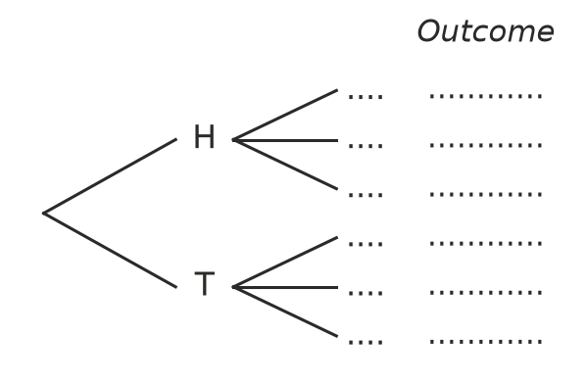
  - Copy and complete the tree diagram. Label the branches R, B and Y, and write each outcome at the end of its branch (for example, H-red).
  - How many outcomes are there?
  - P(heads and red)
  - P(blue)
  - P(tails and not yellow)

 Reasoning
- Two dice are rolled and the numbers are added. Ella says, “The totals go from 2 to 12. That is 11 totals, so P(total of 7) is $\frac{1}{11}$.” Explain why Ella is wrong and give the correct probability.
- Max tosses a coin and rolls a die. He says, “There are 2 + 6 = 8 possible outcomes.” Explain his mistake and give the correct number of outcomes.

 Problem solving
- A coin is tossed three times.
- 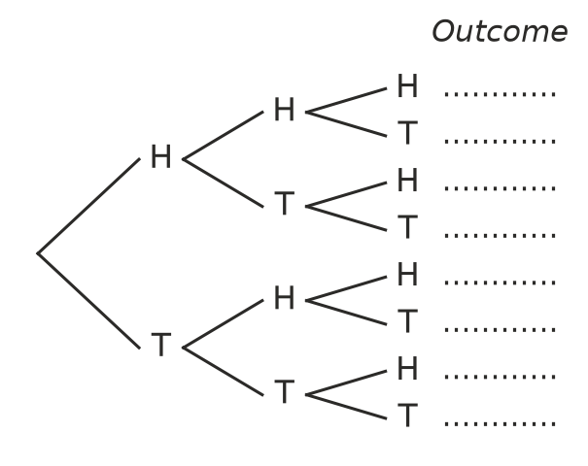
  - Write all the outcomes at the ends of the branches.
  - How many outcomes are there?
  - P(three heads)
  - P(exactly two heads)
  - P(at least one tail)
- A bag holds 2 red marbles and 1 green marble. Call them R1, R2 and G. A marble is taken, its colour is written down, and it is put back. Then a second marble is taken.
- 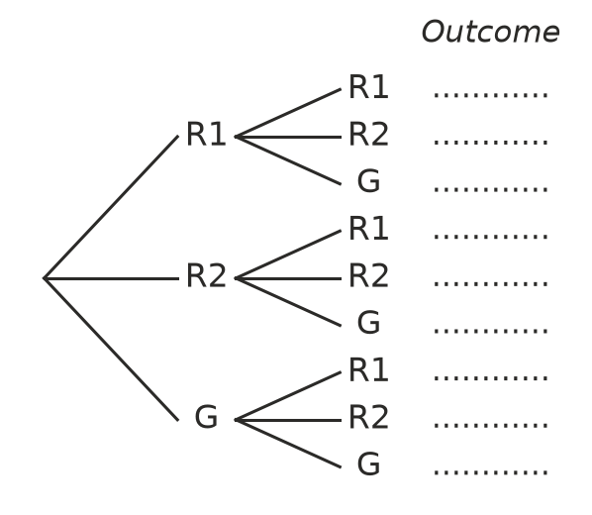
  - Write all 9 outcomes at the ends of the branches.
  - P(two red marbles)
  - P(two green marbles)
  - P(one red and one green, in any order)
- A box holds 24 pens. The probability of choosing a blue pen is $\frac{1}{3}$ and the probability of choosing a black pen is $\frac{1}{4}$. The rest are red.
  - How many red pens are in your book?
  - Find P(red).
  - Six more red pens are added. Find the new P(red).
- A spinner has 4 equal sections numbered 1 to 4. It is spun twice and the two numbers are multiplied.
× | 1 | 2 | 3 | 4
1
2
3
4

  - Copy and complete the table.
  - P(product is even)
  - P(product is a square number)
  - P(product is less than 5)
- A locker code is one letter (A, B or C) followed by one digit (0 to 9), for example B7.
  - How many different codes are there?
  - A code is chosen at random. Find P(A7).
  - Find P(the digit is even).
  - Find P(the letter is not C and the digit is less than 3).

