10.01 Calculate probability
Year 8 Maths · A5 question sheet · Level 1 · Warm-up
This worksheet practises finding probabilities by counting outcomes, for one event and for two events in a row. Tip: when all outcomes are equally likely, P(event) = number of favourable outcomes ÷ total number of outcomes. Always write the fraction in simplest form.

 Understanding
- A bag holds 3 red, 5 blue and 2 green marbles. One marble is taken without looking.
  - How many marbles are in the bag altogether?
  - P(red)
  - P(blue)
  - P(not green)
- Which of these could not be a probability?
  - 0.7
  - $\frac{3}{2}$
  - 0
  - 45%

 Fluency
- A normal six-sided die is rolled.
  - Write the sample space (all the possible outcomes).
  - P(4)
  - P(even number)
  - P(number greater than 4)
  - P(number less than 7)
  - P(8)
- This spinner has 8 equal sections. It is spun once.
- 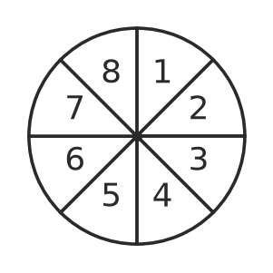
  - P(odd number)
  - P(multiple of 3)
  - P(prime number)
  - P(not 8)
- A coin is tossed twice. The tree diagram shows the first toss, then the second toss.
- 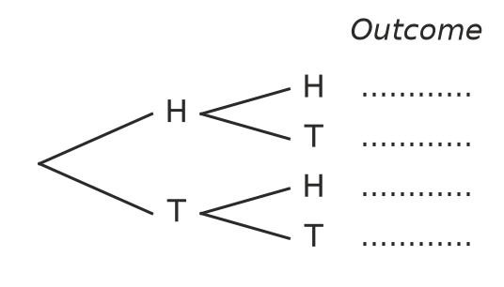
  - Write each outcome at the end of its branch (for example, HT means heads then tails).
  - How many outcomes are there?
  - P(two heads)
  - P(one head and one tail, in any order)
- Two normal dice are rolled and the two numbers are added.
+ | 1 | 2 | 3 | 4 | 5 | 6
1 | 2 | 3 | 4 | 5 | 6 | 7
2 | 3
3 | 4
4 | 5
5 | 6
6 | 7

  - Copy and complete the table.
  - How many outcomes are there?
  - P(total of 7)
  - P(total of 12)
  - P(total less than 5)

 Reasoning
- Mia says, “Tomorrow it will either rain or not rain, so the probability of rain is $\frac{1}{2}$.” Explain why Mia is wrong.
- Jack rolls a die and gets a 6 three times in a row. He says, “A 6 is now less likely on my next roll.” Is Jack right? Explain.

 Problem solving
- The canteen meal deal is one sandwich (chicken, salad or ham) and one drink (water or juice).
  - List every possible meal deal.
  - Leo chooses a meal deal at random. Find P(chicken and juice).
  - Find P(salad sandwich).
- A jar holds 20 jelly beans. Eight are red, some are yellow and the rest are green. The probability of taking a yellow one is $\frac{1}{4}$.
  - How many yellow jelly beans are there?
  - How many green jelly beans are there?
  - Find P(green).
- A spinner has 3 equal sections labelled A, B and C. It is spun twice.
  - List all the outcomes (for example, AB means A then B).
  - P(the same letter twice)
  - P(at least one A)

