2.02 Find the whole
Year 8 Maths · Worksheet · Level 2 · Core
Name: ____________________ Date: ______________
This worksheet practises finding the whole amount when you know a part and its percentage. Tip: if 35% of a number n is 42, write it as 0.35 × n = 42, then divide: n = 42 ÷ 0.35. You can always check by finding the percentage of your answer.

 Understanding
- On a road trip, the Nguyen family has driven 135 km. This is 60% of the whole trip.
- 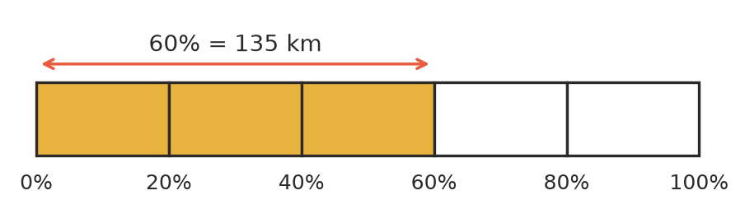
  - How far is 20% of the trip? ______________
  - How long is the whole trip? ______________
  - How far do they still have to drive? ______________
- 35% of a number n is 42.
  - Write this as an equation using a decimal. ______________
  - Solve your equation to find n. ______________
- 18 is 12% of which number? Answer: ______________
  - 2.16
  - 30
  - 150
  - 216

 Fluency
- Find the whole amount.
  - 15% of a number is 21. ______________
  - 35% of a number is 77. ______________
  - 45% of a number is 63. ______________
  - 8% of a number is 6. ______________
  - 125% of a number is 40. ______________
  - 2.5% of a number is 7. ______________

- Find the number.
  - 62% of what number is 31? ______________
  - 120% of what number is 84? ______________
  - 0.5% of what number is 3? ______________
  - 37.5% of what number is 27? ______________
- Find the whole amount. Include the unit.
  - 12% of an amount of money is $9.60. ______________
  - 65% of a length is 26 m. ______________
  - 4% of a mass is 1.8 kg. ______________
  - 140% of a volume is 350 mL. ______________

 Reasoning
- Kayla says: “20% of a number is 30. So 80% is 30 × 4 = 120, and the number is 120.” Explain her mistake and find the correct number.

- 15% of a number is 36. Show two different ways to find the number.

- 60% of A is the same as 40% of B. Which is larger, A or B? Explain your answer.

 Problem solving
- At church camp, 72 campers chose kayaking. This is 45% of all the campers.
  - How many campers are at the camp? ______________
  - 25% of the campers chose archery. How many is that? ______________

- A phone battery shows 35%. The phone says this is enough for 2 hours 48 minutes of use. How long should a full battery last? Give your answer in hours. ______________

- In a maths test, 21 students passed. This was 84% of the class. How many students did not pass? ______________

- 30% of a paddock is planted with wheat, and the wheat covers 18 hectares. 25% of the same paddock is planted with barley. How many hectares of barley are there? ______________

- Nan spent 40% of her money on a birthday present. Then she spent 25% of the money she had left on lunch. She now has $54. How much money did she start with? Show your working. ______________

