2.02 Find the whole
Year 8 Maths · A5 question sheet · Level 1 · Warm-up
This worksheet practises working backwards: when you know a part and what percentage it is, you can find the whole amount. Tip: find 10% or 1% first, then multiply up to 100%.

 Understanding
- The bar shows that 30% of a number is 24.
- 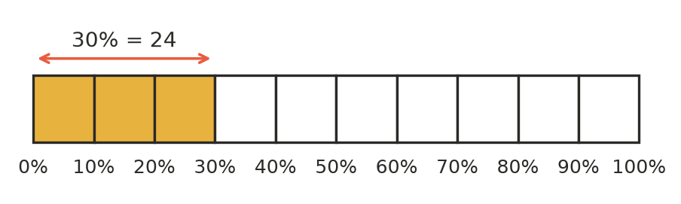
  - What is 10% of the number?
  - What is 100% of the number?
- Complete each statement.
  - 50% of a number is 13. The number is
  - 25% of a number is 9. The number is
  - 10% of a number is 7. The number is
  - 1% of a number is 4. The number is
- 20% of Sam’s savings is $15. How much has Sam saved altogether?
  - $3
  - $35
  - $75
  - $300

 Fluency
- Find the whole by finding 10% first.
  - 30% of a number is 27. 10% is ______________, so the number is
  - 70% of a number is 56. 10% is ______________, so the number is
  - 40% of a number is 120. 10% is ______________, so the number is
  - 90% of a number is 63. 10% is ______________, so the number is
- Find the whole by finding 1% first.
  - 5% of a number is 12. 1% is ______________, so the number is
  - 2% of a number is 9. 1% is ______________, so the number is
  - 15% of a number is 45. 1% is ______________, so the number is
  - 8% of a number is 32. 1% is ______________, so the number is
- Use a fraction to find the whole. For example, 25% is $\frac{1}{4}$, so the whole is 4 times as big.
  - 25% of a number is 14. The number is
  - 75% of a number is 60. The number is
  - 20% of a number is 11. The number is
  - 50% of a number is 3.5. The number is

 Reasoning
- Lily says: “40% of a number is 20, so the number is 20 + 40 = 60.” Explain why Lily is wrong, and find the correct number.
- Josh worked out that if 20% of a number is 18, then the number is 90. Show how Josh can check his answer.

 Problem solving
- Ella has saved $45. This is 30% of the price of the bike she wants. How much does the bike cost?
- In a Year 8 class, 12 students walk to school. This is 40% of the class.
  - How many students are in the class?
  - How many students do not walk to school?
- A water tank is 60% full. It holds 1500 L of water. How many litres does the tank hold when it is full?
- In a box of apples, 15% are bruised. There are 9 bruised apples.
  - How many apples are in your book?
  - How many apples are not bruised?

