Measurement: Practice test 3
Year 8 Maths · Test · Test 3
Name: ____________________ Date: ______________
Time: 45 minutes
Total: 40 marks
Show your working in the boxes. Then write each final answer on the answer sheet on the last page. Diagrams are not drawn to scale, so use the measurements written on them. Write units with every answer.

 Section A: No calculator
- Perimeter.
  - A regular octagon has sides of 4.5 cm. Find its perimeter. (1 mark)

  - An isosceles triangle has two equal sides of 13 m and a perimeter of 34 m. How long is the third side? (1 mark)

- This is the shape of a trophy base, seen from the front. All the corners are right angles.
- 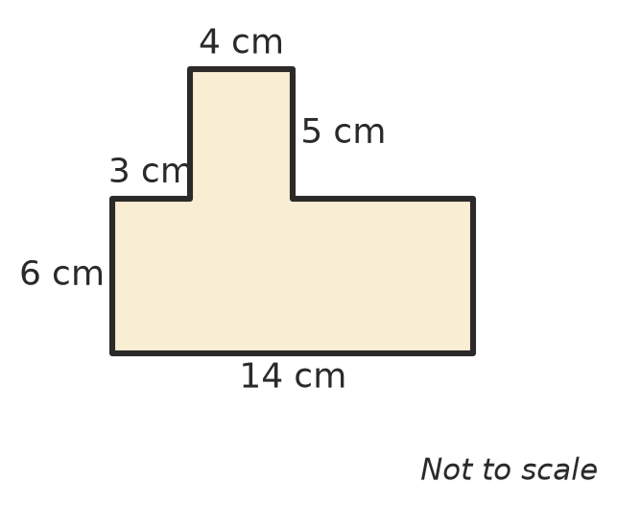
  - Find the perimeter of the shape. (2 marks)

  - Find the area of the shape. (2 marks)

- Circumference.
  - A circle has a diameter of 13 m. Write its exact circumference in terms of $π$. (1 mark)

  - A round cake tin has a radius of 25 cm. Use $π$ ≈ 3.14 to find its circumference. (1 mark)

- Convert each area to the unit shown.
  - 0.8 m² to cm² (1 mark)

  - 350 mm² to cm² (1 mark)

  - A national park picnic area covers 120 000 m². Write this area in hectares. (1 mark)

- A lake is drawn on a map grid. Each square stands for 1 ha. Estimate the area of the lake. (1 mark)
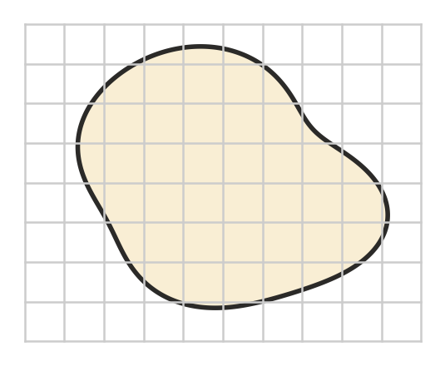

- Find the area of each shape. The dashed lines are perpendicular heights.
- 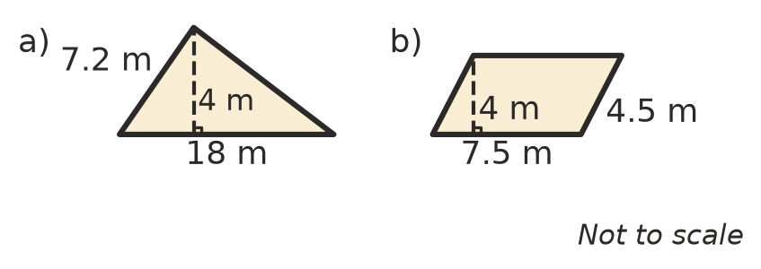
  - Triangle a) (1 mark)

  - Parallelogram b) (1 mark)

- Find the area of this trapezium. (2 marks)
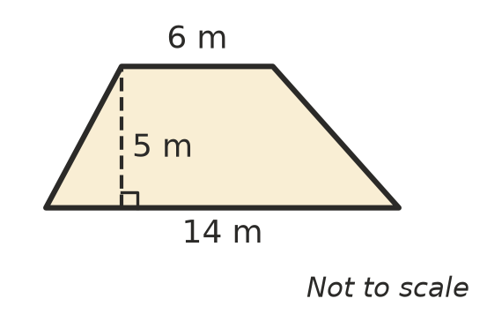

- Rhombuses and kites.
  - A rhombus has diagonals of 18 cm and 6 cm. Find its area. (1 mark)

  - One diagonal of a kite is twice as long as the other. The area of the kite is 64 cm². How long is each diagonal? (2 marks)

- Area of a circle.
  - A circle has a radius of 9 m. Write its exact area in terms of $π$. (1 mark)

  - A round table cloth has a diameter of 40 cm. Use $π$ ≈ 3.14 to find its area. (1 mark)

- Noah is finding the perimeter of a semicircle with a radius of 10 cm. He writes: “Half of 2 × $π$ × 10 is 10$π$, which is about 31.4 cm.” Explain Noah’s mistake. Then find the correct perimeter, using $π$ ≈ 3.14. (2 marks)

- Convert each volume or capacity to the unit shown.
  - 0.35 L to mL (1 mark)

  - 5 m³ to L (1 mark)

  - 12 000 mL to L (1 mark)

- Find the volume of this prism. Its cross-section is a trapezium. (2 marks)
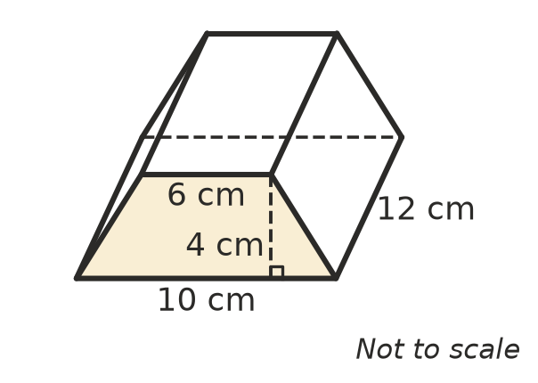

 Section B: Calculator allowed
- Look at this circle. Use the $π$ key on your calculator.
- 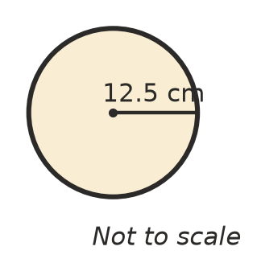
  - Find its circumference, correct to 1 decimal place. (1 mark)

  - Find its area, correct to 1 decimal place. (1 mark)

- A square tile has a pattern. The shaded part is a quarter circle with its centre at the bottom left corner of the tile. Give your answers correct to 2 decimal places.
- 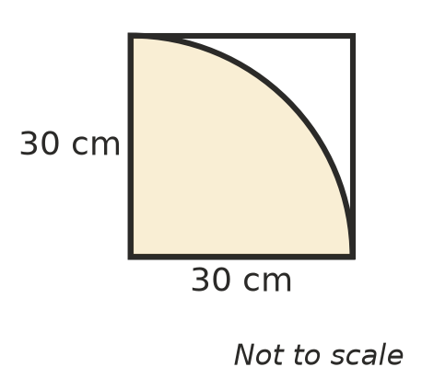
  - Find the perimeter of the shaded part. (2 marks)

  - Find the area of the part of the tile that is not shaded. (2 marks)

- A circular rug has an area of 50 m². Find its radius, correct to 2 decimal places. (2 marks)

- A fish tank is a rectangular prism 60 cm long, 35 cm wide and 40 cm tall. It is filled with water to 5 cm below the top. How many litres of water are in the tank? (2 marks)

- A concrete ramp is a triangular prism. The triangle at each end has a base of 3.2 m and a perpendicular height of 0.5 m. The ramp is 1.5 m wide. Concrete costs $245 per cubic metre. Find the cost of the concrete for the ramp. (2 marks)

 Answer sheet
Name: ____________________
Write your final answer for each question in the table.
Question | Answer | Marks | Question | Answer | Marks
1a |  | /1 | 9a |  | /1
1b |  | /1 | 9b |  | /1
2a |  | /2 | 10 |  | /2
2b |  | /2 | 11a |  | /1
3a |  | /1 | 11b |  | /1
3b |  | /1 | 11c |  | /1
4a |  | /1 | 12 |  | /2
4b |  | /1 | 13a |  | /1
4c |  | /1 | 13b |  | /1
5 |  | /1 | 14a |  | /2
6a |  | /1 | 14b |  | /2
6b |  | /1 | 15 |  | /2
7 |  | /2 | 16 |  | /2
8a |  | /1 | 17 |  | /2
8b |  | /2
 |  |  |  | Total | /40

