Measurement: Practice test 2
Year 8 Maths · Test · Test 2
Name: ____________________ Date: ______________
Time: 45 minutes
Total: 40 marks
Show your working in the boxes. Then write each final answer on the answer sheet on the last page. Diagrams are not drawn to scale, so use the measurements written on them. Write units with every answer.

 Section A: No calculator
- Perimeter.
  - Find the perimeter of a square with sides of 8.5 m. (1 mark)

  - A rectangular photo frame is 6 cm wide and has a perimeter of 40 cm. How long is it? (1 mark)

- This is the shape of a set of concrete steps, seen from the side. All the corners are right angles.
- 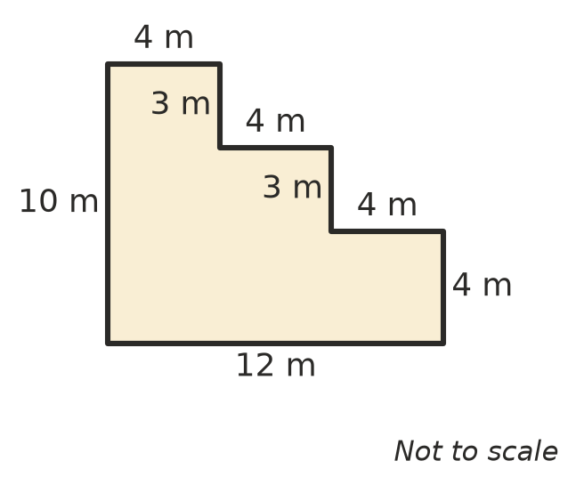
  - Find the perimeter of the shape. (2 marks)

  - Find the area of the shape. (2 marks)

- Circumference.
  - A circle has a radius of 7 cm. Write its exact circumference in terms of $π$. (1 mark)

  - A bike wheel has a diameter of 30 cm. Use $π$ ≈ 3.14 to find its circumference. (1 mark)

- Convert each area to the unit shown.
  - 9 m² to cm² (1 mark)

  - 2500 mm² to cm² (1 mark)

  - A vineyard block has an area of 0.8 ha. Write this area in m². (1 mark)

- A pond is drawn on a grid. Each square is 1 m². Estimate the area of the pond. (1 mark)
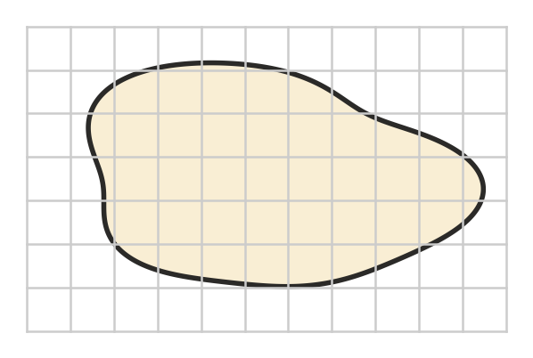

- Find the area of each shape. The dashed lines are perpendicular heights.
- 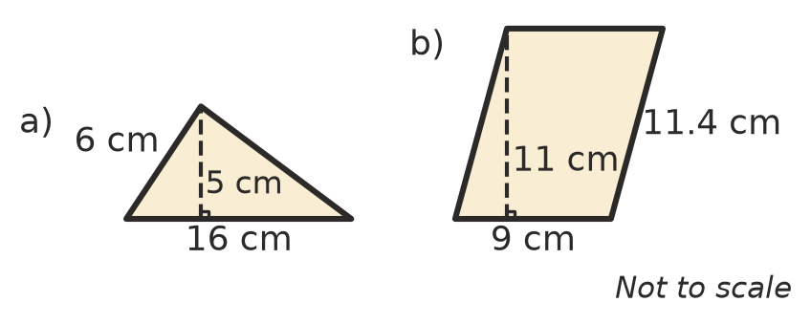
  - Triangle a) (1 mark)

  - Parallelogram b) (1 mark)

- Find the area of this trapezium. (2 marks)
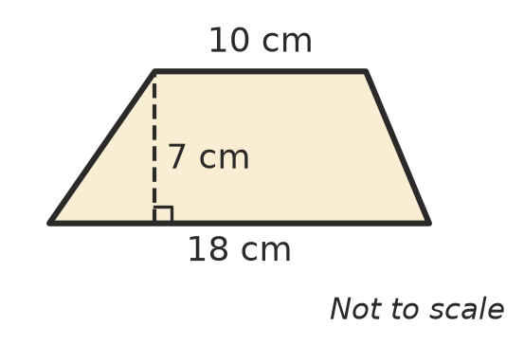

- Kites and trapeziums.
  - A kite-shaped garden has diagonals of 12 m and 9 m. Find its area. (1 mark)

  - A trapezium has an area of 60 cm² and a perpendicular height of 6 cm. One of its parallel sides is 8 cm long. How long is the other parallel side? (2 marks)

- Area of a circle.
  - A circle has a diameter of 8 cm. Write its exact area in terms of $π$. (1 mark)

  - A sprinkler waters a circle with a radius of 20 m. Use $π$ ≈ 3.14 to find the area it waters. (1 mark)

- Ava says the area of a circle with a diameter of 10 cm is 100$π$ cm². Explain her mistake and give the correct exact area. (2 marks)

- Convert each volume or capacity to the unit shown.
  - 3.2 L to mL (1 mark)

  - 0.6 m³ to L (1 mark)

  - 4000 cm³ to L (1 mark)

- Find the volume of this triangular prism. (2 marks)
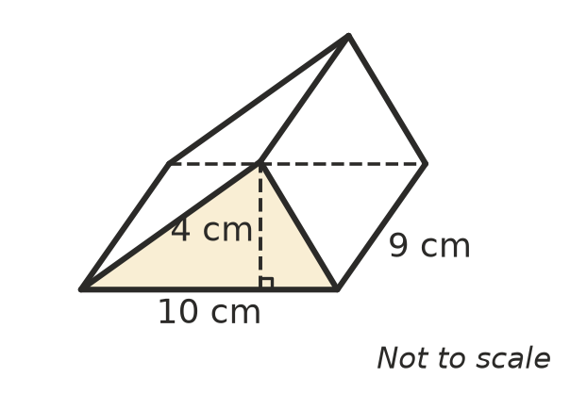

 Section B: Calculator allowed
- Look at this circle. Use the $π$ key on your calculator.
- 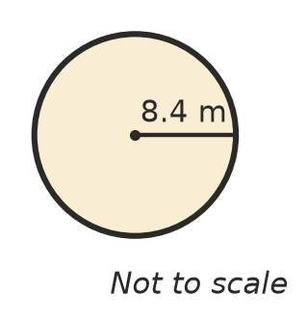
  - Find its circumference, correct to 1 decimal place. (1 mark)

  - Find its area, correct to 1 decimal place. (1 mark)

- A garden bed in the corner of a yard is a quarter circle. Give your answers correct to 2 decimal places.
- 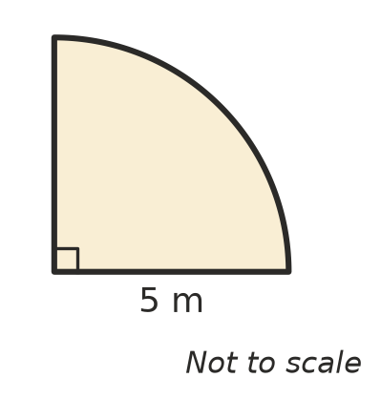
  - Find the perimeter of the garden bed. (2 marks)

  - Find the area of the garden bed. (2 marks)

- A path 1.5 m wide is built around a round pond with a radius of 3 m. Find the area of the path, correct to 2 decimal places. (2 marks)
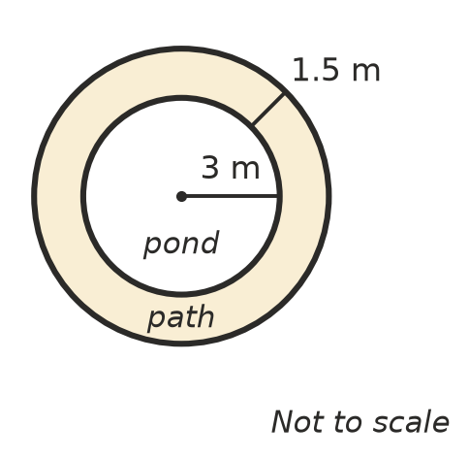

- A rainwater tank is a rectangular prism 1.5 m long, 0.8 m wide and 2 m tall.
  - How many litres does the tank hold when it is full? (1 mark)

  - A family uses 60 L of tank water each day. How many days will a full tank last? (1 mark)

- A swimming pool is a prism. Its side is a trapezium with parallel sides of 1 m (shallow end) and 2.2 m (deep end), which are 20 m apart. The pool is 8 m wide. How many kilolitres of water does the pool hold when it is full? (2 marks)

 Answer sheet
Name: ____________________
Write your final answer for each question in the table.
Question | Answer | Marks | Question | Answer | Marks
1a |  | /1 | 9a |  | /1
1b |  | /1 | 9b |  | /1
2a |  | /2 | 10 |  | /2
2b |  | /2 | 11a |  | /1
3a |  | /1 | 11b |  | /1
3b |  | /1 | 11c |  | /1
4a |  | /1 | 12 |  | /2
4b |  | /1 | 13a |  | /1
4c |  | /1 | 13b |  | /1
5 |  | /1 | 14a |  | /2
6a |  | /1 | 14b |  | /2
6b |  | /1 | 15 |  | /2
7 |  | /2 | 16a |  | /1
8a |  | /1 | 16b |  | /1
8b |  | /2 | 17 |  | /2
 |  |  |  | Total | /40

