Measurement: Practice test 1
Year 8 Maths · Test · Test 1
Name: ____________________ Date: ______________
Time: 45 minutes
Total: 40 marks
Show your working in the boxes. Then write each final answer on the answer sheet on the last page. Diagrams are not drawn to scale, so use the measurements written on them. Write units with every answer.

 Section A: No calculator
- Perimeter.
  - Find the perimeter of a rectangle that is 9.5 cm long and 4 cm wide. (1 mark)

  - An equilateral triangle has a perimeter of 39 m. How long is each side? (1 mark)

- This is the shape of a garden bed. All the corners are right angles.
- 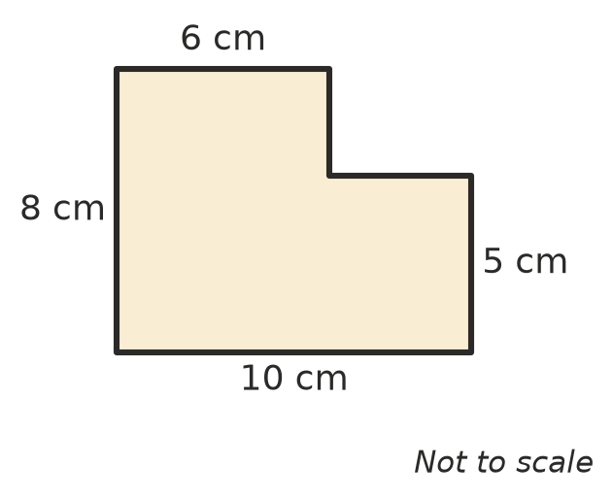
  - Find the perimeter of the garden bed. (2 marks)

  - Find the area of the garden bed. (2 marks)

- Circumference.
  - A circle has a diameter of 9 cm. Write its exact circumference in terms of $π$. (1 mark)

  - A round rainwater tank has a radius of 50 cm. Use $π$ ≈ 3.14 to find the distance around the tank. (1 mark)

- Convert each area to the unit shown.
  - 7 cm² to mm² (1 mark)

  - 60 000 cm² to m² (1 mark)

  - A farm paddock has an area of 3 ha. Write this area in m². (1 mark)

- A gum leaf is traced onto a grid. Each square is 1 cm². Estimate the area of the leaf. (1 mark)
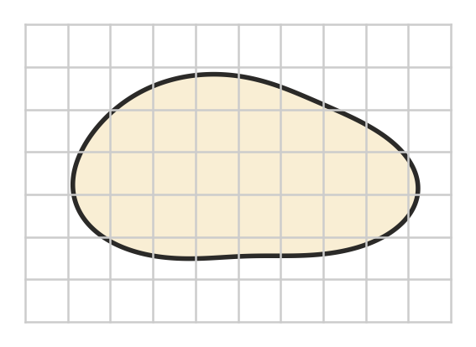

- Find the area of each shape. The dashed lines are perpendicular heights.
- 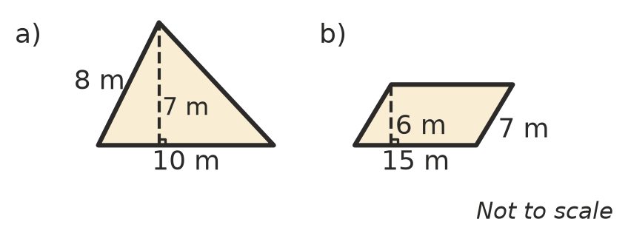
  - Triangle a) (1 mark)

  - Parallelogram b) (1 mark)

- Find the area of this trapezium. (2 marks)
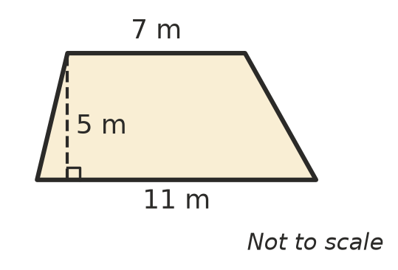

- Rhombuses and kites.
  - A rhombus has diagonals of 14 cm and 8 cm. Find its area. (1 mark)

  - A kite for the beach has an area of 90 cm². One of its diagonals is 15 cm long. How long is the other diagonal? (2 marks)

- Area of a circle.
  - A circle has a radius of 3 cm. Write its exact area in terms of $π$. (1 mark)

  - A round trampoline has a diameter of 4 m. Use $π$ ≈ 3.14 to find its area. (1 mark)

- Mia says, “A square with sides of 1 m has an area of 100 cm², because 1 m = 100 cm.” Explain Mia’s mistake and give the correct area in cm². (2 marks)

- Convert each volume or capacity to the unit shown.
  - 750 mL to L (1 mark)

  - 2.5 L to cm³ (1 mark)

  - 4500 L to m³ (1 mark)

- A pencil box is a rectangular prism.
- 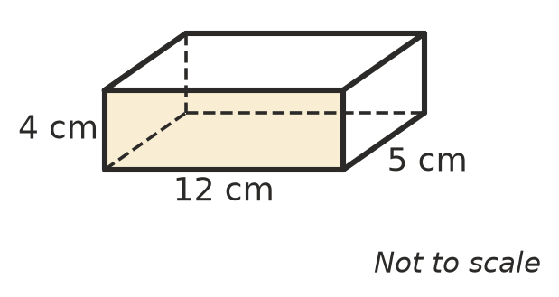
  - Find the volume of the box. (1 mark)

  - How many millilitres of sand would fill the box? (1 mark)

 Section B: Calculator allowed
- Look at this circle. Use the $π$ key on your calculator.
- 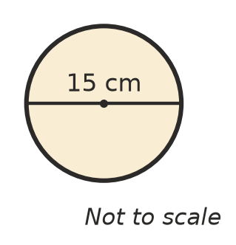
  - Find its circumference, correct to 1 decimal place. (1 mark)

  - Find its area, correct to 1 decimal place. (1 mark)

- A lawn is a rectangle with a semicircle on one end. Give your answers correct to 2 decimal places.
- 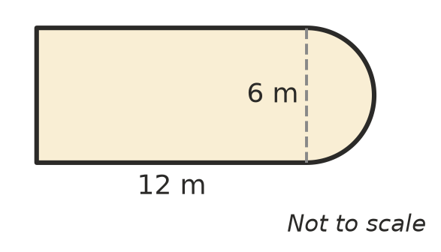
  - Find the perimeter of the lawn. (2 marks)

  - Find the area of the lawn. (2 marks)

- A tent for church camp is a triangular prism. The triangle at each end has a base of 4.5 m and a perpendicular height of 2.2 m. The tent is 6 m long. Find the volume of air inside the tent. (2 marks)

- A round table top has a circumference of 3.5 m. Find its radius, in centimetres, correct to the nearest centimetre. (2 marks)

- A raised garden bed is a rectangular prism 2.4 m long, 1.2 m wide and 0.45 m deep.
  - How many litres of soil are needed to fill it? (1 mark)

  - Soil is sold in 25 L bags. How many bags must be bought? (1 mark)

 Answer sheet
Name: ____________________
Write your final answer for each question in the table.
Question | Answer | Marks | Question | Answer | Marks
1a |  | /1 | 9b |  | /1
1b |  | /1 | 10 |  | /2
2a |  | /2 | 11a |  | /1
2b |  | /2 | 11b |  | /1
3a |  | /1 | 11c |  | /1
3b |  | /1 | 12a |  | /1
4a |  | /1 | 12b |  | /1
4b |  | /1 | 13a |  | /1
4c |  | /1 | 13b |  | /1
5 |  | /1 | 14a |  | /2
6a |  | /1 | 14b |  | /2
6b |  | /1 | 15 |  | /2
7 |  | /2 | 16 |  | /2
8a |  | /1 | 17a |  | /1
8b |  | /2 | 17b |  | /1
9a |  | /1
 |  |  |  | Total | /40

