9.11 Volume of right prisms
Year 8 Maths · Worksheet · Level 1 · Warm-up
Name: ____________________ Date: ______________
A right prism has the same cross-section all the way through, and its sides are at right angles to its ends. Its volume is V = A × h, where A is the area of the cross-section and h is the height (the distance between the two ends, sometimes called the length). Tip: find the area of the end face first, then multiply.

 Understanding
- Write yes or no: is each object shaped like a prism?
  - a cereal box ______________
  - a square-based pyramid ______________
  - a chocolate bar box with triangular ends ______________
  - a tennis ball ______________
- This triangular prism has a cross-section shaded at the front.
- 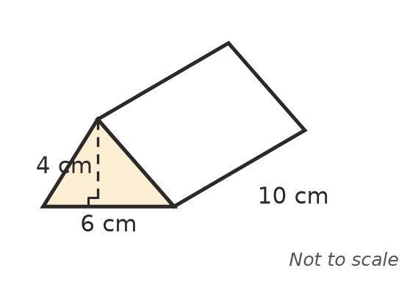
  - Find the area of the triangular cross-section. ______________
  - Find the volume of the prism. ______________

 Fluency
- Find the volume of each rectangular prism.
- 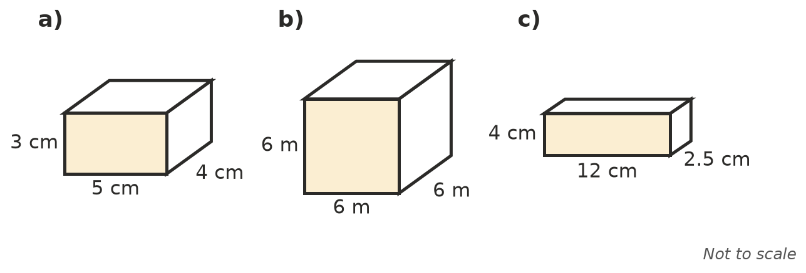
  - ______________
  - ______________
  - ______________
- The area of the shaded cross-section is given. Find the volume of each prism.
- 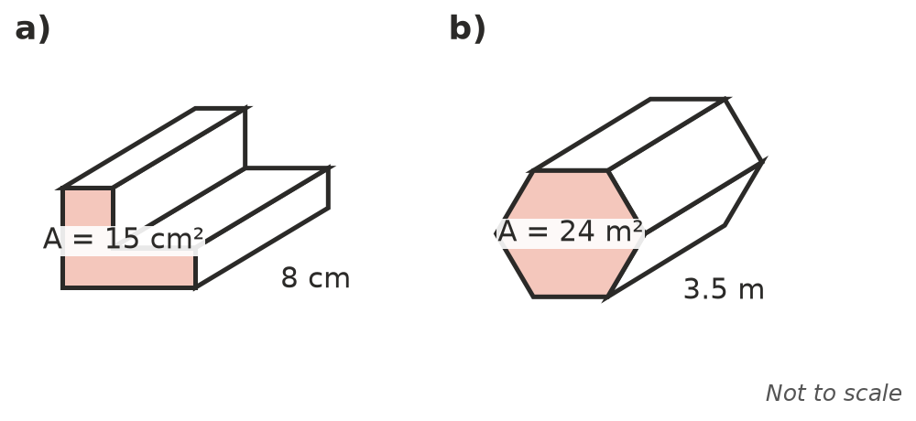
  - ______________
  - ______________
- A triangular prism has a cross-section with a base of 8 cm and a height of 5 cm. The prism is 12 cm long. Find its volume.

 Reasoning
- Explain why V = A × h works for a prism. (Hint: think of the prism as layers that are each 1 unit thick.)

- Box A is 4 cm by 4 cm by 4 cm. Box B is 8 cm by 4 cm by 2 cm. Which box has the larger volume? Show your working.

 Problem solving
- A fish tank is 50 cm long, 25 cm wide and 30 cm high. Find its volume in cm³, and its capacity in litres.

- A sandpit is 2 m long and 1.5 m wide. It is filled with sand to a depth of 0.3 m. How many cubic metres of sand are needed?

- A box has a volume of 600 cm³. Its base is 10 cm by 6 cm. How tall is it?

