9.11 Volume of right prisms
Year 8 Maths · A5 question sheet · Level 3 · Challenge
This worksheet stretches your skills with prisms: composite cross-sections, hidden lengths, algebra, capacity and multi-step problems. Tip: write V = A × h at the start of each question, and make sure every length is in the same unit before you multiply.

 Understanding
- This prism has a T-shaped cross-section. All corners of the cross-section are right angles, and the T is symmetrical.
- 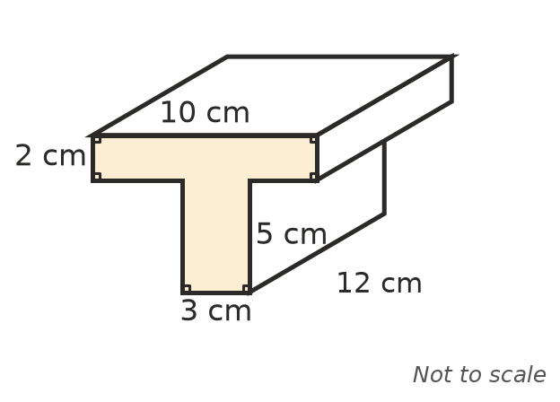
  - Find the area of the cross-section.
  - Find the volume of the prism.
- Write a simplified expression for the volume of each prism.
  - a rectangular prism x cm by 2x cm by 5 cm
  - a triangular prism whose triangle has base a and height b, with the prism c long

 Fluency
- Find the volume of each prism. In b), the triangle is isosceles; use Pythagoras’ theorem to find its height first. In c), a square hole with sides of 4 cm goes right through the block.
- 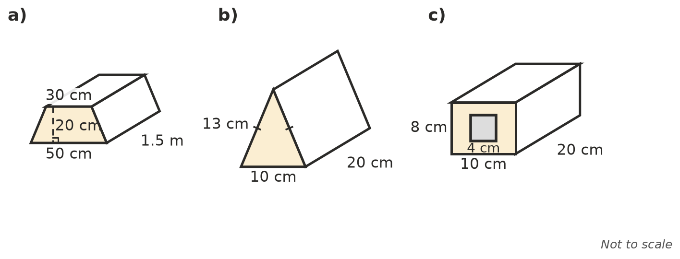
  - ______________ (give your answer in cm³ and in m³)

- Find the missing measurement.
  - A trapezoidal prism is 3 m long and has a volume of 1.8 m³. The parallel sides of the trapezium are 0.5 m and 0.7 m. Find the height of the trapezium.
  - A cube-shaped container holds exactly 8 L. Find its side length in cm.

 Reasoning
- Prism P is a triangular prism. Explain what happens to its volume if a) only its length is doubled, b) only the base and height of the triangle are both doubled.
- A rectangular prism and a triangular prism have the same length. The triangle’s base and height are the same as the rectangle’s width and height. Explain why the rectangular prism has exactly twice the volume.

 Problem solving
- A swimming pool is 20 m long and 8 m wide. It is 1 m deep at one end and 2.2 m deep at the other, sloping evenly.
- 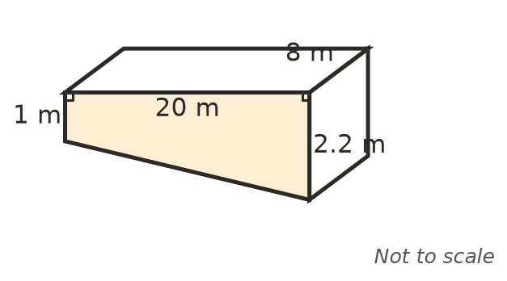
  - Find its capacity in kilolitres.
  - A hose fills it at 300 L per minute. How many hours does it take to fill? Round to 1 decimal place.
- A raised garden bed is 4 m long and 1.2 m wide, and is filled with soil to a depth of 35 cm. Soil is sold in half cubic metres at $65 per m³. How much soil must be bought, and what does it cost?
- A roof gutter is 15 m long. Its cross-section is a trapezium 12 cm wide at the top, 8 cm wide at the bottom and 10 cm deep. How many litres can it hold?
- A rectangular tank has a base 2 m by 1.5 m. It holds 4.2 kL of water. How deep is the water?
- How many boxes 30 cm by 20 cm by 10 cm fit in a crate 1.2 m long, 0.8 m wide and 0.6 m high, if they are all packed the same way?
- A block of candle wax 20 cm by 10 cm by 6 cm is melted down and poured into moulds. Each mould is a triangular prism 10 cm long, with a triangle of base 4 cm and height 3 cm. How many candles can be made?

