9.11 Volume of right prisms
Year 8 Maths · A5 question sheet · Level 2 · Core
This worksheet practises V = A × h for rectangular, triangular, trapezoidal and composite prisms, including capacity and working backwards. Tip: the cross-section is the face that is the same all the way through. It might be at the front, at the end or on the bottom, so find it first.

 Understanding
- This prism has an L-shaped cross-section. All corners of the cross-section are right angles.
- 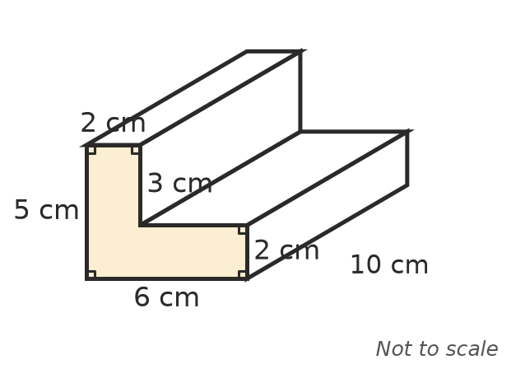
  - Find the area of the cross-section.
  - Find the volume of the prism.

 Fluency
- Find the volume of each prism.
  - 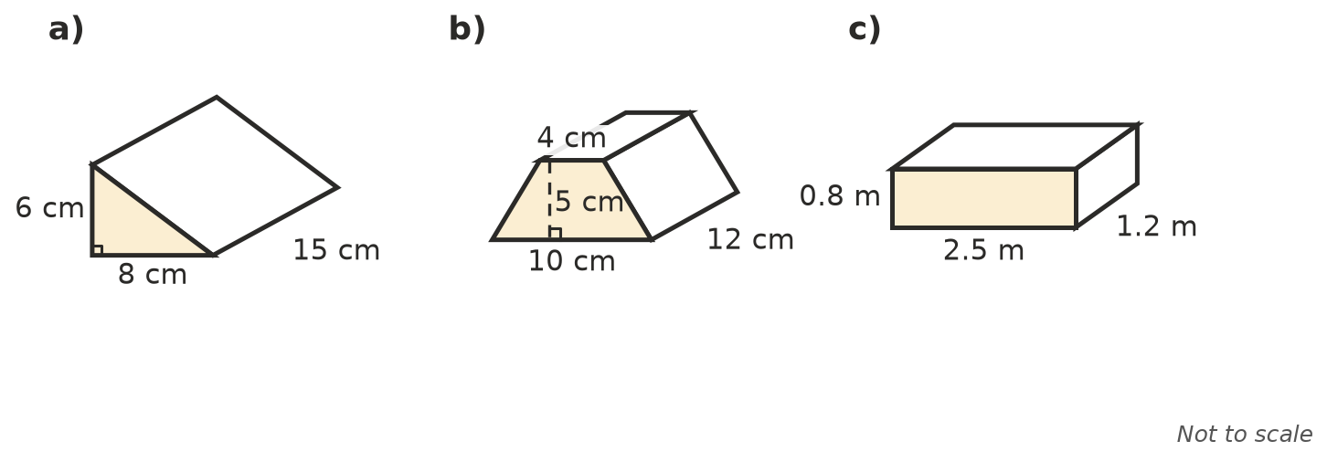

- A storage box is 1.2 m long, 50 cm wide and 40 cm high. Find its volume in m³, and its capacity in litres.
- Find the missing measurement.
  - A prism has a volume of 360 cm³ and a cross-section area of 24 cm². Find its height.
  - A cube has a volume of 125 cm³. Find its side length.
  - A triangular prism is 10 m long and has a volume of 210 m³. Its triangular cross-section has a base of 7 m. Find the height of the triangle.

 Reasoning
- A triangular prism is lying on its side. Explain why the “height” in V = A × h might be a horizontal length.
- Every length of a rectangular prism is doubled. What happens to its volume? Explain with an example.

 Problem solving
- A swimming pool is 25 m long and 10 m wide. It is 1.2 m deep at the shallow end and 2.0 m deep at the deep end, sloping evenly. Its side is a trapezium. How many kilolitres of water does it hold?
- 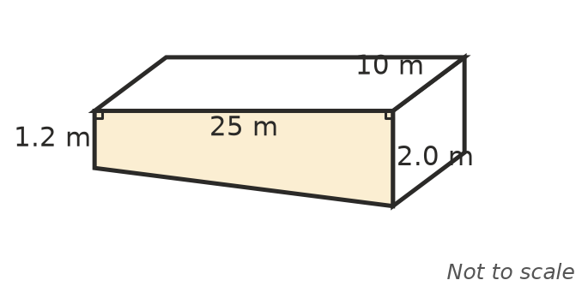
- A tent is a triangular prism. The triangular end has a base of 2.4 m and a height of 1.5 m, and the tent is 3 m long. Find the volume of air inside.
- A concrete slab is 6 m long, 4 m wide and 10 cm thick. Concrete costs $260 per m³. Find the cost of the concrete.
- A milk carton has a square base 7 cm by 7 cm and holds 1 L. How tall must the milk be inside it? Round to 1 decimal place.
- A water trough is a triangular prism 2 m long. Its triangular cross-section is 40 cm wide at the top and 30 cm deep. How many litres does it hold?
- How many cubes with 2 cm sides fit exactly inside a box 10 cm by 8 cm by 6 cm?

