9.10 Units of volume and capacity
Year 8 Maths · Worksheet · Level 2 · Core
Name: ____________________ Date: ______________
This worksheet practises converting units of volume (mm³, cm³, m³) and capacity (mL, L, kL, ML), and linking the two. Key facts: 1 cm³ = 1000 mm³, 1 m³ = 1 000 000 cm³, 1 cm³ holds 1 mL, 1 L = 1000 cm³ and 1 m³ holds 1 kL. Tip: for volume, the length conversion is cubed (used three times).

 Understanding
- Find the volume of each solid by counting cubes. No cubes are hidden.
- 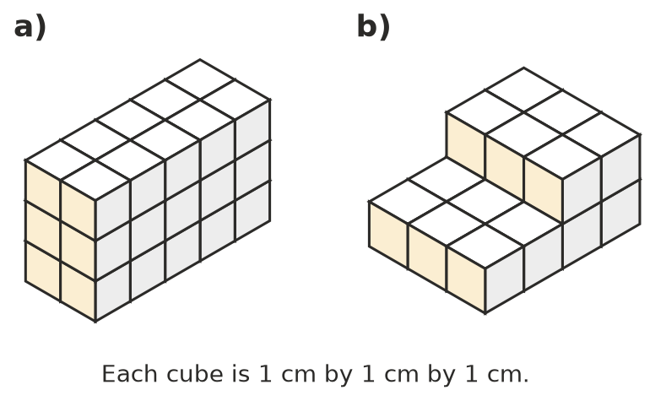
  - ______________
  - ______________
- Explain why 1 m³ = 1 000 000 cm³.

 Fluency
- Convert each volume.
  - 4.2 cm³ = ______________ mm³
  - 85 000 mm³ = ______________ cm³
  - 0.3 m³ = ______________ cm³
  - 2 500 000 cm³ = ______________ m³
- Convert each capacity.
  - 3.75 L = ______________ mL
  - 450 mL = ______________ L
  - 12.5 kL = ______________ L
  - 3 400 000 L = ______________ ML
- Convert between volume and capacity.
  - 650 cm³ = ______________ mL
  - 2.4 L = ______________ cm³
  - 6 m³ = ______________ kL = ______________ L
  - 0.8 m³ = ______________ L
- Write these amounts in order from smallest to largest: 1.2 L, 1150 mL, 1250 cm³, 0.0011 m³.

 Reasoning
- Explain the difference between the volume of a coffee mug and its capacity.

- Sam says 1 m³ holds 100 L, because 1 m = 100 cm. Explain his mistake.

 Problem solving
- A box measures 30 cm by 20 cm by 10 cm. Find its volume in cm³, and how many litres it could hold.

- A rainwater tank holds 22 kL. A household uses 180 L of tank water a day. For how many full days will a full tank last?

- A fish tank is 60 cm long, 30 cm wide and 40 cm high.
  - Find its capacity in litres. ______________
  - It is filled with water to 5 cm below the top. How many litres of water are in it? ______________

- An Olympic swimming pool holds about 2.5 ML. A garden hose delivers 20 L per minute. About how many days would it take to fill the pool with the hose? Round to the nearest day.

