9.10 Units of volume and capacity
Year 8 Maths · A5 question sheet · Level 1 · Warm-up
Volume is the amount of space an object takes up, measured in cubic units such as cm³ and m³. Capacity is how much a container can hold, measured in millilitres (mL), litres (L), kilolitres (kL) and megalitres (ML). They are linked: 1 cm³ holds 1 mL, and 1 m³ holds 1 kL. Tip: to change to a smaller unit, multiply; to change to a bigger unit, divide.

 Understanding
- Find the volume of each solid by counting cubes. No cubes are hidden.
  - 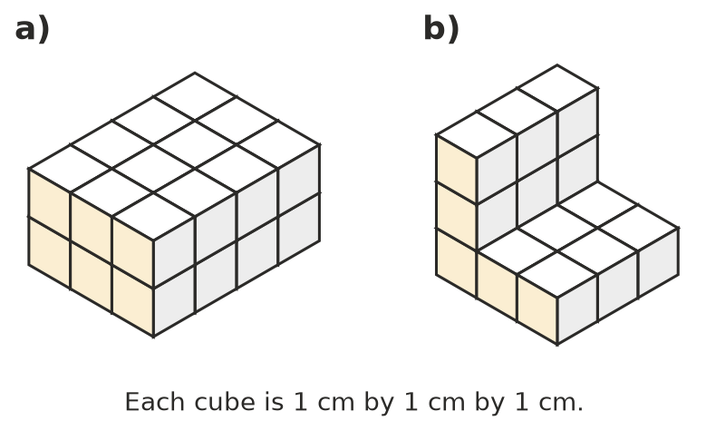

- Complete each fact.
  - 1 L = ______________ mL
  - 1 kL = ______________ L
  - 1 cm³ holds ______________ mL
  - 1 m³ holds ______________ L

 Fluency
- Choose the best unit to measure the capacity of each container: mL, L, kL or ML.
  - a teaspoon
  - a carton of milk
  - a backyard swimming pool
  - a large dam
- Convert each capacity.
  - 3 L = ______________ mL
  - 2500 mL = ______________ L
  - 4 kL = ______________ L
  - 750 cm³ = ______________ mL
- Convert each volume.
  - 1 cm³ = 10 mm × 10 mm × 10 mm = ______________ mm³
  - 3 m³ = ______________ L
  - 5000 cm³ = ______________ L

 Reasoning
- A cube with sides of 1 cm holds 1 mL. How many millilitres does a cube with sides of 10 cm hold? How many litres is that? Explain.
- Which is more: 1.5 L or 1600 mL? Show how you know.

 Problem solving
- A water bottle holds 600 mL. How many bottles can be filled from a 3 L jug?
- A rainwater tank holds 2.5 kL. How many 10 L buckets of water is that?
- A dose of cough medicine is 5 mL. How many doses are in a 200 mL bottle?

