9.09 More composite areas
Year 8 Maths · Worksheet · Level 2 · Core
Name: ____________________ Date: ______________
This worksheet practises the area of composite shapes that include circles, semicircles, quadrants, rings and other curved parts. Calculators are allowed; round to 1 decimal place unless a question says otherwise. Tip: write a word plan first, such as “rectangle − semicircle”, then fill in the numbers.

 Understanding
- A semicircle has been cut out of the end of this 12 m by 8 m rectangle.
- 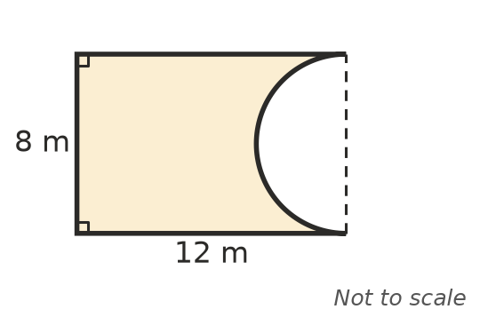
  - Write a word plan for the area, such as “rectangle + triangle”. ______________
  - Find the area. ______________
- Complete: a sector with angle θ and radius r has area ______________ × $π$r².

 Fluency
- Find each shaded area. In b), the shaded part is between a quadrant and a straight line. In c), four quadrants with a radius of 6 cm are cut from the corners of the square.
- 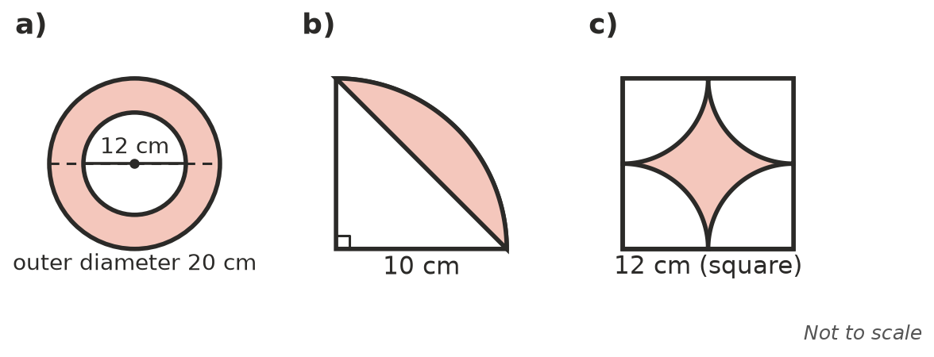
  - ______________
  - ______________
  - ______________
- A window is a rectangle with a semicircle on top. Find the area of glass.
- 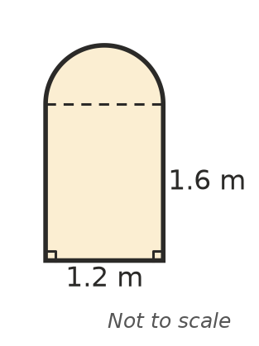

- An ice-cream cone shape is a triangle with a base of 6 cm and a perpendicular height of 10 cm, with a semicircle on top. Find its area.
- 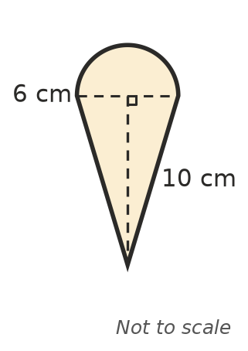

 Reasoning
- A circle fits exactly inside a square. Show that the four corner pieces outside the circle make up about 21.5% of the square, whatever the size. (Hint: use radius r.)

- Write the exact area of the shape in Question 5 in the form a + b$π$.

 Problem solving
- The grass inside a running track is a rectangle 85 m by 64 m with a semicircle on each 64 m end. New turf costs $14 per m². Find the cost, to the nearest dollar.

- A round pond has a radius of 4.5 m. A gravel path 1.5 m wide is laid around it. Find the area of the path.

- An archery target has circles with radii 10 cm, 20 cm and 30 cm, all with the same centre.
  - Find the area of the outer ring (between 20 cm and 30 cm). ______________
  - What fraction of the whole target is the outer ring? ______________

- A sprinkler in the centre of a square lawn 10 m by 10 m waters a circle with a radius of 5 m. What area of lawn is not watered?

- A metal washer is a ring with an outer diameter of 3 cm and a hole with a diameter of 1.2 cm. Find its area, to 2 decimal places.

