9.09 More composite areas
Year 8 Maths · Worksheet · Level 1 · Warm-up
Name: ____________________ Date: ______________
This worksheet uses the area of circles and parts of circles inside composite shapes. Add the areas of the pieces, or subtract the parts that are cut out. Calculators are allowed; round to 1 decimal place. Tip: a semicircle is half of $π$r² and a quadrant is a quarter.

 Understanding
- This shape is a rectangle with a semicircle on one end.
- 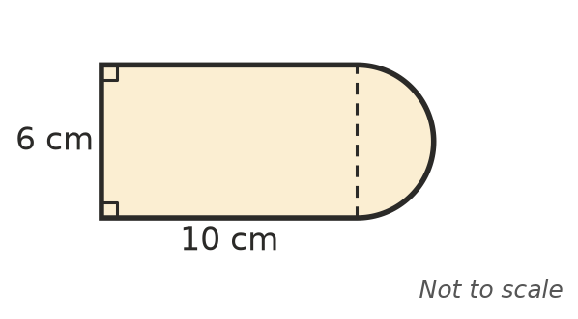
  - Area of the rectangle: ______________
  - The semicircle has a diameter of 6 cm. What is its radius? ______________
  - Area of the semicircle: ______________
  - Total area: ______________
- A ring is made by cutting a small circle out of a bigger circle with the same centre. Find the shaded area.
- 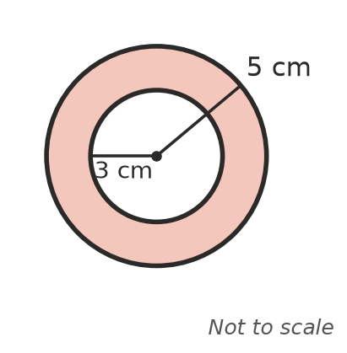
  - Area of the big circle: ______________
  - Area of the small circle: ______________
  - Shaded area: ______________

 Fluency
- Find the shaded area. In a), the white part is a quadrant.
- 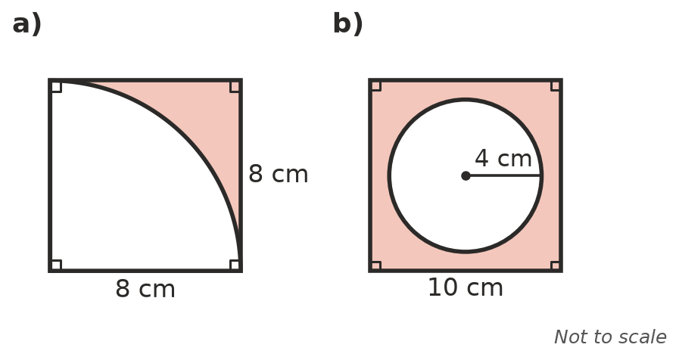
  - ______________
  - ______________
- This arch is a square with a semicircle on top. Find its area.
- 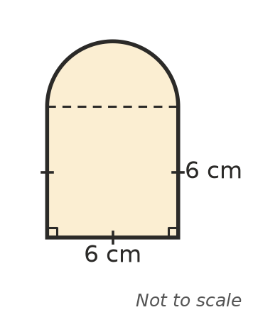

- A shape is a rectangle 20 m by 10 m with a semicircle on each of the short ends. Sketch the shape and find its area.

 Reasoning
- Explain in your own words how to find the area of a ring, like the one in Question 2.

- Write the exact area of the shape in Question 1 in the form a + b$π$.

 Problem solving
- A round pool has a radius of 3 m. A path 1 m wide goes all the way around it. Find the area of the path.

- A rectangular garden is 8 m by 5 m. In one corner there is a flower bed shaped like a quadrant with a radius of 2 m. The rest is lawn. Find the area of the lawn.

- A CD has a diameter of 12 cm, with a hole in the middle that has a diameter of 1.5 cm. Find the area of one side of the CD.

