9.09 More composite areas
Year 8 Maths · A5 question sheet · Level 3 · Challenge
This worksheet stretches your skills with composite shapes made from circles and sectors: exact answers, segments, algebra and working backwards. Calculators are allowed; round to 1 decimal place unless a question says otherwise. Tip: keep answers in terms of $π$ until the end; many shapes simplify nicely.

 Understanding
- A circle with radius r fits exactly inside a square. Write a simplified expression for the area inside the square but outside the circle.
- A segment is the part of a circle between an arc and a straight line (a chord). For a quadrant with a radius of 6 cm, write the exact area of the segment as sector − triangle.

 Fluency
- Find each shaded area, exactly in terms of $π$ and rounded. In a), two equal semicircles are cut from a big semicircle. In b), semicircles are drawn outward on each side of a 10 cm square. In c), a semicircle is cut from a quadrant.
  - 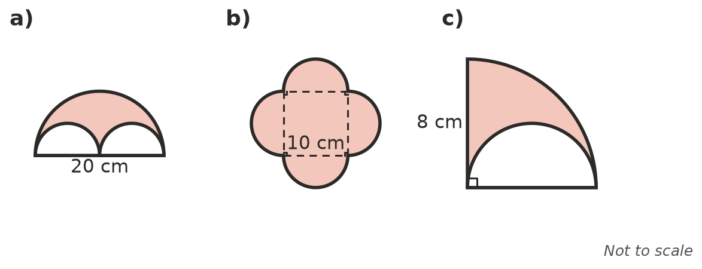

- A running track has two straights of 100 m. Each end is a semicircular ring with an outer radius of 40 m and an inner radius of 32 m. Find the area of the track surface (the straights are 8 m wide too).
- Find the area of the shaded segment, to 1 decimal place.
- 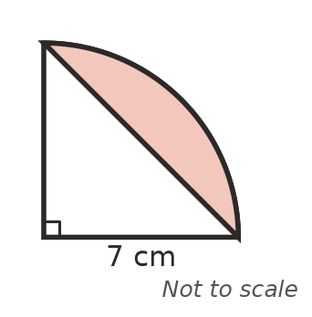

 Reasoning
- Look at your answer to Question 3 a). Explain why the shaded area is exactly half of the big semicircle.
- Which is bigger: a ring between circles of radius 10 cm and 9 cm, or a circle with a radius of 4 cm? Use exact values.

 Problem solving
- A window is a rectangle 1.4 m wide and 2 m high, with a semicircle on top. Glass costs $180 per m². Find the cost of the glass.
- A square courtyard is 14 m by 14 m. A circular lawn with a diameter of 12 m is in the middle and the rest is paved. Find the paved area.
- A ring has an area of 75$π$ cm². The inner circle has a radius of 5 cm. Find the outer radius.
- A logo is a circle with a radius of 6 cm, with two circles of radius 3 cm cut out of it. Find the area that is left. What fraction of the big circle is cut out?
- A pizza has a diameter of 32 cm. The crust is the outer ring, 2 cm wide. What percentage of the pizza’s area is crust? Round to 1 decimal place.

