9.08 Area of a circle
Year 8 Maths · Worksheet · Level 2 · Core
Name: ____________________ Date: ______________
This worksheet practises A = $π$r² for circles, semicircles, quadrants and sectors, exact answers in terms of $π$, and working backwards to the radius. Calculators are allowed; round to 1 decimal place unless a question says otherwise. Tip: a sector with angle θ is $\frac{θ}{360}$ of a whole circle.

 Understanding
- A circle has a radius of 5 cm. Match each calculation to what it finds, and give the unit.
  - 2 × $π$ × 5 finds the ______________, in ______________
  - $π$ × 5² finds the ______________, in ______________
- Without a calculator, use $π$ ≈ 3 to estimate the area of a circle with a radius of 10 cm. Is the real area a bit more or a bit less? ______________

 Fluency
- Find the area of each circle.
- 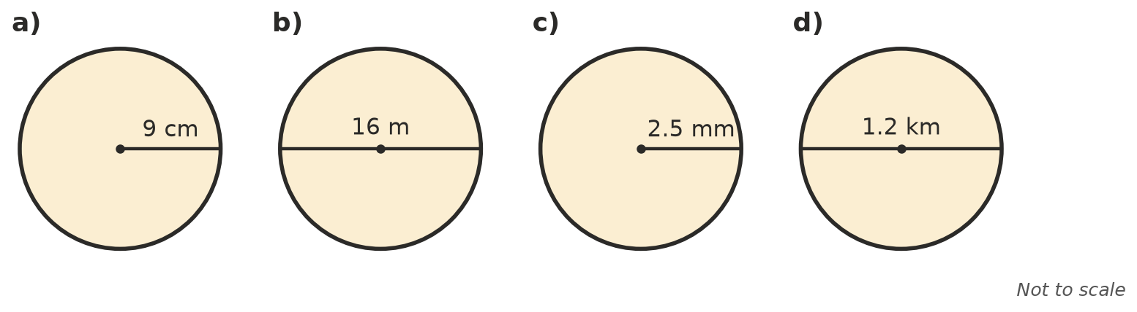
  - ______________
  - ______________
  - ______________
  - ______________
- Give the exact area of each circle, in terms of $π$.
  - radius 6 cm ______________
  - diameter 10 m ______________
  - radius 1.5 cm ______________
- Find the area of a) the semicircle, b) the quadrant and c) the sector.
- 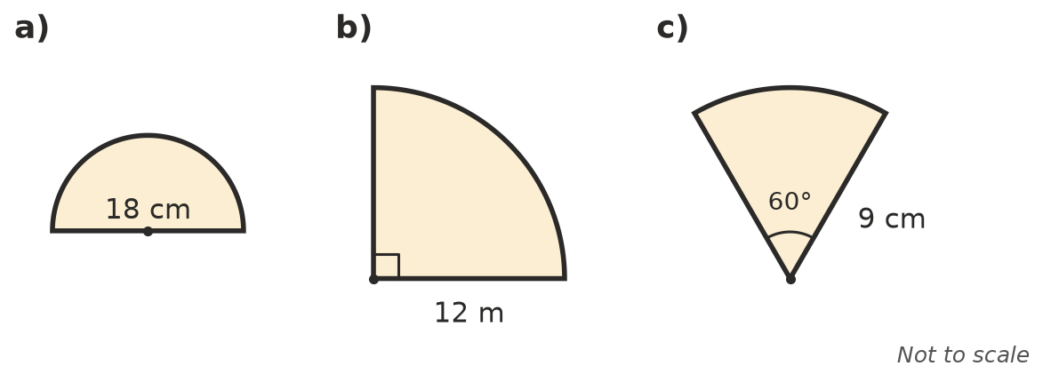
  - ______________
  - ______________
  - ______________
- Work backwards.
  - A circle has an area of 153.9 cm². Find its radius. ______________
  - A circle has an area of 64$π$ m². Find its radius. ______________
  - A circle has an area of 1000 m². Find its diameter. ______________

 Reasoning
- The radius of a circle is doubled. What happens to its area? Explain using the formula.

- Lena found the area of a circle with a radius of 6 cm by typing ($π$ × 6)² into her calculator. Explain her mistake and find the correct area.

 Problem solving
- A medium pizza has a diameter of 25 cm and costs $14. A large pizza has a diameter of 35 cm and costs $24. Which pizza gives more pizza per dollar? Show your working.

- A circular lawn has a radius of 7.5 m. Fertiliser is spread at 30 g per m². How many kilograms of fertiliser are needed? Round to 1 decimal place.

- A circle has the same area as a square with sides of 10 cm. Find the radius of the circle, to 2 decimal places.

- A round table top has a diameter of 1.5 m. It needs two coats of varnish, and 1 L of varnish covers 4 m². How much varnish is needed? Round to 2 decimal places.

