9.08 Area of a circle
Year 8 Maths · Worksheet · Level 1 · Warm-up
Name: ____________________ Date: ______________
The area of a circle is A = $π$ × r × r, written A = $π$r². Calculators are allowed: use the $π$ key and round to 1 decimal place unless a question says otherwise. Tip: if you are given the diameter, halve it to get the radius first.

 Understanding
- Complete each sentence.
  - A = $π$ × ______________ × ______________
  - Area is measured in square units, such as ______________ or ______________
  - A circle has a diameter of 10 cm. Before using the formula, I change this to a radius of ______________ cm.
- Find r and r² for each circle.
  - radius 3 cm: r² = ______________
  - diameter 14 m: r = ______________, r² = ______________

 Fluency
- Find the area of each circle.
- 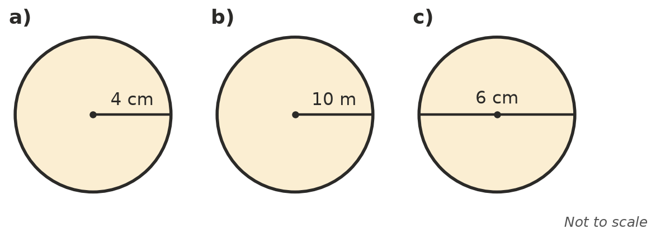
  - ______________
  - ______________
  - ______________
- Use $π$ ≈ 3.14 to find the area of each circle.
  - radius 2 cm ______________
  - radius 10 m ______________
  - diameter 20 cm ______________
- Give the exact area of each circle, in terms of $π$.
  - radius 3 cm ______________
  - radius 7 m ______________
- Find the area of a) the semicircle and b) the quadrant (a quarter of a circle).
- 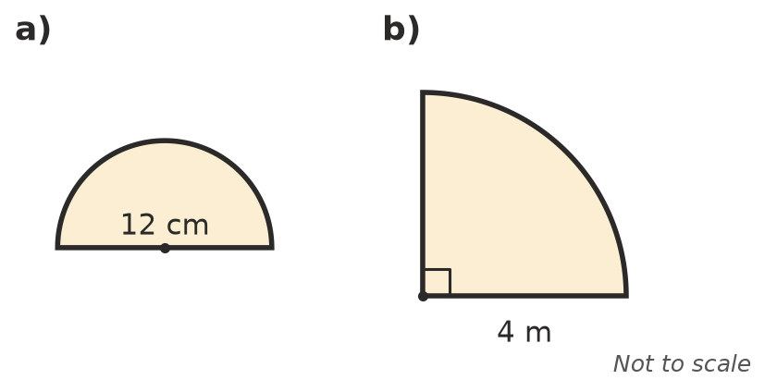
  - ______________
  - ______________

 Reasoning
- Josh found the area of a circle with a radius of 4 cm as 2 × $π$ × 4 ≈ 25.1 cm². Explain his mistake and find the correct area.

 Problem solving
- A round tablecloth has a radius of 0.8 m. Find its area.

- A garden sprinkler waters a circle with a radius of 3 m. What area of lawn does it water?

- A large pizza has a diameter of 30 cm and a small pizza has a diameter of 20 cm.
  - Find the area of each pizza. ______________
  - How many times as much pizza is in the large one? Round to 2 decimal places. ______________

