9.08 Area of a circle
Year 8 Maths · A5 question sheet · Level 3 · Challenge
This worksheet stretches your skills with the area of circles and sectors: exact answers, algebra, unit changes and working backwards. Calculators are allowed; round to 1 decimal place unless a question says otherwise. Tip: keep answers exact (in terms of $π$) until the last step.

 Understanding
- Halving a circle halves its area, but it does not halve its perimeter. Explain why, using a circle with a radius of 4 cm.
- Write each area exactly, in terms of $π$.
  - a circle with a diameter of 2x cm
  - a circle with a radius of 3a m
  - a circle whose circumference is 10$π$ cm

 Fluency
- Find the area of each sector. In a), three-quarters of the circle is left.
  - 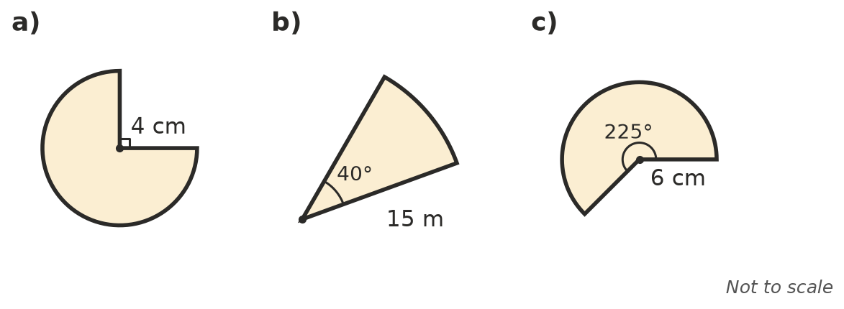

- Work backwards.
  - A circle has an area of 200 cm². Find its radius.
  - A semicircle has an area of 100 m². Find its diameter.
  - A circle has a circumference of 50 cm. Find its area.
- A round mirror has a radius of 45 cm. Find its area in m², to 2 decimal places.

 Reasoning
- Show that the area of a circle with diameter d is A = $\frac{πd^{2}}{4}$.
- Which has the larger area: one circle with a radius of 10 cm, or two circles that each have a radius of 7 cm? Answer with exact values.
- For one circle, the area (in cm²) and the circumference (in cm) are the same number. Find its radius.

 Problem solving
- A radio station can be heard up to 45 km from its tower in every direction. Over what area can it be heard? Round to the nearest km².
- For the same price, you can buy one pizza with a diameter of 40 cm or two pizzas with a diameter of 28 cm. Which gives more pizza, and by how much?
- The area of a circle grows from 50 cm² to 200 cm². By what factor did its radius grow? Explain.
- A dog is tied to the outside corner of a square shed with a 6 m rope. The shed’s walls are longer than 6 m. The shed stops it from reaching the quarter-circle on the shed’s side. Find the area the dog can reach.

