9.08 Area of a circle
Year 8 Maths · A5 question sheet · Level 1 · Warm-up
The area of a circle is A = $π$ × r × r, written A = $π$r². Calculators are allowed: use the $π$ key and round to 1 decimal place unless a question says otherwise. Tip: if you are given the diameter, halve it to get the radius first.

 Understanding
- Complete each sentence.
  - A = $π$ × ______________ ×
  - Area is measured in square units, such as ______________ or
  - A circle has a diameter of 10 cm. Before using the formula, I change this to a radius of ______________ cm.
- Find r and r² for each circle.
  - radius 3 cm: r² =
  - diameter 14 m: r = ______________, r² =

 Fluency
- Find the area of each circle.
  - 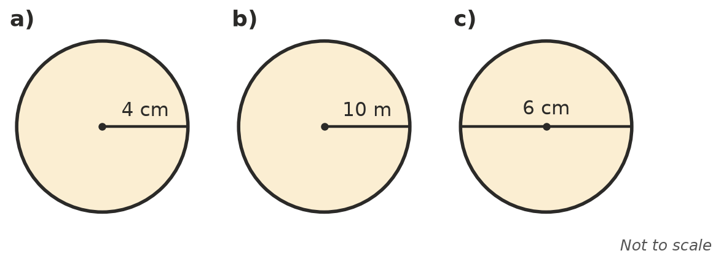

- Use $π$ ≈ 3.14 to find the area of each circle.
  - radius 2 cm
  - radius 10 m
  - diameter 20 cm
- Give the exact area of each circle, in terms of $π$.
  - radius 3 cm
  - radius 7 m
- Find the area of a) the semicircle and b) the quadrant (a quarter of a circle).
  - 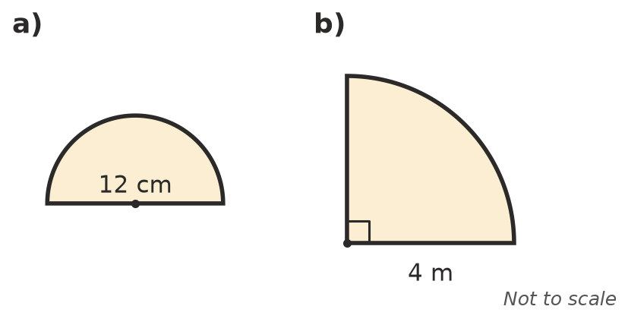

 Reasoning
- Josh found the area of a circle with a radius of 4 cm as 2 × $π$ × 4 ≈ 25.1 cm². Explain his mistake and find the correct area.

 Problem solving
- A round tablecloth has a radius of 0.8 m. Find its area.
- A garden sprinkler waters a circle with a radius of 3 m. What area of lawn does it water?
- A large pizza has a diameter of 30 cm and a small pizza has a diameter of 20 cm.
  - Find the area of each pizza.
  - How many times as much pizza is in the large one? Round to 2 decimal places.

