Investigation: Area of circles
Year 8 Maths · A5 question sheet
You already know that the circumference of a circle is $π$ × d. But how much space does a circle cover? In this investigation you will estimate the area of a circle by counting squares, trap it between two squares, and then cut a circle into slices and rearrange them to discover a formula. You will need a calculator, a compass, scissors, glue and a sheet of coloured paper.

Part A: Count the squares
- This circle has a radius of 5 cm and is drawn on a grid of 1 cm squares.
- 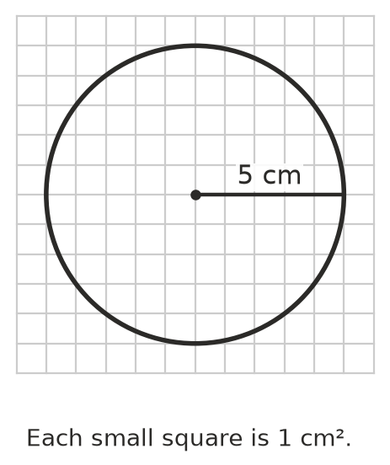
  - Count the squares that are completely inside the circle.
  - Count the squares that are partly inside the circle.
  - Estimate the area: full squares + half of the part squares.
- Why is your answer to Question 1 only an estimate?

Part B: Trap the circle between two squares
- The outer square fits around the circle, and the inner square fits inside it with its corners on the circle. The circle has radius r.
- 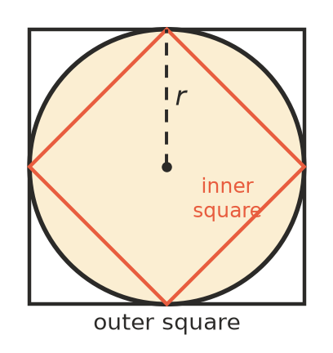
  - The side of the outer square is 2r. Write its area in terms of r.
  - The inner square is exactly half of the outer square. (Cut the outer square into four quarters through the centre: a side of the inner square cuts each quarter in half.) Write its area in terms of r.
  - Complete: the area of a circle is between ______________ × r² and ______________ × r².
- For the circle in Part A, r = 5 cm, so r² = 25 cm².
  - Work out your estimate from Question 1 ÷ 25.
  - What number do you think the circle’s area ÷ r² is close to?

Part C: Slice and rearrange
- Use a compass to draw a circle with a radius of 6 cm on coloured paper. Cut it out, fold it in half three times, and unfold it. Colour one half. Cut along the folds to make 8 slices, then fold and cut each slice in half again to make 16 slices.
- Arrange the 16 slices in a row, pointing up and down in turn, as in the picture. Glue them in your book below.
- 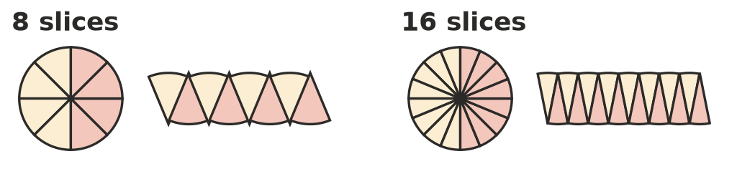
- The more slices you use, the more the shape looks like a rectangle.
  - The height of the “rectangle” is the length of a slice. What part of the circle is this?
  - Half the slices have their curved edges along the top. What fraction of the circumference is along the top?
  - The circumference is 2$π$r. Write the length of the top of the “rectangle” in terms of r.
  - Area of the rectangle = length × height = ______________ × ______________ =
- You have discovered the formula for the area of a circle: A = $π$ × r × r = $π$r². How does this fit with your answers to Question 4?

Part D: Use your discovery
- Use A = $π$r² and the $π$ key to copy and complete the table. Round to 1 decimal place.
Radius (cm) | r² (cm²)
1
2
3
5
10

- Look at your table. When the radius doubles from 5 cm to 10 cm, what happens to the area? Explain why.
- How close was your estimate in Question 1 to the area from the formula? Give the difference.
- A pizza has a diameter of 30 cm. Find its area. (Careful: the formula uses the radius.)

 Part E: Reflect
- The area of a circle with a radius of 1 m is exactly $π$ m². Because $π$ is irrational, this area can’t be written exactly as a decimal. Explain what that means, and why we usually round areas of circles.
- Which method do you trust more for finding the area of a circle, counting squares or the formula? Give a reason.

