9.07 Area of trapeziums, kites, and rhombuses
Year 8 Maths · Worksheet · Level 1 · Warm-up
Name: ____________________ Date: ______________
A trapezium has one pair of parallel sides, a and b. Its area is A = $\frac{1}{2}$ × (a + b) × h, where h is the perpendicular distance between the parallel sides. A kite or a rhombus with diagonals x and y has area A = $\frac{1}{2}$ × x × y. Tip: for a trapezium, add the parallel sides first.

 Understanding
- Complete each formula.
  - Trapezium: A = $\frac{1}{2}$ × (______________ + ______________) × ______________
  - Kite or rhombus: A = $\frac{1}{2}$ × ______________ × ______________
- Follow the steps to find the area of this trapezium.
- 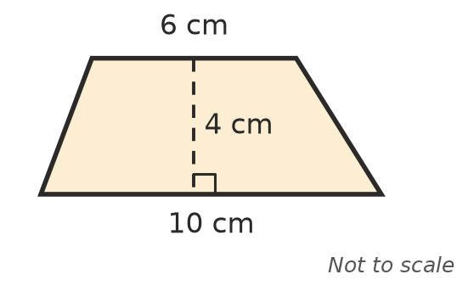
  - Add the parallel sides: ______________ + ______________ = ______________
  - Multiply by the height: ______________ × 4 = ______________
  - Halve it: area = ______________

 Fluency
- Find the area of each trapezium.
- 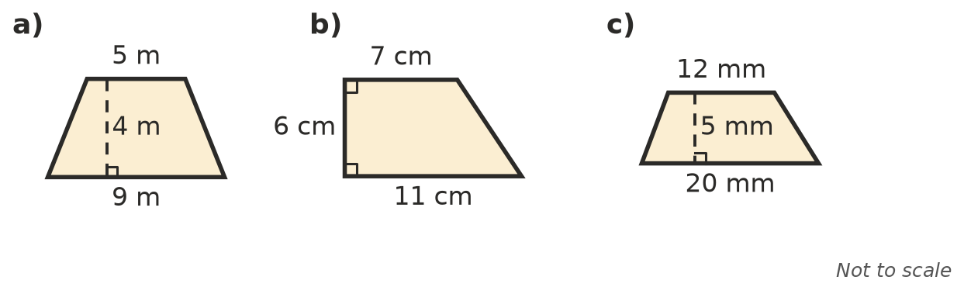
  - ______________
  - ______________
  - ______________
- The dashed lines are the diagonals. Find the area of a) the kite and b) the rhombus.
- 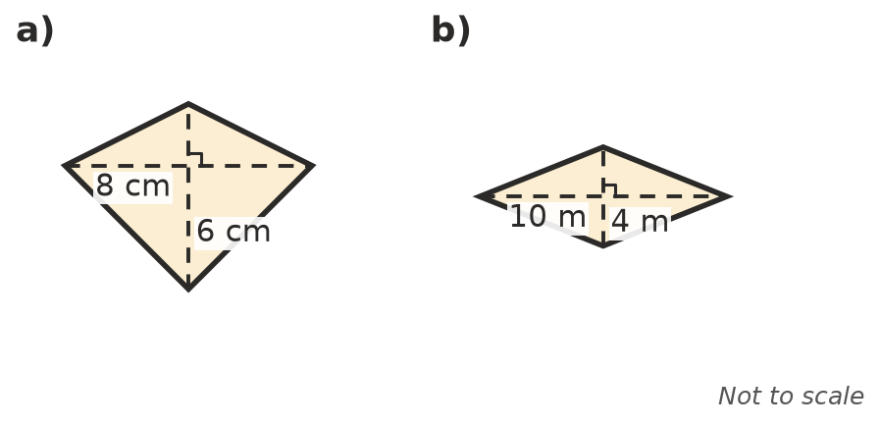
  - ______________
  - ______________
- Find the area of each shape.
  - a trapezium with parallel sides of 3 m and 7 m, and a height of 2 m ______________
  - a kite with diagonals of 12 cm and 9 cm ______________
  - a rhombus with diagonals of 14 mm and 6 mm ______________

 Reasoning
- A kite fits inside a rectangle whose sides are the same length as the kite’s diagonals. Explain why the kite’s area is half the rectangle’s area. A sketch may help.

- A trapezium has parallel sides of 4 cm and 8 cm and a height of 3 cm.
  - Use the formula to find its area. ______________
  - Check your answer by splitting it into a 4 cm by 3 cm rectangle and a triangle with a base of 4 cm. ______________

 Problem solving
- A garden bed is a trapezium. Its parallel sides are 6 m and 4 m long and they are 3 m apart. One bag of mulch covers 2 m². How many bags are needed?

- A kite for flying has diagonals of 80 cm and 50 cm. Find its area in cm² and in m².

- Rhombus-shaped tiles have diagonals of 20 cm and 12 cm. How many tiles are needed to cover 1.2 m²?

