9.07 Area of trapeziums, kites, and rhombuses
Year 8 Maths · A5 question sheet · Level 3 · Challenge
This worksheet stretches your skills with trapeziums, kites and rhombuses: missing lengths, algebra, and shapes where you must work out a measurement before you can use the formula. Tip: Pythagoras’ theorem is often the key to a missing length.

 Understanding
- A diagonal splits a trapezium with parallel sides a and b and height h into two triangles. Use the two triangles to show that A = $\frac{1}{2}$(a + b)h.
- Write a simplified expression for each area.
  - a trapezium with parallel sides of x cm and (x + 6) cm, and a height of 4 cm
  - a kite with diagonals of 2a m and 3a m

 Fluency
- Find the area of each shape. In a), the trapezium is symmetrical. In c), the numbers are parts of the diagonals.
  - 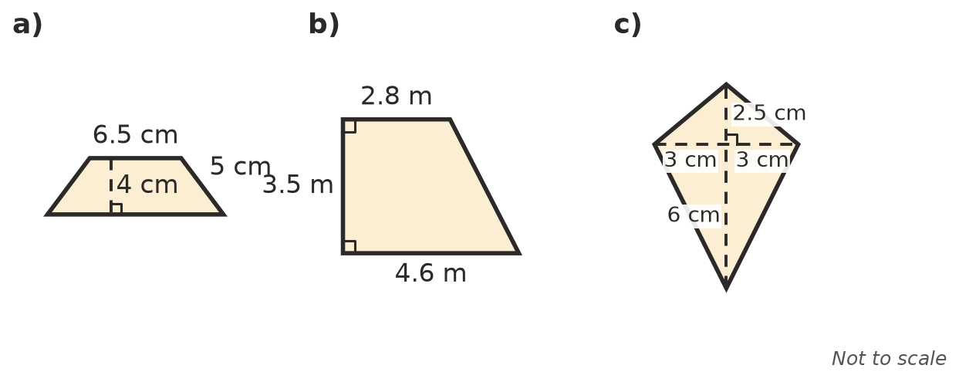

- A trapezium has parallel sides of 85 mm and 12 cm, and a height of 6.4 cm. Find its area in cm².
- Find the missing lengths.
  - A trapezium has an area of 84 cm² and a height of 7 cm. One parallel side is 4 cm longer than the other. Find both parallel sides.
  - A kite has an area of 1.08 m². One diagonal is 90 cm. Find the other diagonal in metres.

 Reasoning
- The diagonals of a rhombus cut it into four right-angled triangles. Use these triangles to show that the area of a rhombus is $\frac{1}{2}$xy.
- A rhombus has sides of 10 cm, diagonals of 12 cm and 16 cm, and a perpendicular height of 9.6 cm. Find its area in two ways: as a parallelogram, and with the diagonals.
- Does A = $\frac{1}{2}$xy work for every quadrilateral whose diagonals are perpendicular, even if it is not a kite or a rhombus? Explain.

 Problem solving
- A hip roof has two trapezium faces, each with parallel sides of 6 m and 12 m and a slant height of 4.5 m, and two triangular faces, each with a base of 7 m and a slant height of 4.1 m. Roof tiles are laid at 10 per m². How many tiles are needed?
- A paddock is a trapezium with parallel sides of 0.4 km and 650 m, which are 280 m apart. Find its area in hectares.
- A rhombus has diagonals of 24 cm and 10 cm and sides of 13 cm. Find its perpendicular height, to 2 decimal places.
- A trapezium has parallel sides of x cm and 3x cm, and its height is also x cm. Its area is 50 cm². Find x.

