9.07 Area of trapeziums, kites, and rhombuses
Year 8 Maths · A5 question sheet · Level 2 · Core
This worksheet practises the trapezium formula A = $\frac{1}{2}$(a + b)h and the diagonal formula A = $\frac{1}{2}$xy for kites and rhombuses, including mixed units and working backwards. Tip: the parallel sides of a trapezium are not always at the top and bottom, so look for the pair of parallel sides first.

 Understanding
- Look at this trapezium.
- 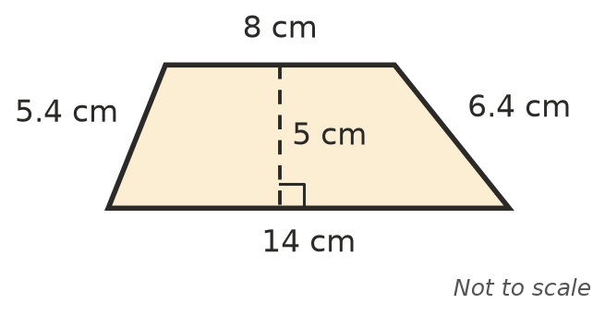
  - Which two lengths are the parallel sides?
  - Which lengths are not needed to find the area?
  - Find the area.
- Two identical copies of a trapezium, one turned upside down, fit together to make a parallelogram. Use this idea to explain where the formula A = $\frac{1}{2}$(a + b)h comes from.

 Fluency
- Find the area of each trapezium.
  - 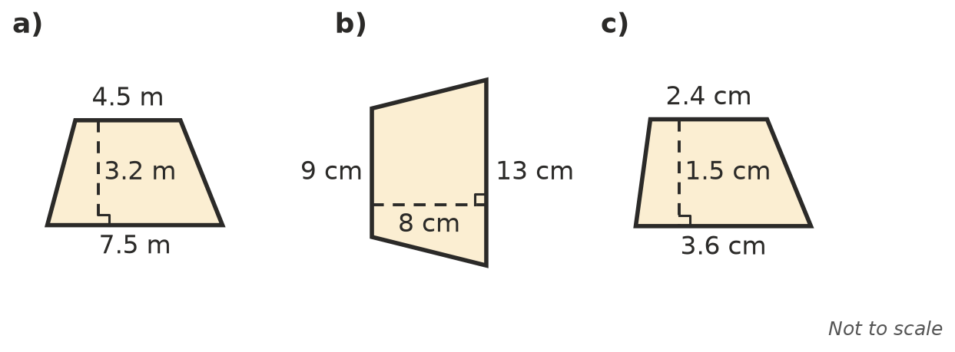

- The dashed lines are the diagonals. Find the area of each kite or rhombus.
  - 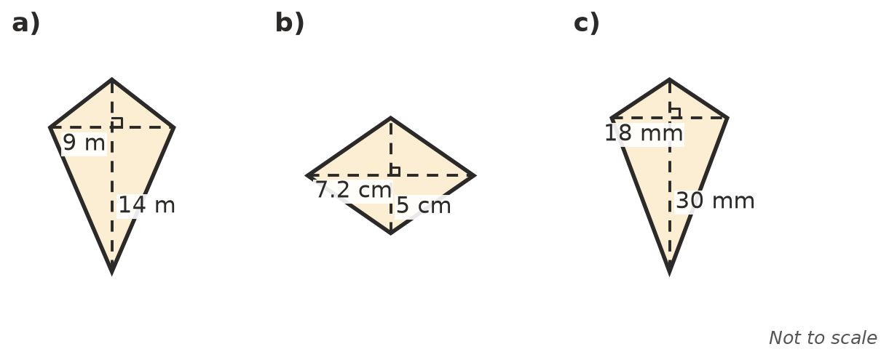

- A trapezium has parallel sides of 1.2 m and 80 cm, and a height of 50 cm. Find its area in m².
- Find the missing length.
  - A trapezium has an area of 60 cm² and parallel sides of 7 cm and 13 cm. Height =
  - A rhombus has an area of 48 m² and one diagonal of 12 m. Other diagonal =
  - A trapezium has an area of 45 cm², a height of 5 cm and one parallel side of 8 cm. Other parallel side =

 Reasoning
- A square is a special rhombus. A square has diagonals of 10 cm. Use the rhombus formula to find its area.
- Mia says the area of a trapezium is (a + b) × h. Explain her mistake, using the trapezium in Question 1.

 Problem solving
- A block of land is a trapezium. Its parallel boundaries are 32 m and 45 m long and they are 28 m apart. Land in the area sells for $350 per m². What is the block worth?
- A kite for flying has diagonals of 1.1 m and 75 cm. How much material, in m², is needed to make 4 kites?
- A cross-section of an earth dam wall is a trapezium. It is 4 m wide at the top, 18 m wide at the bottom and 9 m high. Find the area of the cross-section.
- One diagonal of a rhombus is twice as long as the other. Its area is 64 cm². Find the length of each diagonal.

