9.06 Area of composite shapes
Year 8 Maths · Worksheet · Level 3 · Challenge
Name: ____________________ Date: ______________
This worksheet stretches your skills with harder composite shapes, shaded regions, algebra and multi-step problems. Tip: there is usually more than one way to split a shape. Choose the way with the fewest parts, and check with a second method.

 Understanding
- All the corners of this shape are right angles.
- 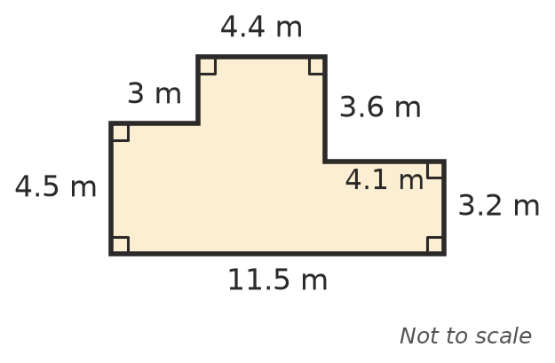
  - Find the unlabelled vertical side. ______________
  - Find the area of the shape. ______________

 Fluency
- Find the area of each shape. In a), a right-angled triangle with shorter sides of 3 cm is cut from each corner of a 10 cm square. In b), a 4 m by 2 m rectangle is cut out.
- 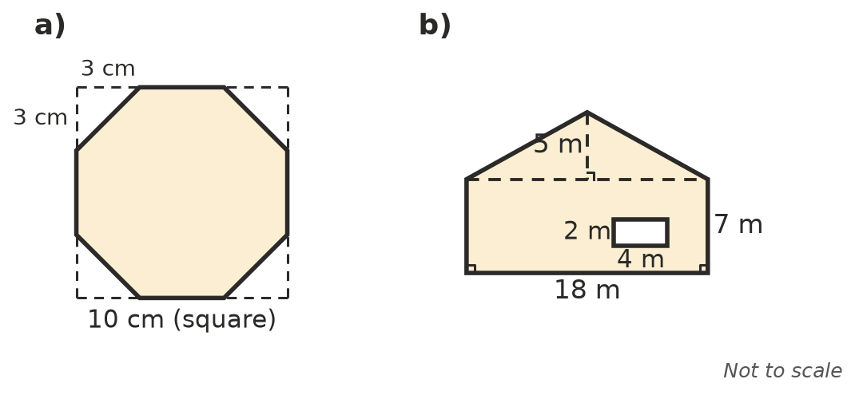
  - ______________
  - ______________
- A tilted square is drawn inside a 12 cm square, with its corners 4 cm from the corners of the big square. Find the shaded area.
- 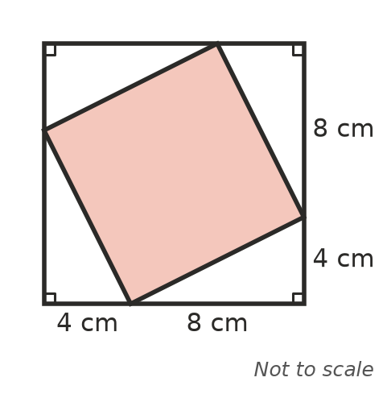

- A shape is made from a square with sides of x cm and a rectangle x cm long and 3 cm wide, joined along a side of length x. Write a simplified expression for its area.

 Reasoning
- Find the area of the shape in Question 1 a second way, and show both methods give the same answer.

- Use Pythagoras’ theorem to find the square of the side length of the tilted square in Question 3. Explain how this checks your answer.

 Problem solving
- A rectangular pool 8 m by 4 m has paving 1.2 m wide all the way around the outside. Find the area of the paving.

- The end wall of a shed is a rectangle 9.5 m wide and 2.7 m high, with a triangle on top 1.8 m high. It has two windows, each 1.2 m by 1.5 m. It needs two coats of paint. One litre covers 14 m², and paint is sold in 4 L tins. How many tins are needed?

- A shape is made by cutting an x m by 4 m rectangle from one corner of a 14 m by 10 m rectangle. The area left is 116 m². Find x.

- A block of land is 32 m by 18 m. It has a house 14 m by 10 m, a shed 4 m by 3 m and a driveway 3 m by 12 m. The rest is garden. Find the garden area, and the percentage of the block that is garden (to 1 decimal place).

- A cross shape is made from 5 equal squares (one in the middle and one on each side). Its area is 245 m². Find its perimeter.

- A lawn is 24 m by 15 m. A straight path crosses it from one long side to the other, shaped like a parallelogram. The path measures 2 m along each long side of the lawn. Find the area of lawn left.

