9.06 Area of composite shapes
Year 8 Maths · Worksheet · Level 2 · Core
Name: ____________________ Date: ______________
This worksheet practises finding the area of composite shapes by adding the areas of the parts or subtracting the parts that are missing. Tip: before you calculate, find any missing side lengths and mark them on the diagram. Check by using a second method if you can.

 Understanding
- All the corners of this shape are right angles.
- 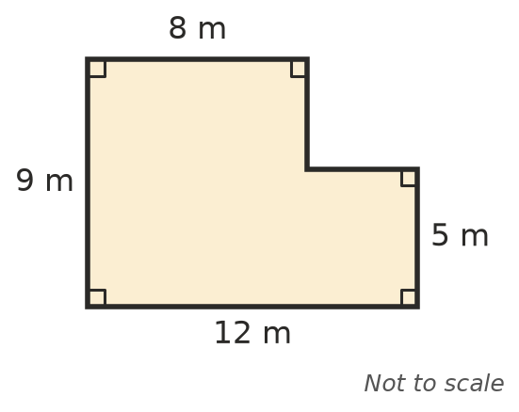
  - Find the area by splitting the shape into two rectangles and adding. ______________
  - Find the area by subtracting the missing corner from a 12 m by 9 m rectangle. ______________

 Fluency
- Find the area of each shape. In b), a right-angled triangle with shorter sides of 3 m has been cut from two corners of a 16 m by 9 m rectangle.
- 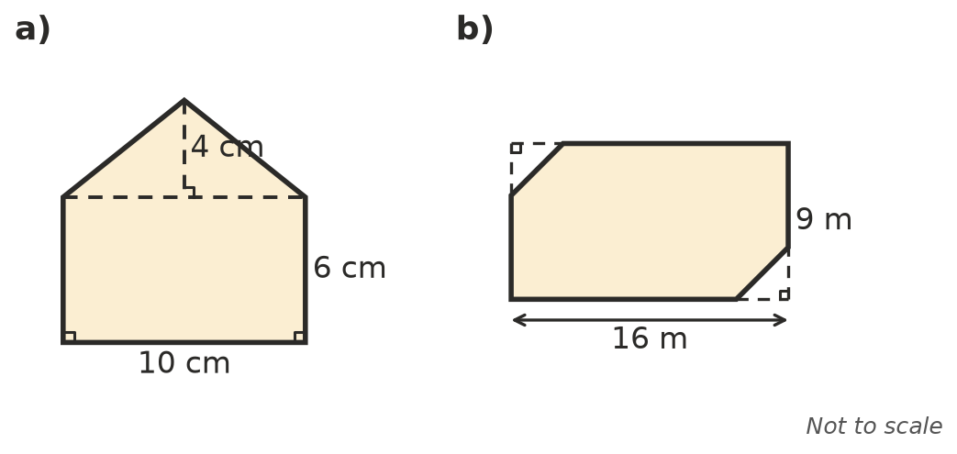
  - ______________
  - ______________
- Find the area of the shaded part of each shape. In a), both shapes are squares.
- 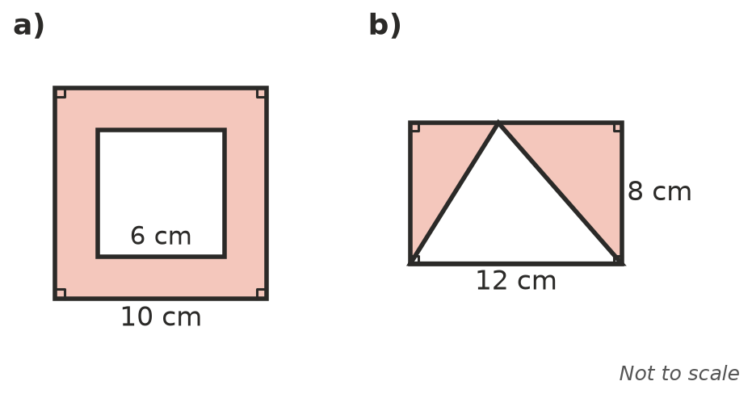
  - ______________
  - ______________
- A rectangular rug is 3 m by 2 m. A rectangle 1.2 m by 80 cm is cut from one corner so it fits around a cupboard. Find the area of the rug that is left, in m².

- Find the area of this arrow.
- 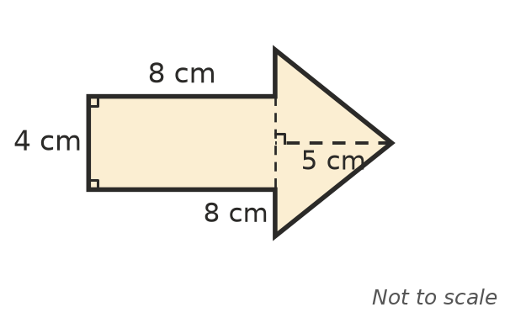

 Reasoning
- Paul found the area of the shape in Question 1 like this: 12 × 5 + 8 × 9 = 132 m². Explain his mistake.

- Can two composite shapes have the same area but different perimeters? Give an example with sketches.

 Problem solving
- A rectangular lawn is 20 m by 14 m. A paved path 1.5 m wide runs all the way around the inside edge of the lawn. Find the area of the path. Pavers cost $45 per m². Find the cost of the path.

- An L-shaped room is made from two rectangles: 6 m by 4.5 m and 3 m by 2.5 m. Carpet costs $65 per m². Find the cost of carpeting the room.

- The end wall of a house is a rectangle 8 m wide and 3 m high, with a triangle on top that is 2.4 m high. The wall has a door 0.9 m by 2.1 m and a window 1.8 m by 1.2 m. Find the area of wall to be painted.

- A square is cut from one corner of a 10 cm by 8 cm rectangle. The area left is 71 cm². How long are the sides of the square?

- A large letter T is made from two rectangles. The top bar is 60 cm by 15 cm. The stem is 15 cm wide. The whole letter has an area of 1500 cm². How long is the stem?

