9.06 Area of composite shapes
Year 8 Maths · Worksheet · Level 1 · Warm-up
Name: ____________________ Date: ______________
A composite shape is made from simpler shapes. To find its area, split it into rectangles and triangles and add their areas, or start with a bigger shape and subtract the parts that are missing. Tip: draw dashed lines on the diagram to show how you split it.

 Understanding
- This shape has been split into two rectangles, A and B. All corners are right angles.
- 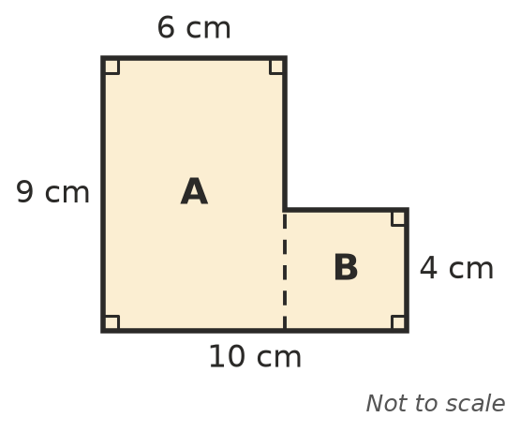
  - Area of A: ______________
  - Area of B: ______________
  - Total area: ______________
- A square hole with sides of 3 cm is cut out of a rectangle 12 cm by 8 cm. Find the area that is left.
- 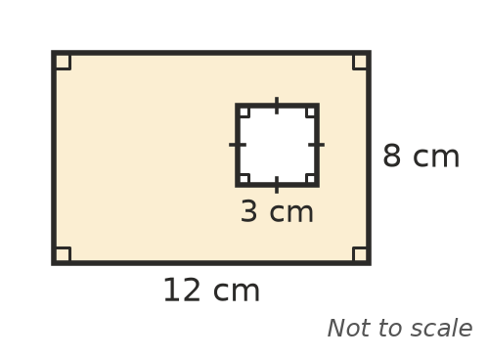

 Fluency
- Find the area of each shape. In a), the shape is symmetrical.
- 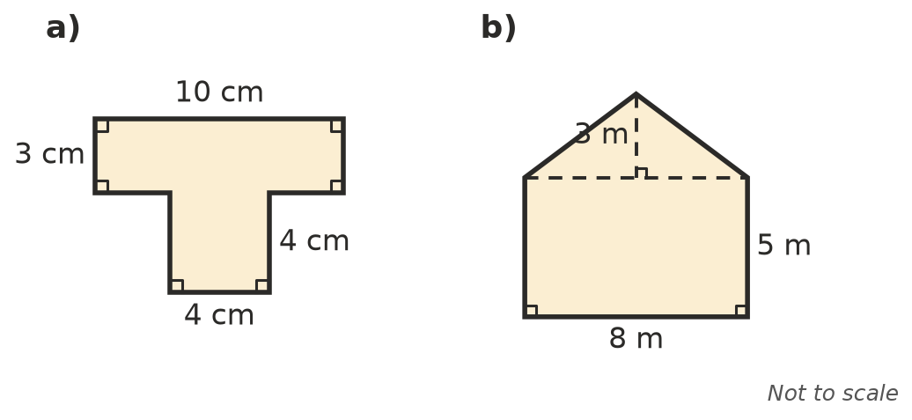
  - ______________
  - ______________
- Find the area of the shaded part of each shape.
- 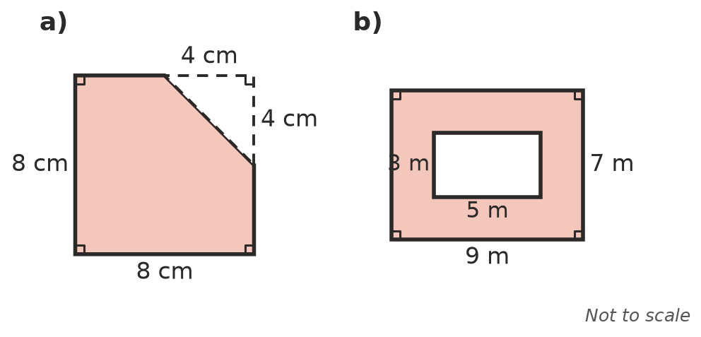
  - ______________
  - ______________
- A shape is made from a rectangle 12 m long and 5 m wide, with a triangle on one end. The triangle has a base of 5 m and a height of 4 m. Sketch the shape and find its area.

 Reasoning
- Look at the shape in Question 1. Show a different way to split it into two rectangles, and check that you get the same total area.

- When do you add areas, and when do you subtract them? Use Questions 1 and 2 to explain.

 Problem solving
- An L-shaped backyard is made from two rectangles: 15 m by 8 m and 6 m by 4 m. Turf costs $11 per m². How much will it cost to turf the whole yard?

- A wall is 5 m long and 2.4 m high. It has a window 1.5 m wide and 1.2 m high. Find the area of the wall that needs painting.

- A photo 20 cm by 15 cm sits in a frame that measures 30 cm by 25 cm on the outside. Find the area of the frame around the photo.

