9.05 Area of rectangles, triangles and parallelograms
Year 8 Maths · A5 question sheet · Level 3 · Challenge
This worksheet stretches your skills with area formulas: heights outside the shape, algebra, working backwards and choosing which base to use. Tip: any side of a triangle can be the base, as long as you use the perpendicular height that goes with it.

 Understanding
- In triangle ABC, BC = 5 cm and AB = 10 cm. The perpendicular height from A to the line BC (extended) is 6 cm.
- 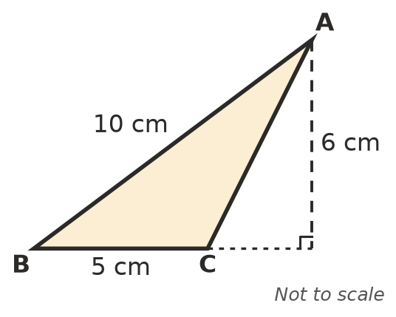
  - Find the area of the triangle.
  - Now use AB as the base. Find the perpendicular distance from C to the line AB.
- Write a simplified expression for the area of each shape.
  - a rectangle (x + 3) cm long and 4 cm wide
  - a triangle with a base of 2x cm and a height of x cm
  - a parallelogram with a base of 3a m and a height of 2b m

 Fluency
- Find the area of each shape. Give c) in m².
  - 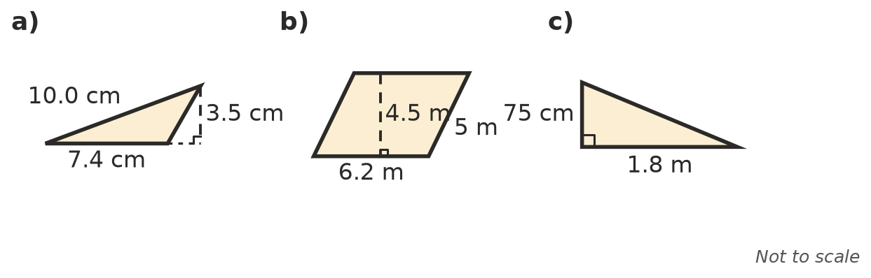

- Find the missing length.
  - A triangle has an area of 27.3 m² and a height of 6.5 m. Base =
  - A parallelogram has an area of 1.2 m² and a base of 80 cm. Height =
  - A rectangle has an area of 0.84 m² and a length of 1.2 m. Width in cm =
- Find the area of each shape on a grid of 1 cm squares. Sketch it first.
  - the triangle with corners at (1, 1), (9, 1) and (4, 6)
  - the parallelogram with corners at (1, 1), (6, 1), (8, 5) and (3, 5)

 Reasoning
- Show, using algebra, what happens to the area of a triangle when both its base and its height are doubled.
- In Question 1, the height is outside the triangle. Explain why A = $\frac{1}{2}$ × base × height still works. (Hint: think of a big right-angled triangle minus a small one.)

 Problem solving
- A shed has two triangular gable ends, each with a base of 9.6 m and a height of 2.8 m. Cladding costs $42 per m². Find the cost of cladding both gables.
- A rectangle has an area of 96 cm² and a perimeter of 40 cm. Find its length and width.
- A parallelogram has sides of 10 cm and 6 cm. The perpendicular height onto the 10 cm side is 4.8 cm.
  - Find its area.
  - Find the perpendicular height onto the 6 cm side.
- A right-angled triangle has shorter sides of 6 cm and 8 cm, and a longest side of 10 cm. Find the perpendicular height from the right angle to the longest side.

