9.05 Area of rectangles, triangles and parallelograms
Year 8 Maths · A5 question sheet · Level 2 · Core
This worksheet revises the area of rectangles (A = l × w), parallelograms (A = b × h) and triangles (A = $\frac{1}{2}$bh), with mixed units and missing lengths. Tip: the height must be perpendicular to the base. Sometimes it falls outside the shape, and slanted sides are not the height.

 Understanding
- For each shape, write the perpendicular height, then find the area.
- 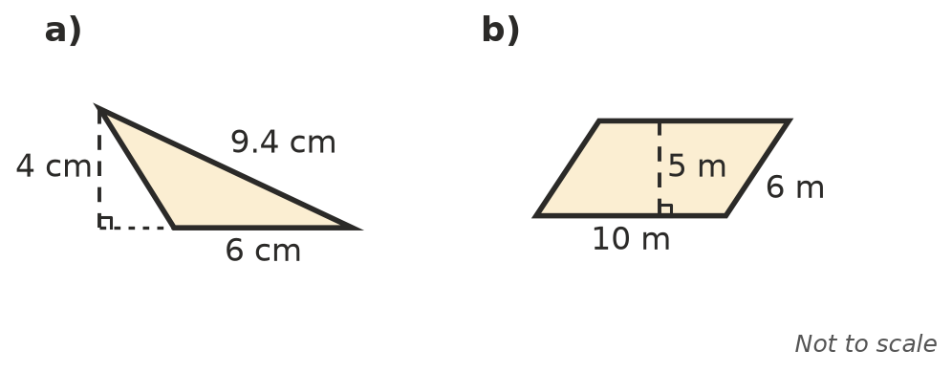
  - height = ______________, area =
  - height = ______________, area =
- Explain why a parallelogram has the same area as a rectangle with the same base and height. A sketch may help.

 Fluency
- Find the area of each shape.
  - 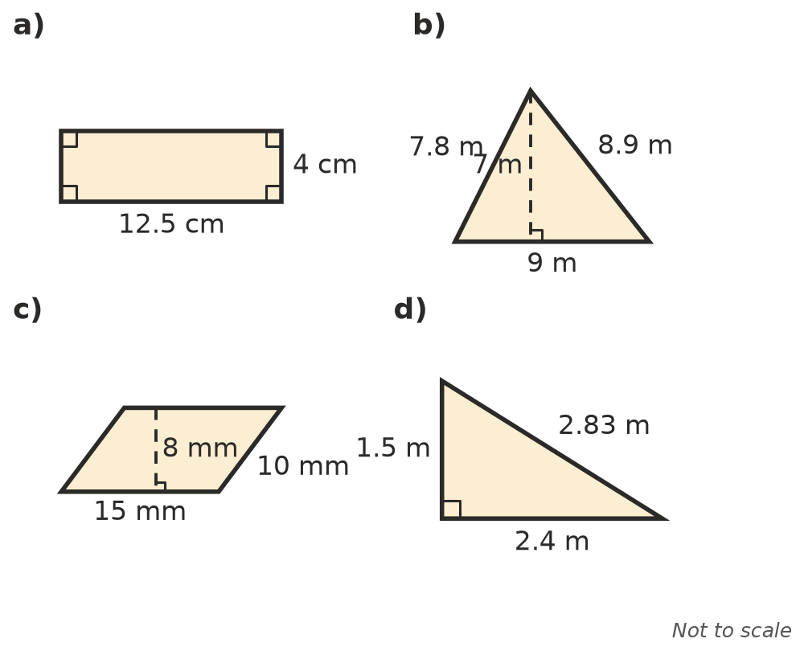

- Find each area in the unit given. Change the units first.
  - a rectangle 1.5 m by 80 cm, in m²
  - a triangle with a base of 45 cm and a height of 1.2 m, in cm²
  - a parallelogram with a base of 2 m and a height of 35 cm, in m²
- Find the missing length.
  - A rectangle has an area of 84 m² and a width of 6 m. Length =
  - A triangle has an area of 36 cm² and a base of 9 cm. Height =
  - A parallelogram has an area of 52 cm² and a height of 6.5 cm. Base =

 Reasoning
- Triangles ABC and ABD have the same base AB. Points C and D both lie on a line parallel to AB. Explain why the two triangles have the same area.
- Leo says the area of the parallelogram in Question 1 b) is 10 × 6 = 60 m². Explain his mistake.
- The base of a triangle is doubled and its height is halved. What happens to its area? Explain.

 Problem solving
- A rectangular wall 4.8 m long and 2.7 m high needs two coats of paint. One litre of paint covers 12 m². Paint is sold in 1 L tins. How many tins are needed?
- A triangular garden bed has a base of 8 m and a height of 5.5 m. One bag of mulch covers 4 m². How many bags are needed?
- A parallelogram has the same area as a 9 cm by 4 cm rectangle. Its base is 12 cm. Find its perpendicular height.
- A square has an area of 2.25 m². Find its perimeter.

