9.05 Area of rectangles, triangles and parallelograms
Year 8 Maths · A5 question sheet · Level 1 · Warm-up
This worksheet revises three area formulas: rectangle A = l × w, parallelogram A = b × h and triangle A = $\frac{1}{2}$ × b × h. The height h is the perpendicular height: it makes a right angle with the base, and is often drawn as a dashed line. Tip: give area in square units, like cm² or m².

 Understanding
- Complete each formula.
  - Rectangle: A = ______________ ×
  - Parallelogram: A = ______________ ×
  - Triangle: A = ______________ × ______________ ×
- Look at this triangle.
- 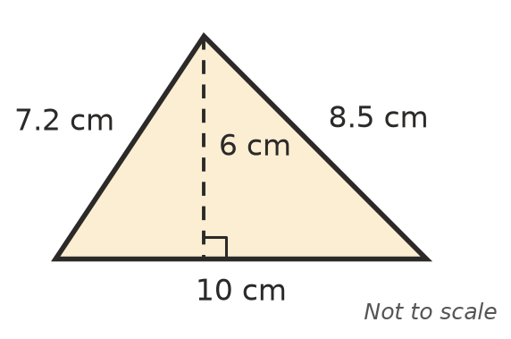
  - Which length is the perpendicular height?
  - Find the area of the triangle.

 Fluency
- Find the area of each shape. Sides with the same marks are equal.
  - 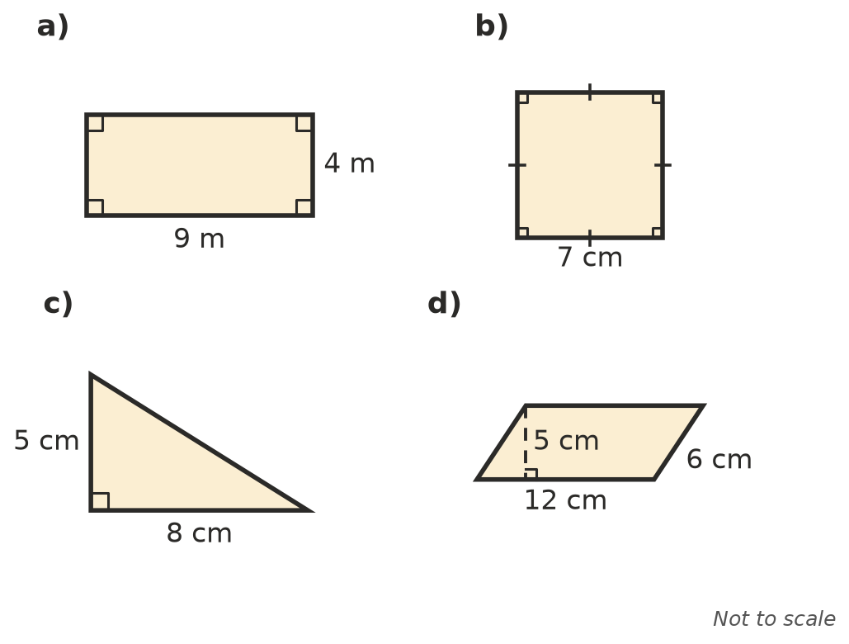

- Find the area of each shape.
  - a rectangle 15 mm long and 6 mm wide
  - a triangle with a base of 14 m and a height of 9 m
  - a parallelogram with a base of 3.5 cm and a height of 4 cm

 Reasoning
- Explain why the area of a triangle is half of base × height. A sketch may help.
- A triangle has the same area as a 6 cm by 4 cm rectangle. The base of the triangle is 8 cm. Find its height.

 Problem solving
- A rectangular lawn is 12 m long and 8 m wide. Instant turf costs $9.50 per m². How much will it cost to turf the lawn?
- A triangular sail has a base of 3 m and a height of 5 m. Find its area.
- A rectangle has an area of 72 cm² and a length of 9 cm. Find its width.
- A rectangular mat is 2 m long and 60 cm wide. Find its area in m².

