9.04 Estimation and units of area
Year 8 Maths · Worksheet · Level 3 · Challenge
Name: ____________________ Date: ______________
This worksheet stretches your skills with area units, including large conversions, map scales and real-world estimates. Tip: when a conversion is confusing, change everything to m² first. 1 m² = 10 000 cm² = 1 000 000 mm², 1 ha = 10 000 m² and 1 km² = 1 000 000 m².

 Understanding
- Write these areas in order from smallest to largest: 0.05 km², 4 ha, 52 000 m², 600 000 000 cm².

- Explain why 1 km² = 100 ha.

 Fluency
- Convert each area.
  - 0.035 m² = ______________ cm²
  - 8 500 000 mm² = ______________ m²
  - 0.0072 km² = ______________ ha
  - 125 000 cm² = ______________ m²
  - 45 ha = ______________ km²
- Estimate the area of this island. Each grid square is 200 m by 200 m.
- 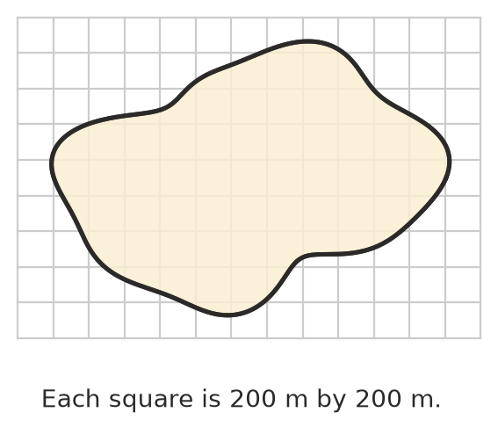
  - What area does one grid square stand for, in hectares? ______________
  - Estimate the area of the island in hectares. ______________
  - Write your estimate in km². ______________
- Find the exact area of each shape by counting whole and half squares.
- 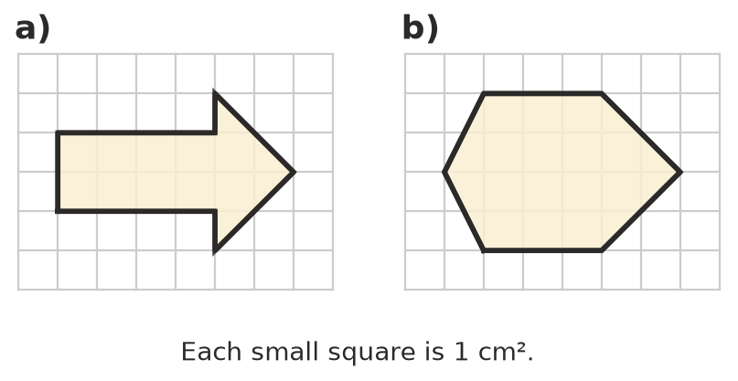
  - ______________
  - ______________

 Reasoning
- On a map, 1 cm stands for 50 m. What real area does 1 cm² on the map stand for, in m² and in hectares? Explain why it is not 50 m².

- For the island in Question 4, explain why counting only the full squares gives an underestimate, and counting every square the island touches gives an overestimate.

 Problem solving
- A farmer spreads fertiliser at 25 kg per hectare on a paddock 450 m long and 320 m wide. How much fertiliser is needed?

- A courtyard 6.4 m by 4.5 m is paved with bricks that are 20 cm by 10 cm. How many bricks are needed?

- A sheet of A0 paper has an area of 1 m². A1 is half of A0, A2 is half of A1, and so on.
  - Find the area of a sheet of A4, in cm². ______________
  - A4 actually measures 21.0 cm by 29.7 cm. How close was your answer? ______________

- A square field has an area of 2.25 ha. How long is each side, in metres?

- A national park has an area of 85 km². A bushfire burned 2300 ha of it. What percentage of the park was burned? Round to 1 decimal place.

